TITLE OF EVENT LOCATION (address) : The Cockpit Theatre, Gateforth street, nw8 8eh
DATE : Saturday 29th August & Sunday 30th August
TIME : 08/29/26 - 7pm & 08/30/26 - 4pm
BASIC VENUE INFO- physical barriers, stairs, toilets etc.
Wheelchair access and access for those with mobility problems
For shows
There is level access to the foyer, bar and foyer toilets but after that it gets tricky. There are six steps down from the foyer to the auditorium. Access to the auditorium is possible for wheelchair users via the car park and rear entrance.
Contact us on the day if you can to let us know you are coming. 0207 258 2925 or email reception@thecockpit.org.uk and try and arrive a bit early because we like to make sure you are comfortable before we let other audience members into the show. We are only allowed four wheelchair users on the premises at any one time. On the upside there are three parking bays for badge holders bang outside the theatre.

TIMINGS OF EVENT- running time, breaks (interval), venue opening/ closing times
Run time: 90 mins without an interval

CONTENT OFEVENT-***Trigger warnings***
loud music, actors interact with audience members and may invite them to the stage, themes of sexual violence, medical trauma and addiction. If at any point you feel the need to leave the room, there will be a quiet space available outside of the room which an usher or member of staff can direct you to discreetly. Attendees can leave and re-enter the room.
SEATING
Audience members may be moved from their original seat to another and may be separated from friends, or family they have attended with during the show.

GETTING TO THE VENUE-
The Cockpit is on Gateforth Street, which is at the north end of Church Street. Church Street runs between Edgware Road and Lisson Grove.
By train:
The nearest stations are Edgware Road (Hammersmith & City, District, Circle, Bakerloo) and Marylebone (Bakerloo and main line). Both are about a 7 minute walk away.
Click here to use the TfL Journey Planner.
By bus:
Buses stopping nearby are 6, 16, 18, 98, 139, 189, 332, 414.
By car:
Saturdays - if you are visiting on a Saturday avoid driving if you can. It is difficult, verging on impossible, to get to us or find parking because of the Church Street Market, and as Lisson Grove is the only Pay & Display parking in the vicinity, spaces are extremely limited. Most other streets near us are Resident Permit Holders only (don't take the chance, you will get a ticket).
There is unrestricted parking (single yellow line) after 6.30 pm and on Sundays in most local streets and just along from the theatre in Gateforth Street. At other times there is Pay and Display parking available on Church Street (not on Saturdays), and Lisson Grove.
There are three disability badge-holder bays directly in front of the Cockpit. Avoid the 'resident only' bays nearby!
Our customers can also get a 10% parking discount by using the COCKPIT10 discount code at YourParkingSpace.

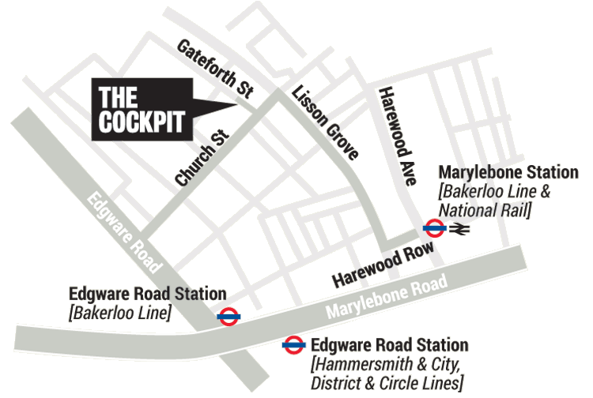

CONTACT INFORMATION
If you have any questions, or accessibility requirements that are not covered here, please call or email the venue on the day 0207 258 2925 or email reception@thecockpit.org.uk

FOLLOW & CONNECT WITH US
- Click here to connect to our Instagram
- Click here to connect to our youtube playlist
- Click here to connect with our director’s Instagram

