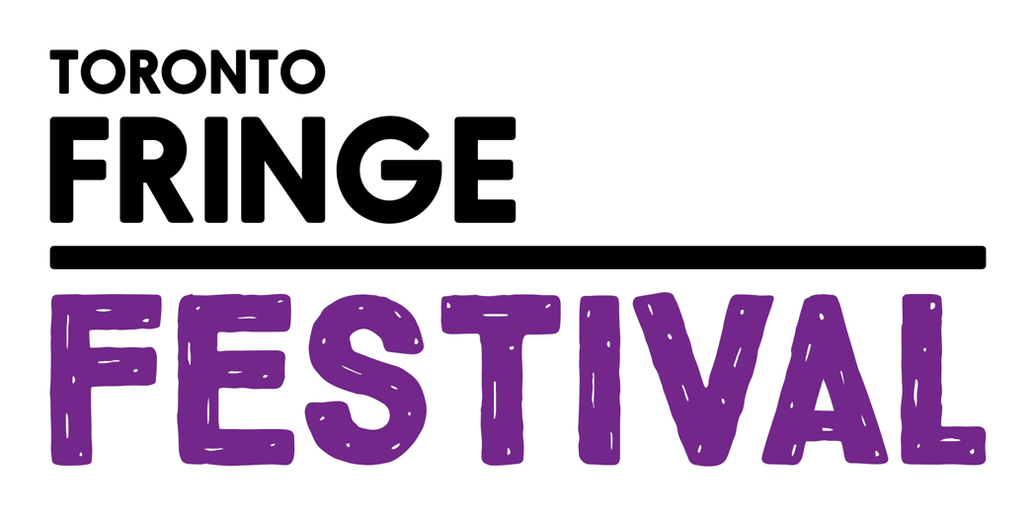

Love, Shakespeare, & Rope
Access Guide



June 30 - July 12, 2026
Birdhaus

This guide uses plain language to provide audiences, particularly neurodiverse audiences, with specific sensory details of programming in advance to help guide your experience.

Table of Contents

Access Measures 3

About Show Name 5

Run Time 5

Content Warnings and Advisories 5

Cast and Characters 6

Set 7

Costumes 8

Get in Touch 9

Access Measures
- We will not be doing any relaxed performances, audio described performances, ASL interpreted performances. We will not be making touch books or tactile immersion chairs. However our performance is primarily movement-based, and audiences will not have a greatly diminished experience without these measures

About Love, Shakespeare, & Rope
Love, Shakespeare, & Rope is a movement-based exploration of a Shakespeare’s sonnets through acrobatic aerial rope bondage.

We are an 18+ show.
There is no explicit nudity. A wild ride but accessible for the curious.

Run Time
90 minutes with a 10 minute intermission (inclusive).

Content Warnings and Advisories
Please be advised that Love, Shakespeare, and Rope

includes/mentions/references/depicts…
- Sexual/Romantic situations
- Aerial rope bondage
- Alcoholic beverages sold on site

Cast and Characters (Not yet available)
ACTOR NAME plays the role of CHARACTER NAME (include character description if desired).
HEADSHOT

HEADSHOT
ACTOR NAME plays the role of CHARACTER NAME (include character description if desired).

HEADSHOT
ACTOR NAME plays the role of CHARACTER NAME (include character description if desired).

Set (not yet available)
PHOTO OF SET

The Set is a thrust space in a bar setting, There is priority seating for Wheelchair users, and folding chairs for attendees.

Costumes (not yet available)
PHOTO OF COSTUME

Describe the costume to the best of your ability here. Insert a photo for each and description for each costume.

Get in Touch
If you have any questions or concerns about this access guide or planning your visit to SHOW NAME at the 2026 Toronto Fringe Festival, please reach out.

Contact Name: Ben
Title/Position: Director
Email: education@birdhausto.com

If you want to tell the Fringe about your experience or have feedback that you would like to share, you can call, write, or send an email to the Fringe.

Our address is:
100 Broadview Avenue, Suite 300
Toronto, ON
M4M 3H3

Our email address is:
access@fringetoronto.com

Our phone number is:
416-966-1062

Thank you for coming to the 2026 Toronto Fringe Festival.

