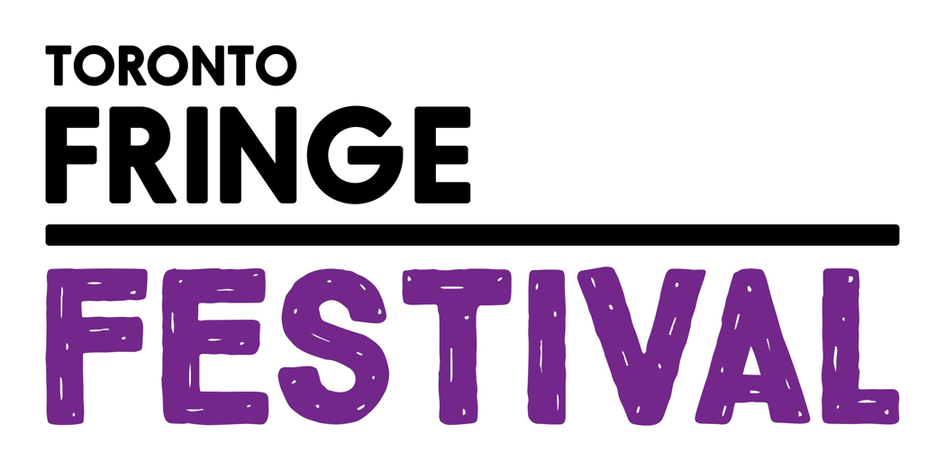

A Conversation With Myself
Access Guide

[INSERT SHOW GRAPHIC HERE]

June 30 - July 12, 2026
B Street Collaborative

This guide uses plain language to provide audiences, particularly neurodiverse audiences, with specific sensory details of programming in advance to help guide your experience.
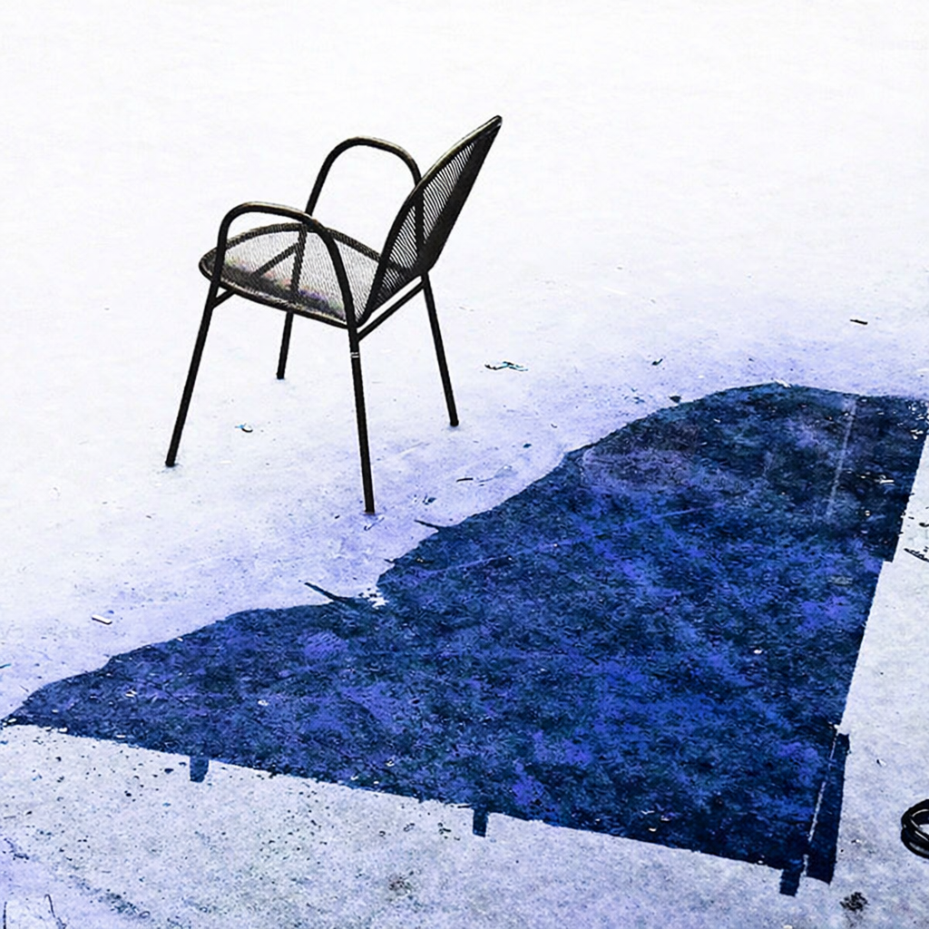

Table of Contents

Access Measures 3

About A Conversation With Myself 4

Run Time 4

Content Warnings and Advisories 4

Cast and Characters 5

Set 6

Costumes 7

Get in Touch 8

Access Measures

No Access Measures will be provided for these performances beyond access to a digital script if an audience member is deaf.

About A Conversation With Myself
A Conversation With Myself is an interactive theatre experience inviting you to step away from your busy, distracted, stressful life and think about what matter to you most.

Voluntary audience reflections, made anonymously, become part of this 4 actor, 98-character deeply moving and uplifting performance of shared life events and mental health and wellness experiences to rediscover and find connection with yourself and others.

It's based on 800 verbatim writings and conversations at an interactive art installation that first appeared in Scotiabank Contact Photography Festival and was last presented at Toronto City Hall for nine days.

Run Time
60 minutes with no intermission

Content Warnings and Advisories
Please be advised that A Conversation With Myself includes depictions of lived experiences that may cause emotions and anxiety to surface. There is no violence depicted, only very personal enactments of what people were thinking and sharing in writings and conversations.

If you feel the need to leave the theatre space to catch your breath and reset, please feel free to step out into a space that is available.

Cast and Characters
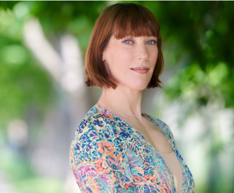
Irena Huljak plays multiple roles of the 98 characters

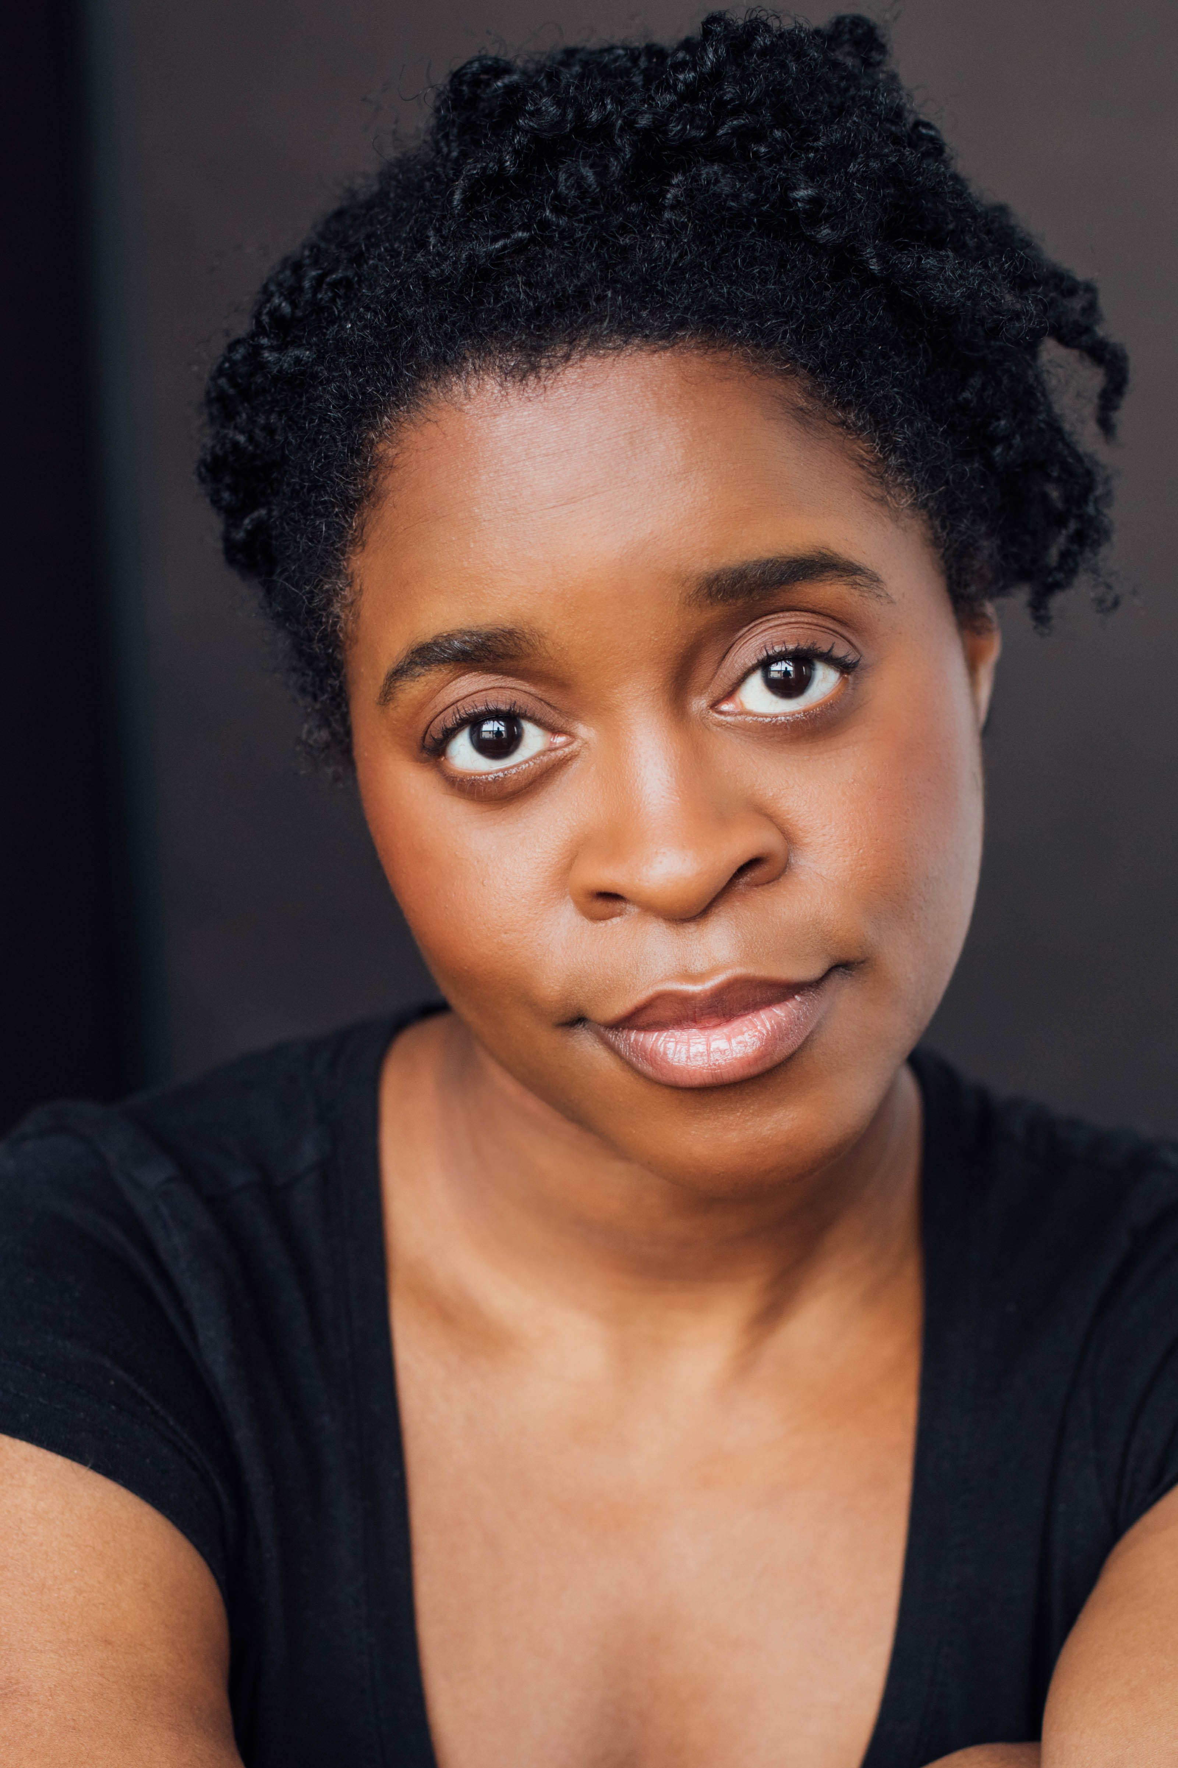DSHOT
Jajube Mandiela (She/Her) plays multiple roles of the 98 characters

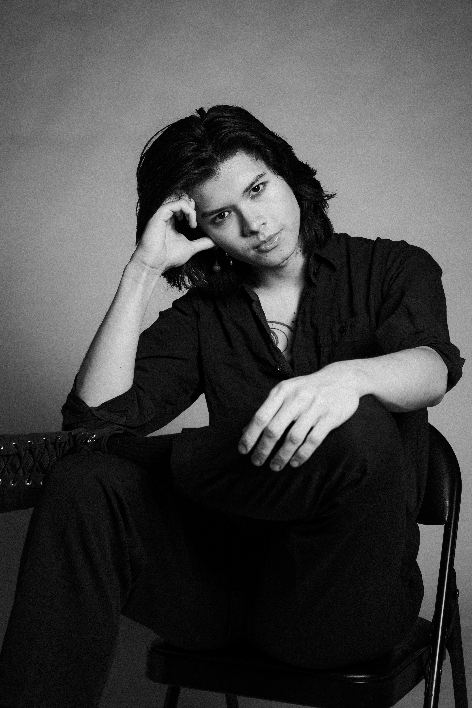
N.L. Lee plays multiple roles of the 98 characters

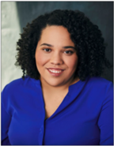
Kaitlin Condie plays multiple roles of the 98
characters

Set
PHOTO OF SET
(Not available Yet)

As the audience arrives, they will be greeted by the actors and invited to discover and learn about the story of the installation and its original impact in a space to the right of where they enter the main theatre space,

This intimate theatre space will be arranged in a ¾ round setting with 26 chairs arching around the space where the actors can come in and out.

There will be large photographic images and words on one wall that is visible to the whole audience.

Costumes
PHOTO OF COSTUMES
(Not Available)

Actors will be wearing a variety of regular clothes, and some small items used as props to reflect certain characters. Examples may include:

A worn-out coat and blanket
- A child’s stuffed toy
- A walking stick or staff
- A hat or scarf
- A backpack

Get in Touch
If you have any questions or concerns about this access guide or planning your visit to A Conversation With Myself at the 2026 Toronto Fringe Festival, please reach out.

Michael Sachter
Creator, Playwright and Co-Producer
ms@strategicmentors.com
416-704-5007

Or

Shawnna Brown
Creative Guide, Stage & Company Manager and Co-Producer
Shawnna@thewineandtravelco.com
416-737-2120

If you want to tell the Fringe about your experience or have feedback that you would like to share, you can call, write, or send an email to the Fringe.

Our address is:
1100 Broadview Avenue, Suite 300
Toronto, ON
M4M 3H3

Our email address is:
access@fringetoronto.com

Our phone number is:
416-966-1062

Thank you for coming to the 2026 Toronto Fringe Festival.

