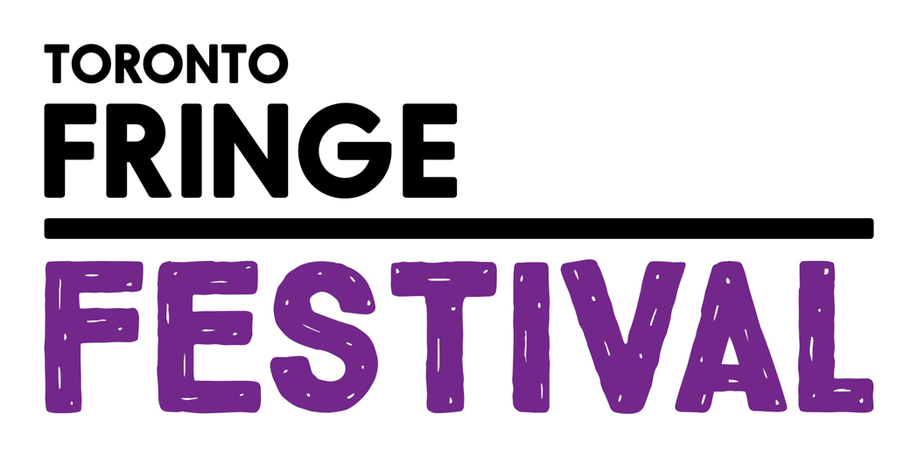

Clowns Reading Shakespeare
Access Guide

[INSERT SHOW GRAPHIC HERE]

June 30 - July 12, 2026
Young People’s Theatre

This guide uses plain language to provide audiences, particularly neurodiverse audiences, with specific sensory details of programming in advance to help guide your experience.

Table of Contents

Access Measures 3

About Clowns Reading Shakespeare 4

Run Time 4

Content Warnings and Advisories 4

Cast and Characters 5-6

Set 7

Costumes 8

Get in Touch 9

Access Measures
Relaxed Performance

Relaxed performances are open to everyone, but the environment has been specifically adapted for those who are neurodivergent and may experience sensory sensitivities, folks with communication or learning disabilities, and people who would benefit from a more relaxed environment.

The 1:00 performance on July 3rd will be a relaxed performance.

About Clowns Reading Shakespeare
Clowns Reading Shakespeare is a family-friendly theatrical performance featuring a troupe of red-nosed clowns auditioning for a diva Director and her yet-to-be-determined Shakespeare show!

Laugh along with this troupe of eager clowns as they explore three of William Shakespeare’s greatest tragedies, Hamlet, Romeo & Juliet, and Macbeth…to the best of their ability. The Clowns make each play their own and interact with the audience as they follow the unusual whims of the Director. Improv and mischief ensues, as the show must go on!

Whether familiar with Shakespeare or not, families and viewers of all ages are sure to laugh, cry, and cheer along as the Clowns ultimately prove that a focus on teamwork and staying true to yourself leads to wonderful art.

Run Time
60 minutes with no intermission

Content Warnings and Advisories
Please be advised that Clowns Reading Shakespeare depicts cartoonish and non literal images/references of death, and injury.

Cast and Characters
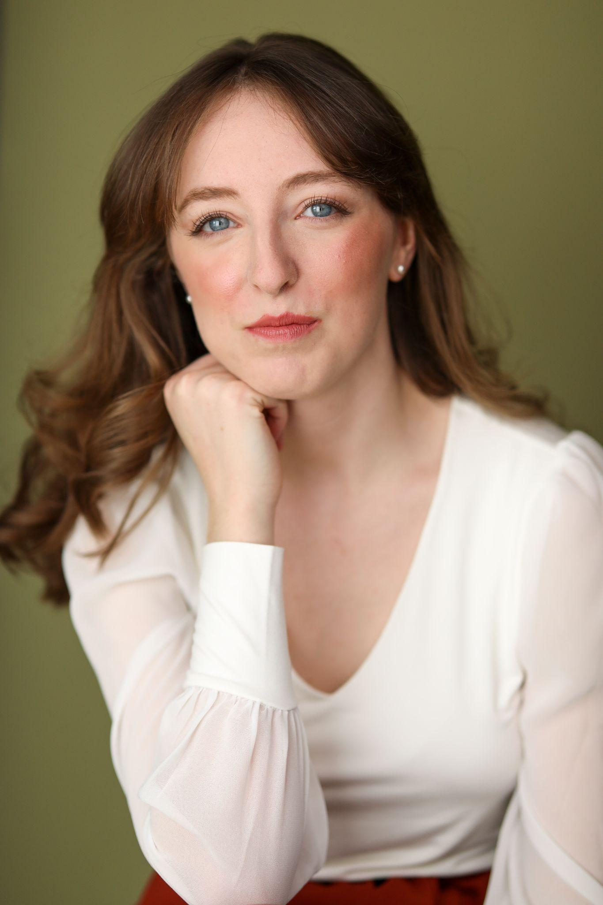
Paige Madsen plays the role of Director.
HEADSHOT

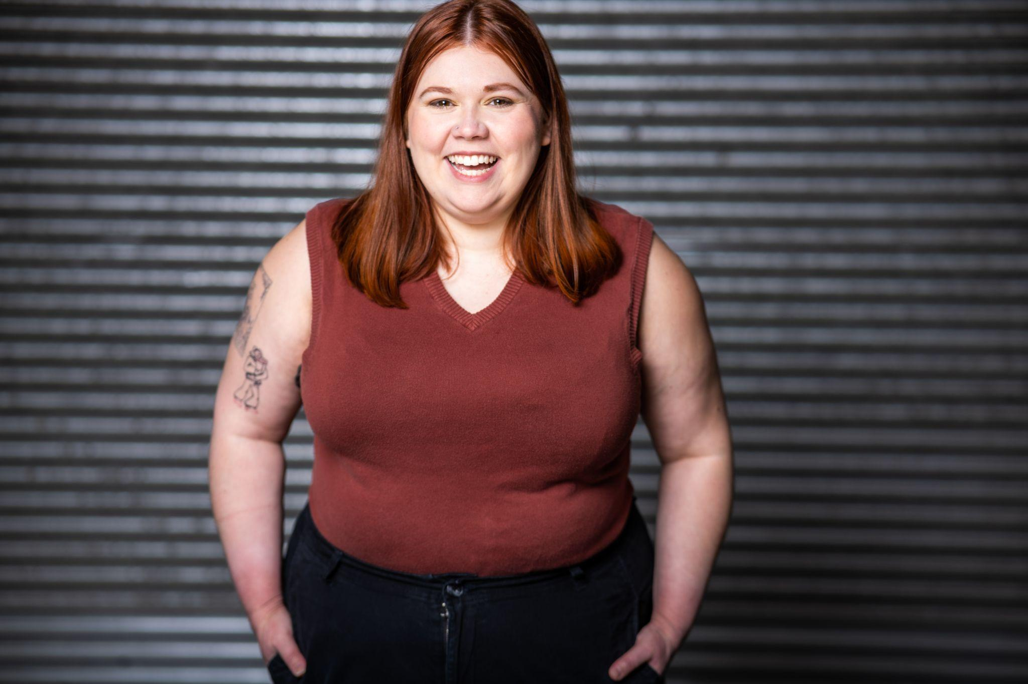
HEADSHOT
Callan Forrester plays the role of Hot Dog.

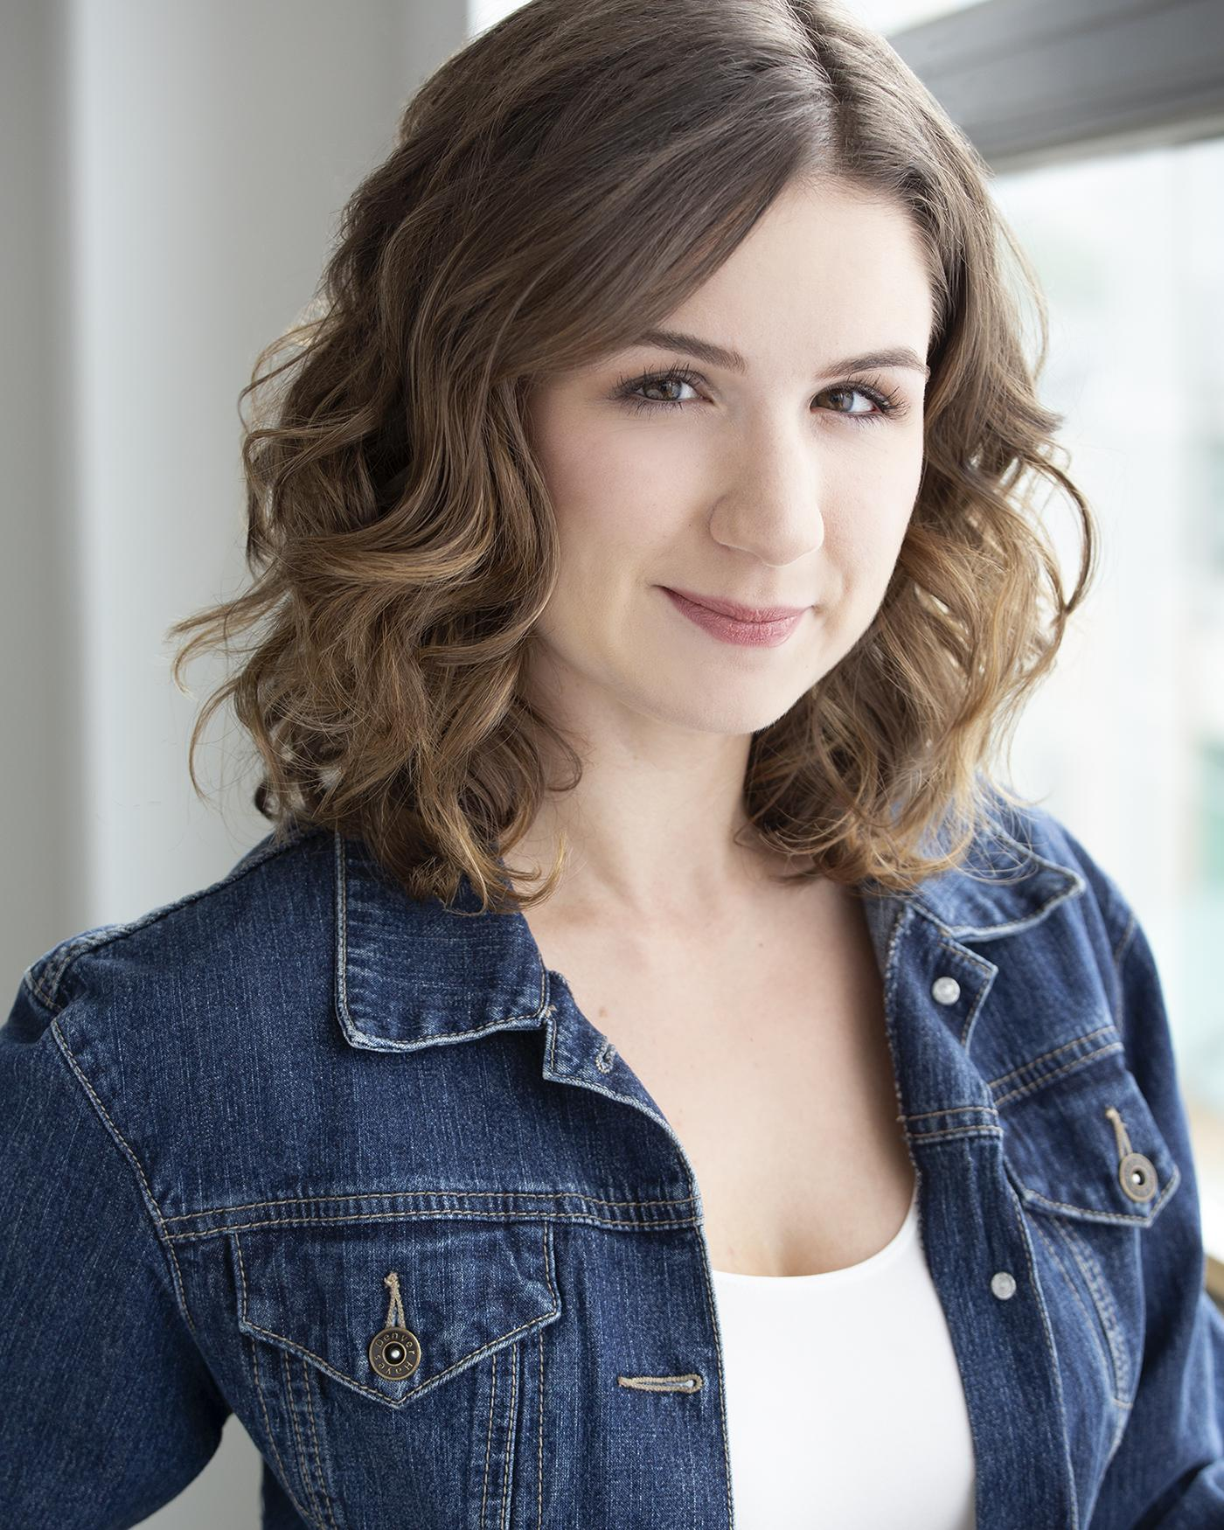
HEADSHOT
Alyssa Pothier plays the role of DinkEEE.

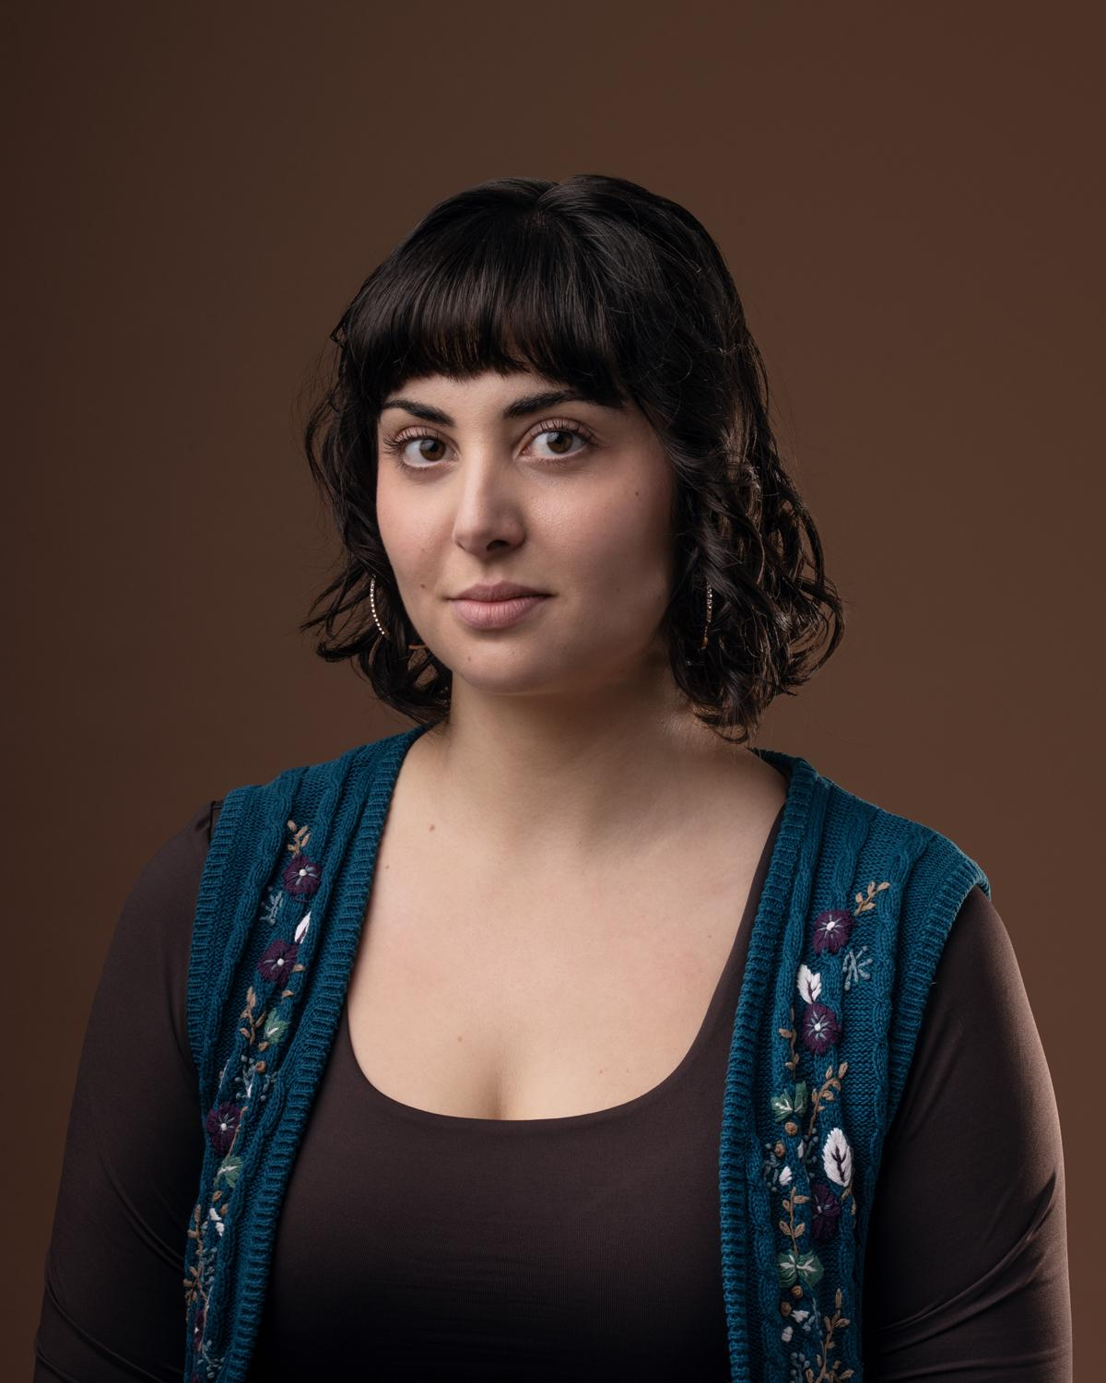
HEADSHOT
Sienna Singh plays the role of Puff.

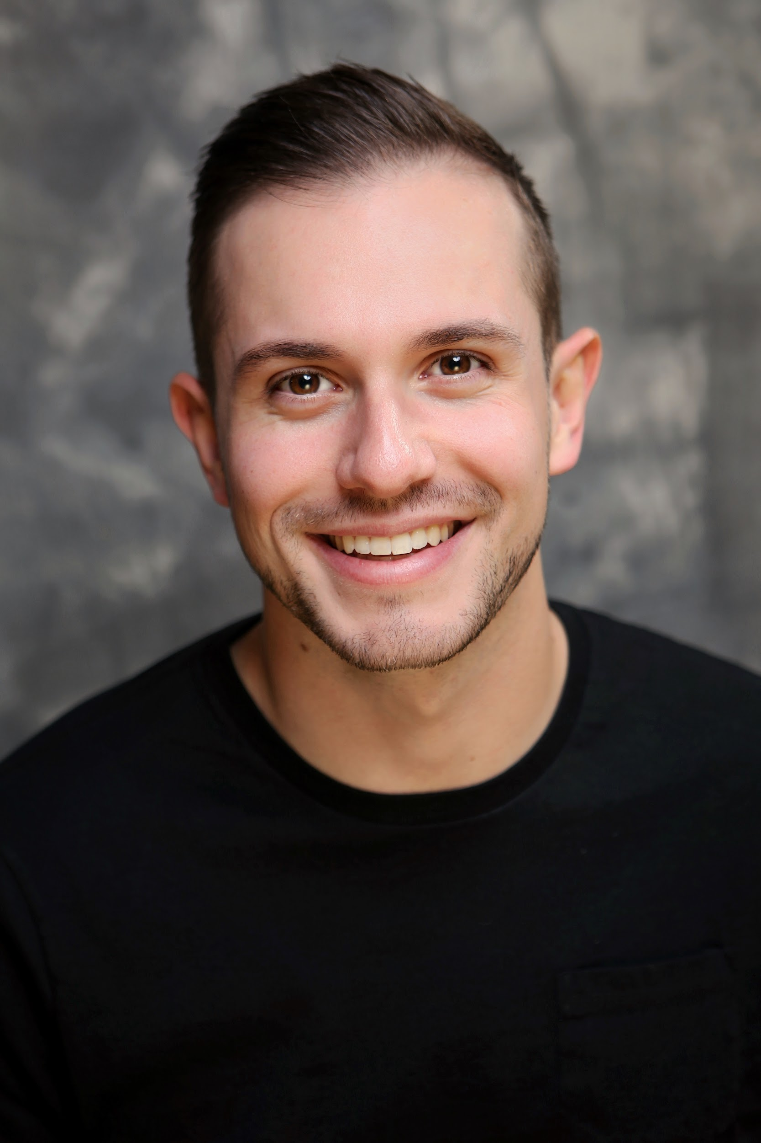
Sebastian Biasucci plays the role of Pockets.
HEADSHOT

Set

Our set is yet to be determined, please reach out to admin@panoplycollective for the most accurate descriptions.

Costumes

Individual costumes are yet to be determined, please reach out to admin@panoplycollective for the most accurate descriptions.

Overall the characters wear red clown noses, bright coloured outfits, and hats.

Get in Touch
If you have any questions or concerns about this access guide or planning your visit to Clowns Reading Shakespeare at the 2026 Toronto Fringe Festival, please reach out.

Contact Name: Sienna - Co-producer
Email: admin@panoplycoillective.com

If you want to tell the Fringe about your experience or have feedback that you would like to share, you can call, write, or send an email to the Fringe.

Our address is:
100 Broadview Avenue, Suite 300
Toronto, ON
M4M 3H3

Our email address is:
access@fringetoronto.com

Our phone number is:
416-966-1062

Thank you for coming to the 2026 Toronto Fringe Festival.

