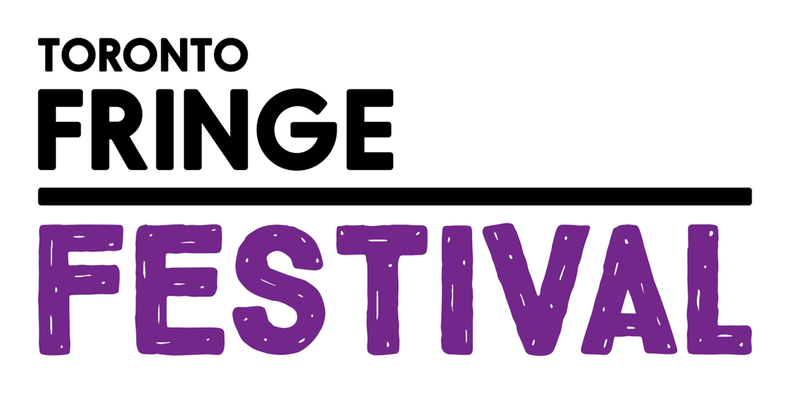

Mirv-“ish”: An Improvised Musical
Access Guide

June 30 - July 12, 2026
Factory Theatre

This guide uses plain language to provide audiences, particularly neurodiverse audiences, with specific sensory details of programming in advance to help guide your experience.

Table of Contents

Access Measures 3

About Mirv-”ish”: An Improvised Musical 5

Run Time 5

Content Warnings and Advisories 5

Cast and Characters 6

Set 7

Costumes 8

Get in Touch 9

Access Measures
Relaxed Performance

Relaxed performances are open to everyone, but the environment has been specifically adapted for those who are neurodivergent and may experience sensory sensitivities, folks with communication or learning disabilities, and people who would benefit from a more relaxed environment.

The TIME performance on DATE will be a relaxed performance.

Audio Described Performance

At an audio described performance, audience members can listen to a description of the visual aspects of the performance described live through a small radio receiver. It is a narration with descriptions of the key visual elements, such as the setting, character descriptions, body language, and other key details that benefit blind and low-vision audiences. Audio description extends beyond the show itself with introductory notes before a performance starts, which include contextual information, the organization of the performance, a description of the cast and costumes, and relevant parts of the program such as credits and/or brief background information.

The TIME performance on DATE will be audio described by DESCRIBER NAME.

ASL Interpreted Performance

ASL interpreted performances are specifically designed to provide access to performances for audience members who are d/Deaf and/or hard of hearing. These performances feature ASL-English and/or Deaf interpreters who interpret all dialogue into American Sign Language (ASL) in real time, either on stage or to the side of the stage.

The TIME performance on DATE will be ASL interpreted by INTERPRETER NAMES.

Tactile Body Immersion (TBI) Chair

The ImmersX Tactile Body Immersion (TBI) Chair allows patrons who are d/Deaf, Hard of Hearing, or deafblind to experience music and other sounds through vibrations that are channeled through the seat and back rest of the chair.

The TBI Chair will be available at the TIME performance on DATE.

Touch Book

Touch books offer a tactile experience of various elements of the set, props, and costumes through touch. Touch books allow patrons from the blind and low vision community to enjoy a more complete experience of a show through touch.

A touch book will be available at the Front of House area for all performances.

About Mirv-”ish”: An Improvised Musical
Ever wished you were at the opening night of Wicked on Broadway? Or Phantom of the Opera? Be in the room to witness the next smash hit musical on opening night! Musical comedy troupe Mirv-ish, aptly named after Canada’s premiere musical theatre company, is performing brand new Canadian musicals every night! By improvising each new musical based on an audience suggestion, every night is a fresh opportunity to be on the forefront of the next big show! No scripts, no sheet music, just a talented cast of comedians directed by the incredible Ashley Botting, from This Hour Has 22 Minutes.

Run Time
60 minutes with no intermission

Content Warnings and Advisories
Please be advised that Mirv- “ish”: An Improvised Musical is made up on the spot each night and so the dialogue and lyrics are not pre-determined. It may contain mature themes and course language.

Cast
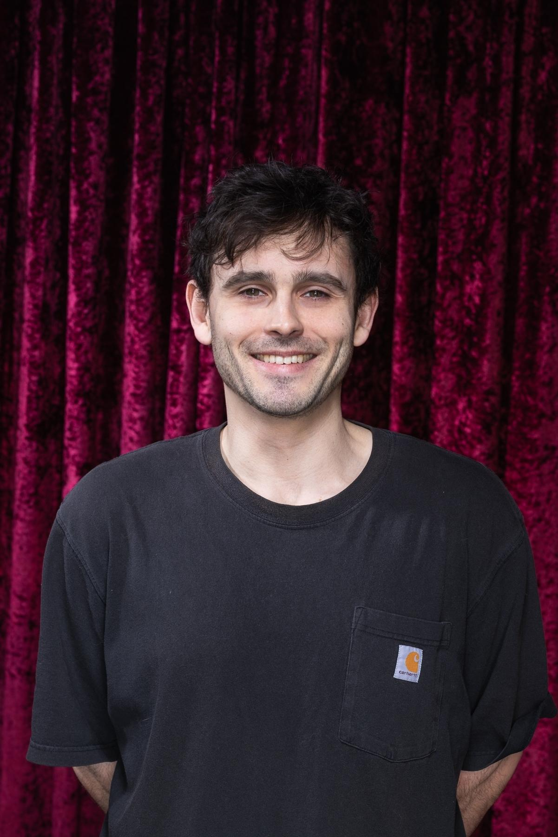
Austin Anonsen

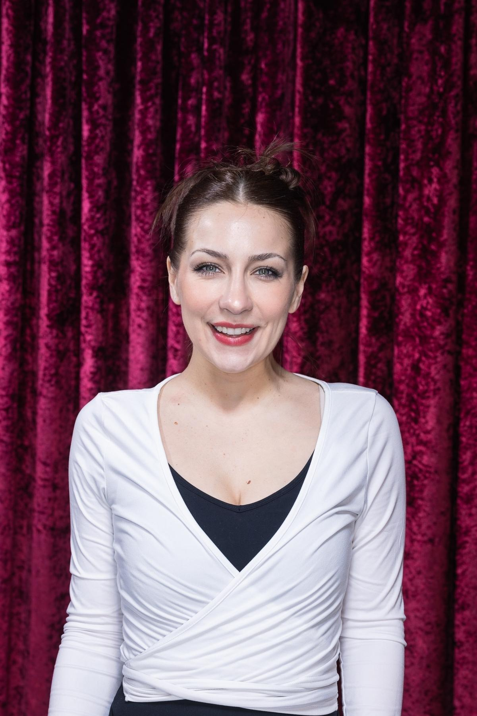
Meredith Mullen

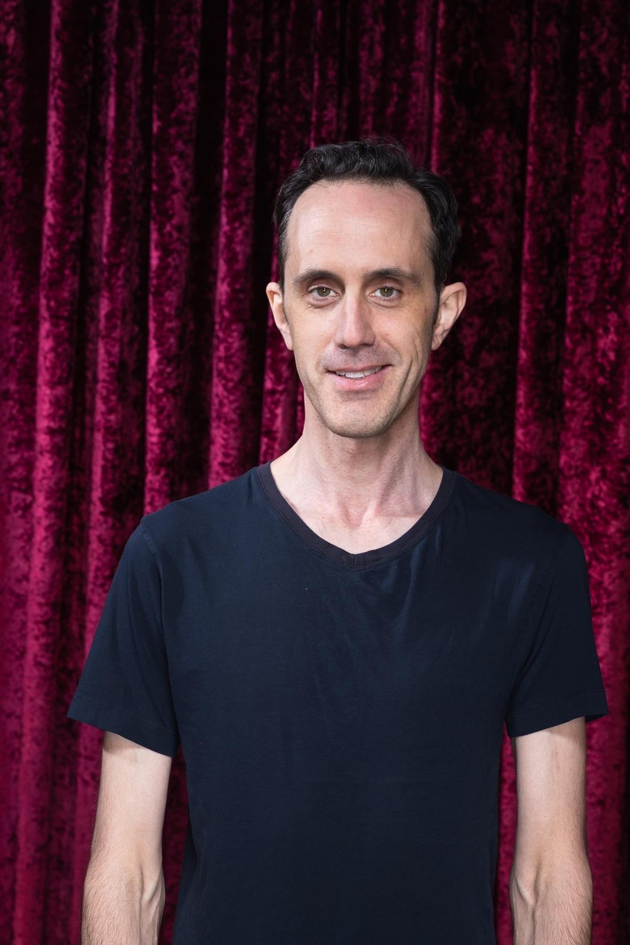
Mark Brown


Rachel Sellan

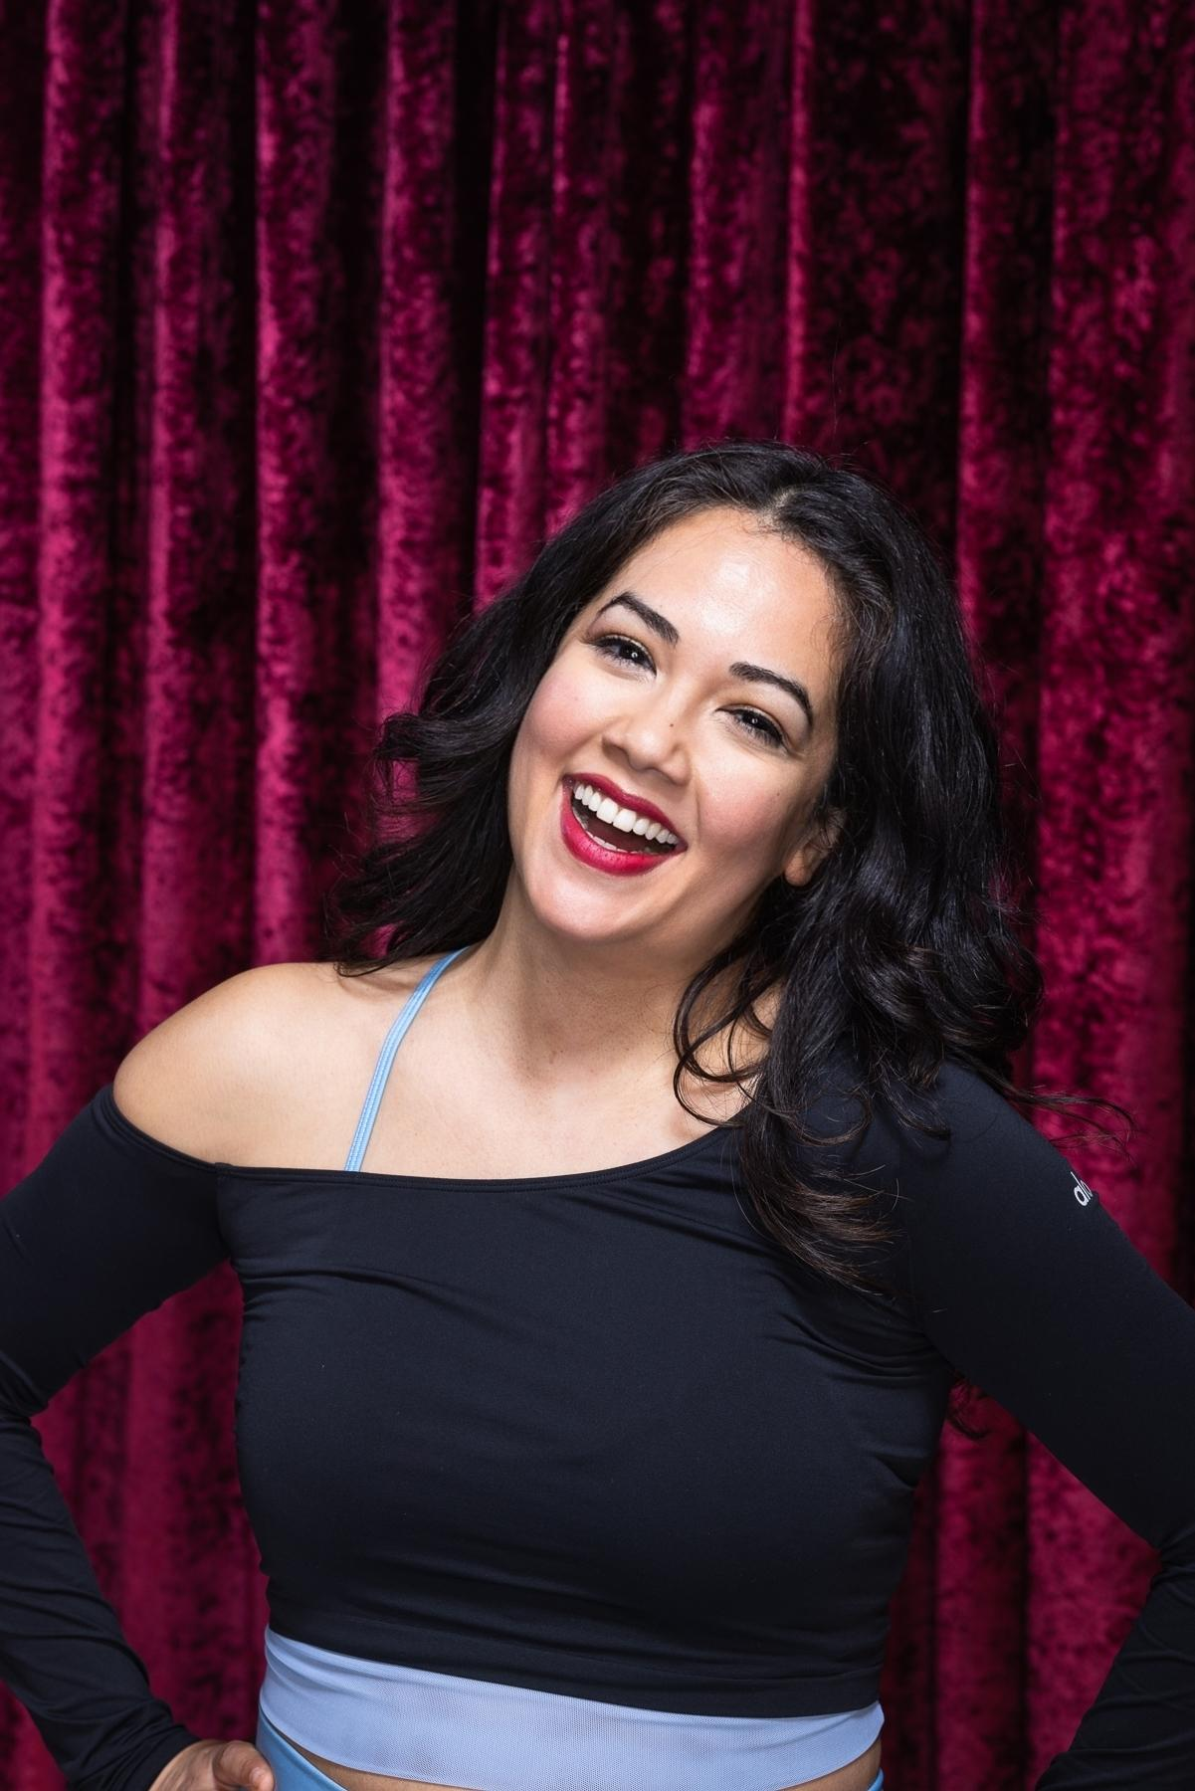
Kara Harun


Janek Gonsalkorale

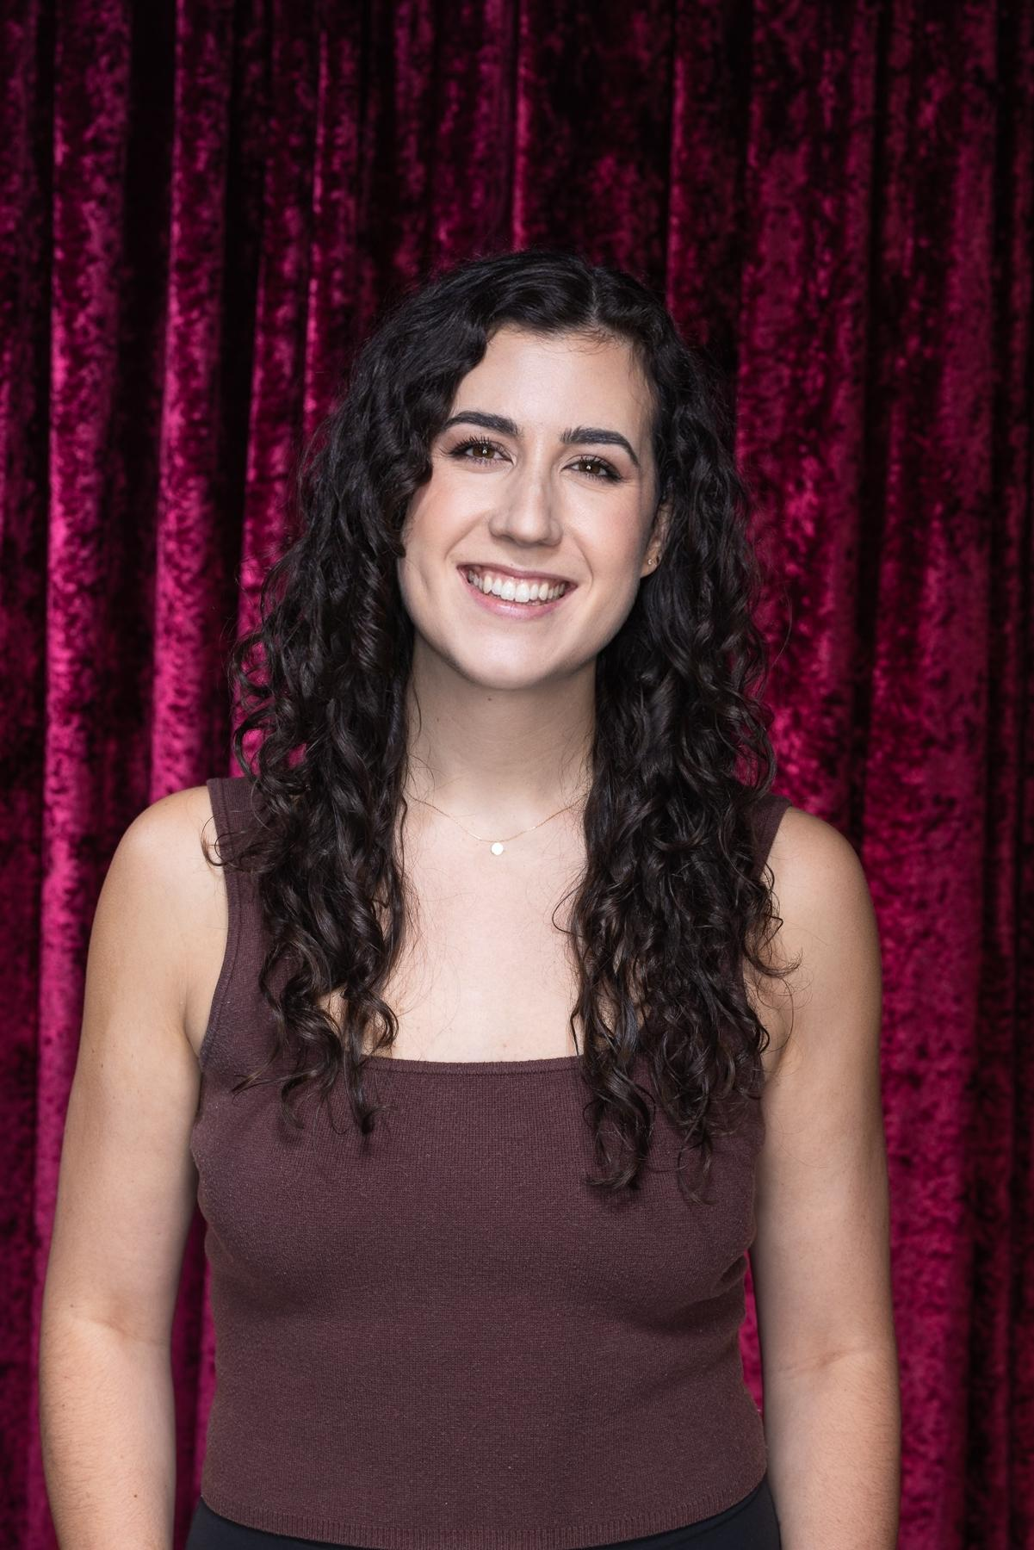
Janelle McGuinness

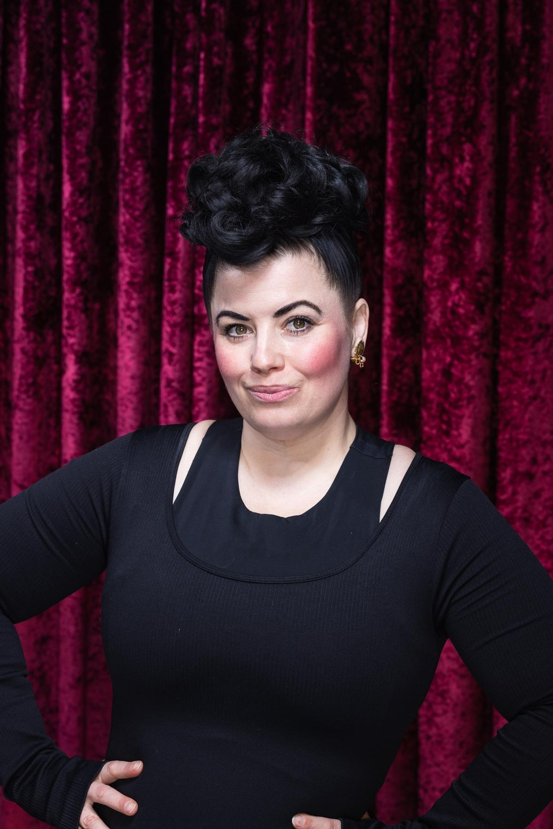
Kendall Savage

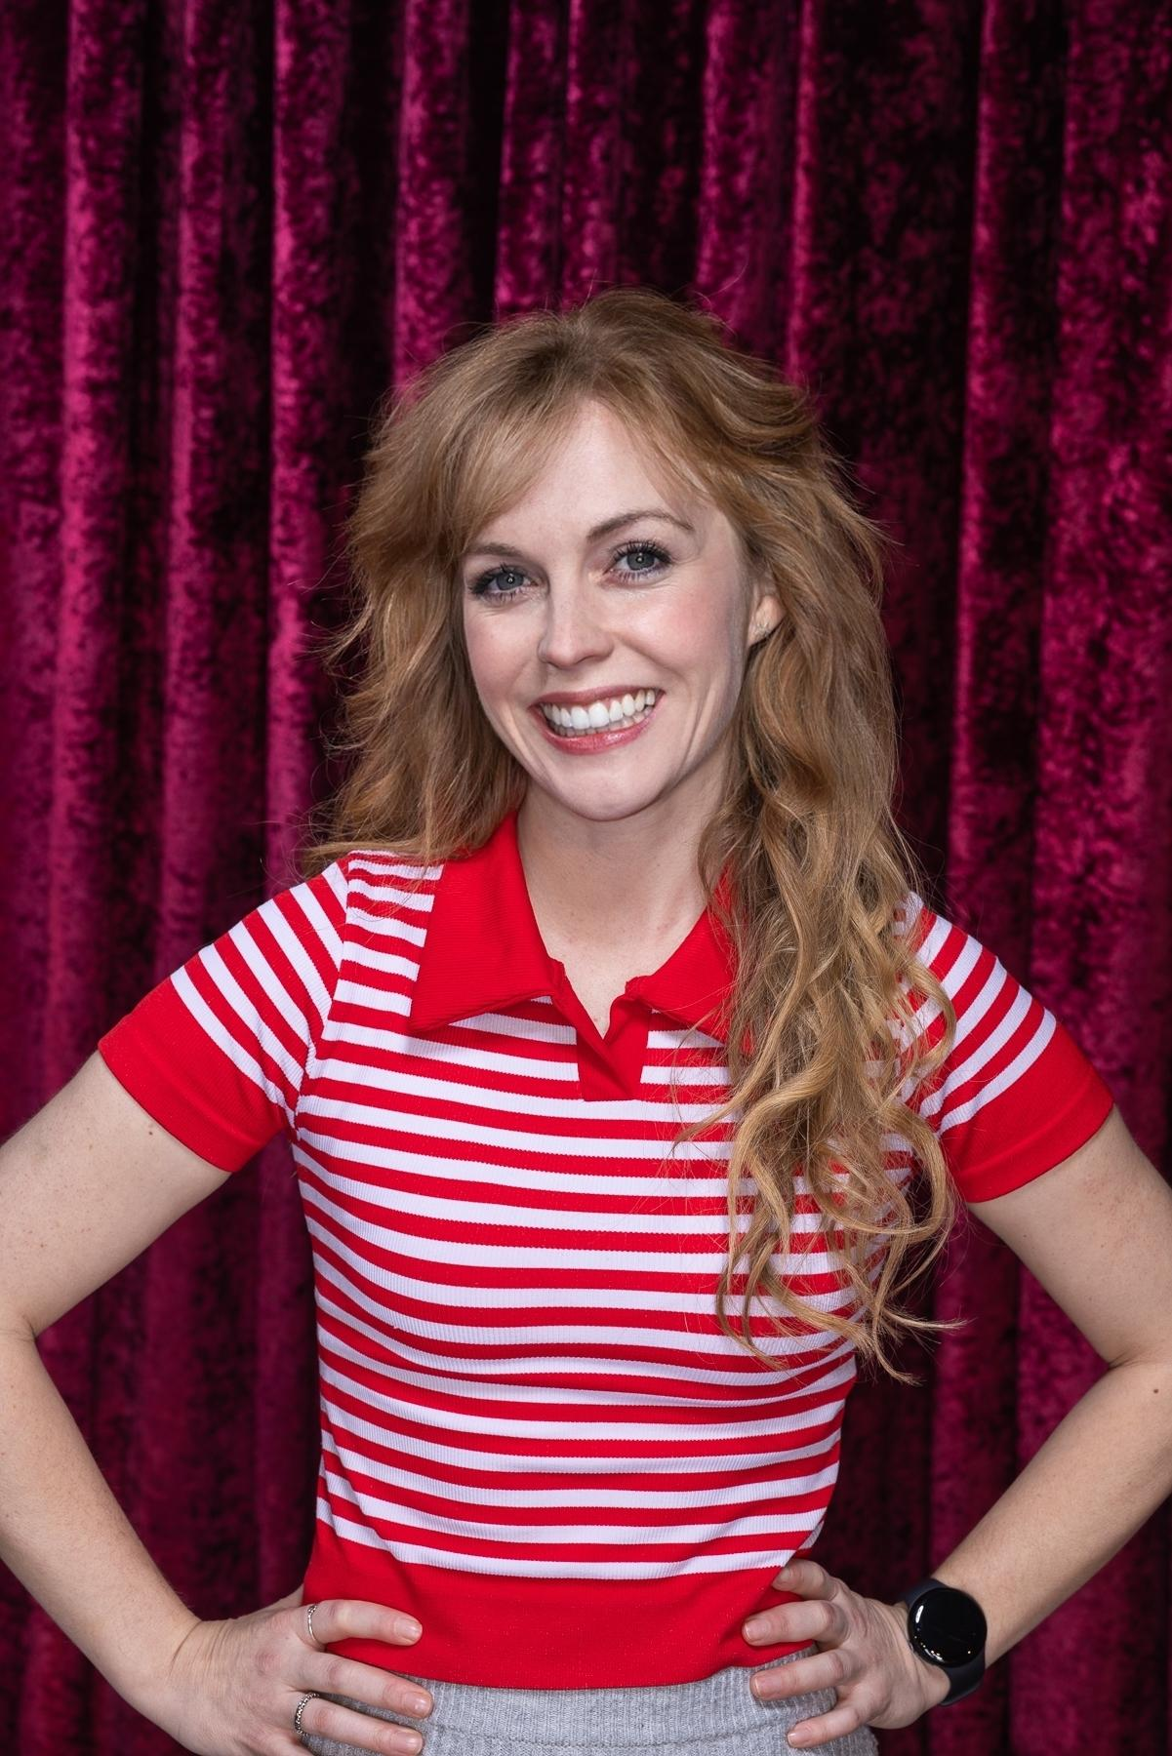
Victoria Kucher


James Atin - Musical Director

Set
PHOTO OF SET

Our show actually doesn’t have a set! We just use an empty stage and sometimes a couple of chairs depending on the needs of a scene.

Costumes
PHOTO OF COSTUME

Our actors don’t wear costumes because the characters they portray change in every show! They’ll all be dressed in semi-formal clothes.

Get in Touch
If you have any questions or concerns about this access guide or planning your visit to Mirv-”ish”: An Improvised Musical at the 2026 Toronto Fringe Festival, please reach out.

Contact Name
Mark Brown/Co-Producer
Email: markbrowntoronto@gmail.com

If you want to tell the Fringe about your experience or have feedback that you would like to share, you can call, write, or send an email to the Fringe.

Our address is:
100 Broadview Avenue, Suite 300
Toronto, ON
M4M 3H3

Our email address is:
access@fringetoronto.com

Our phone number is:
416-966-1062

Thank you for coming to the 2026 Toronto Fringe Festival.

