

Springtime
Access Guide

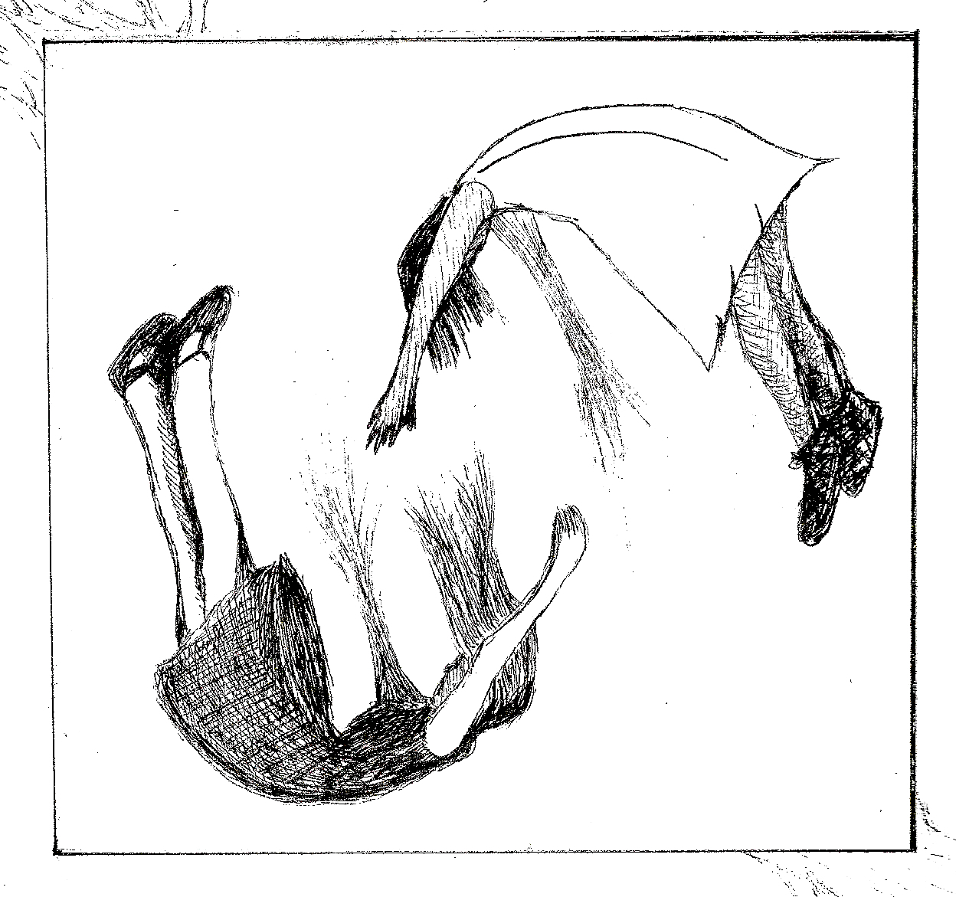

July 3-10, 2026
CineCycle

This guide uses plain language to provide audiences, particularly neurodiverse audiences, with specific sensory details of programming in advance to help guide your experience.

Table of Contents

Access Measures 3

About Springtime 5

Run Time 5

Content Warnings and Advisories 5

Cast and Characters 6

Set 7

Costumes 8

Get in Touch 9

Access Measures

About Springtime
May and June are wanted enemies of the state hiding in a box buried under a pig farmer's barn. To pass their time in hiding, they play games, tell stories, and escape into their imaginations. When the farmer begins inviting May on excursions above ground, both women must confront how much they are willing to sacrifice for survival.

Run Time
60 minutes with no intermission

Content Warnings and Advisories
Please be advised that Springtime includes abrupt sound and lighting cues, mature language, pretend smoking, pretend hair burning, references to nonconsensual sexual acts, and references to the threat of violence.

Cast and Characters
Katie Lawrence plays the role of May. She is older, manipulative, and careful.


HOT
Kendra Cordick plays the role of June. She is younger, playful, and reckless.

Set
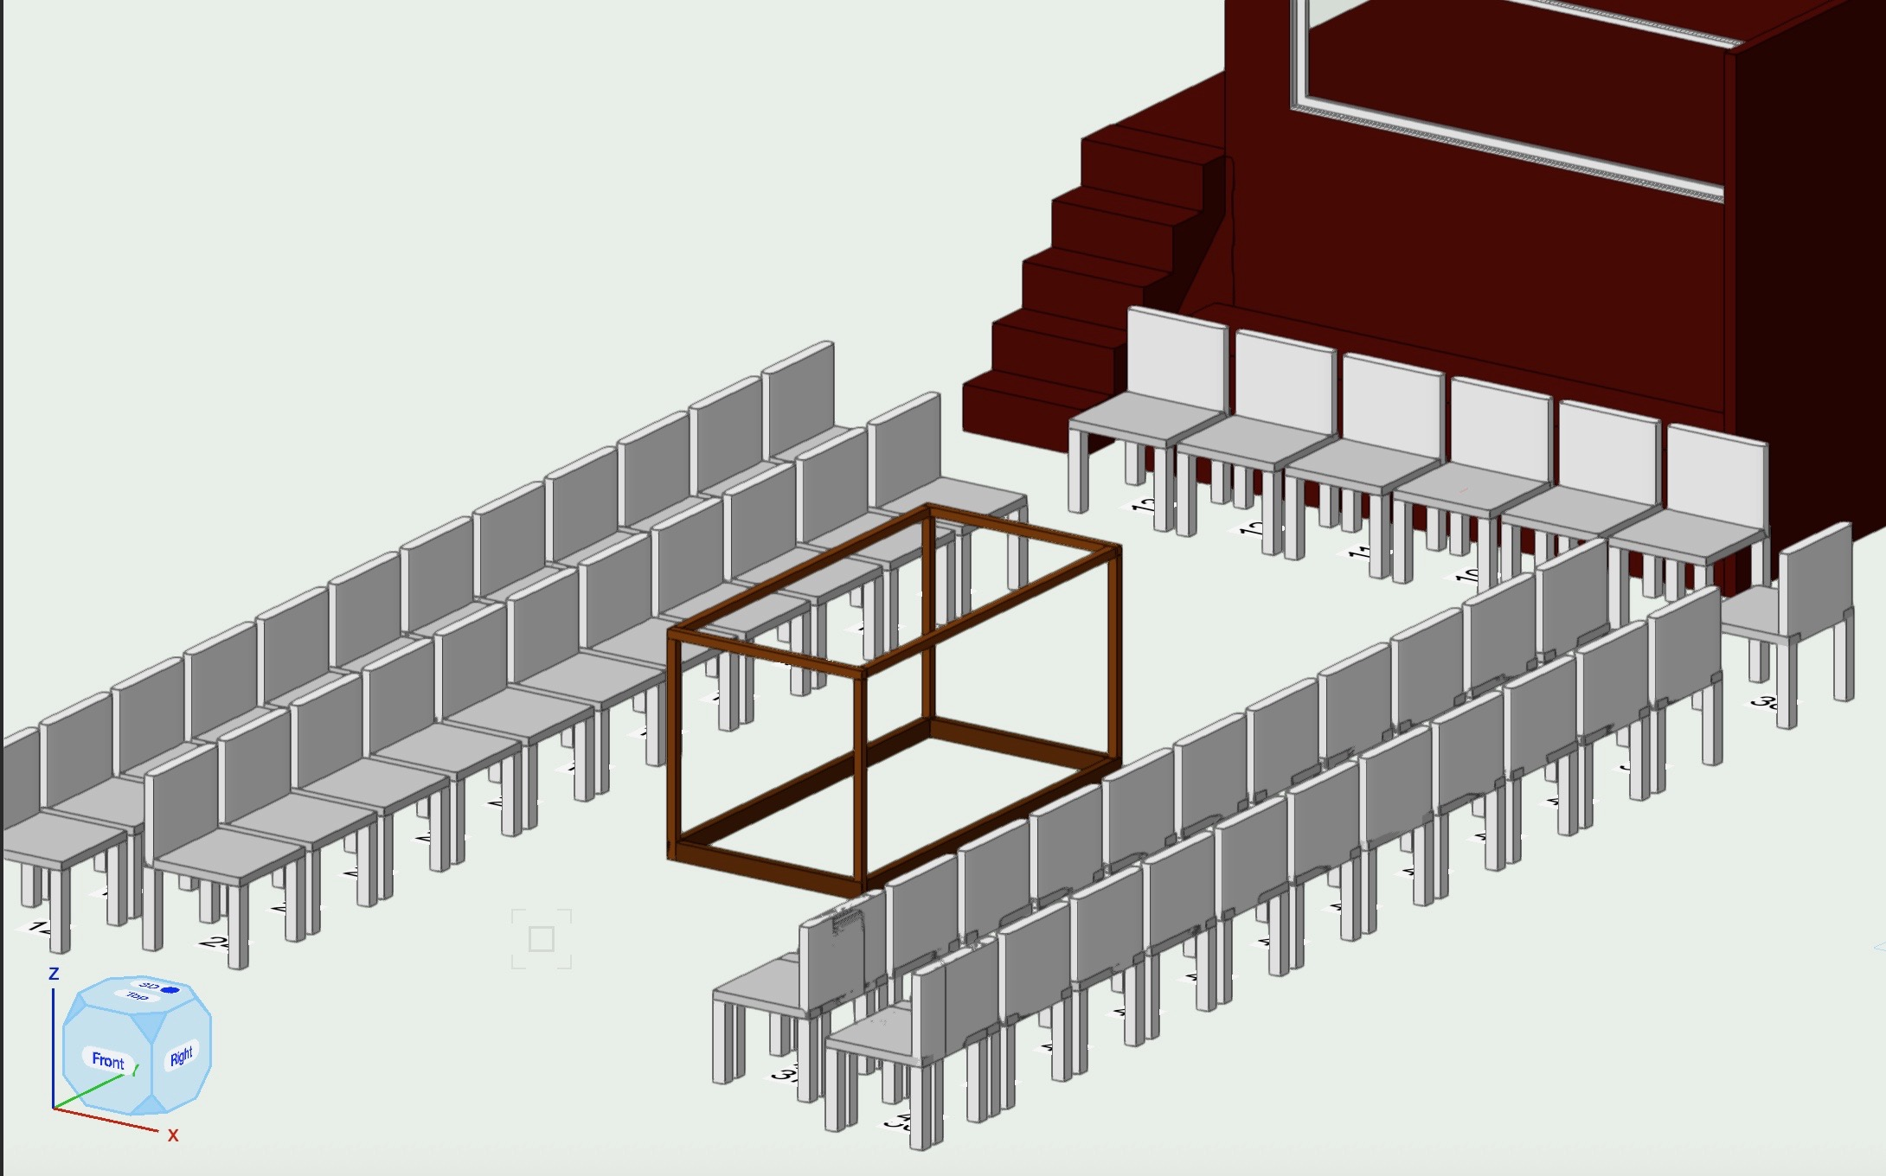

The set is comprised of an open wooden rectangular box that stands four feet tall, four feet deep, and eight feet long. There is a projector screen on one end.

Costumes
PHOTO OF COSTUME

May and June wear faded men’s band tees from the 70s and 80s and jean shorts. They are barefoot. When it gets colder in the box, they wear men’s flannels over their shirts and men’s wool socks on their feet.

Get in Touch
If you have any questions or concerns about this access guide or planning your visit to Springtime at the 2026 Toronto Fringe Festival, please reach out.

Katie Lawrence
Writer, Performer, and Producer
Email: katieellalawrence@gmail.com

If you want to tell the Fringe about your experience or have feedback that you would like to share, you can call, write, or send an email to the Fringe.

Our address is:
100 Broadview Avenue, Suite 300
Toronto, ON
M4M 3H3

Our email address is:
access@fringetoronto.com

Our phone number is:
416-966-1062

Thank you for coming to the 2026 Toronto Fringe Festival.

