

Tango After Midnight
Access Guide

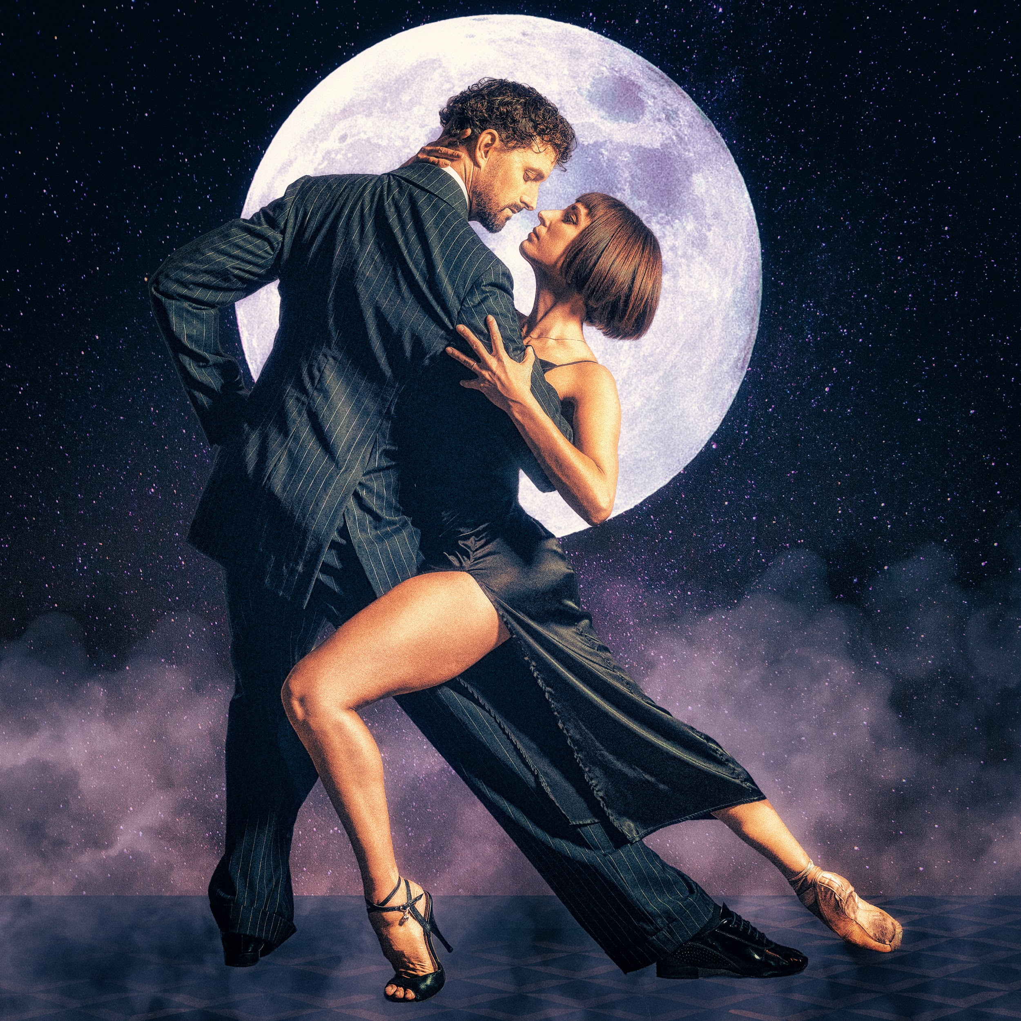

July 2 - July 11, 2026
Tarragon Theatre - Mainstage

This guide uses plain language to provide audiences, particularly neurodiverse audiences, with specific sensory details of programming in advance to help guide your experience.

Table of Contents

Access Measures 3

About Tango After Midnight 5

Run Time 5

Content Warnings and Advisories 5

Cast and Characters 6

Set 7

Costumes 8

Get in Touch 9

Access Measures

In four different scenes, video projections show English text while music plays, and one projection includes Spanish narration with the translated English text on the screen. The story is conveyed through movement and video projections, making it accessible for people who are hard of hearing and for people whose first language is not English.

About Tango After Midnight
[“Tango After Midnight” is a dance show with 2 dancers telling the story of a night out in Buenos Aires dancing Argentine tango, tango-ballet fusion and acrobatics. Between dance scenes, the story develops through video projections depicting the dancers’ journey through the streets of Buenos Aires, Argentina.]

Run Time
55 minutes with no intermission

Content Warnings and Advisories
Please be advised that TANGO AFTER MIDNIGHT includes
many lighting cues such as sudden blackouts at the end of songs. There will be flashing lights on the video projection between minutes 37:00 and 44:00 of the show. Video projection with sounds, tango music in Spanish and some text will play throughout the show. The dancers will perform various sequences in many different costumes and will manipulate glowing balls of light on stage during 2 different scenes. The show can be enjoyed by people who are deaf/hard of hearing but is not recommended for people with impaired vision as it is a dance/movement show with video projections and no dialogue.
*Clapping and cheering are encouraged. Optional one on one interaction with the audience after the show.

Cast and Characters
ERIN SCOTT-KAFADAR plays the role of LEAD FEMALE DANCER 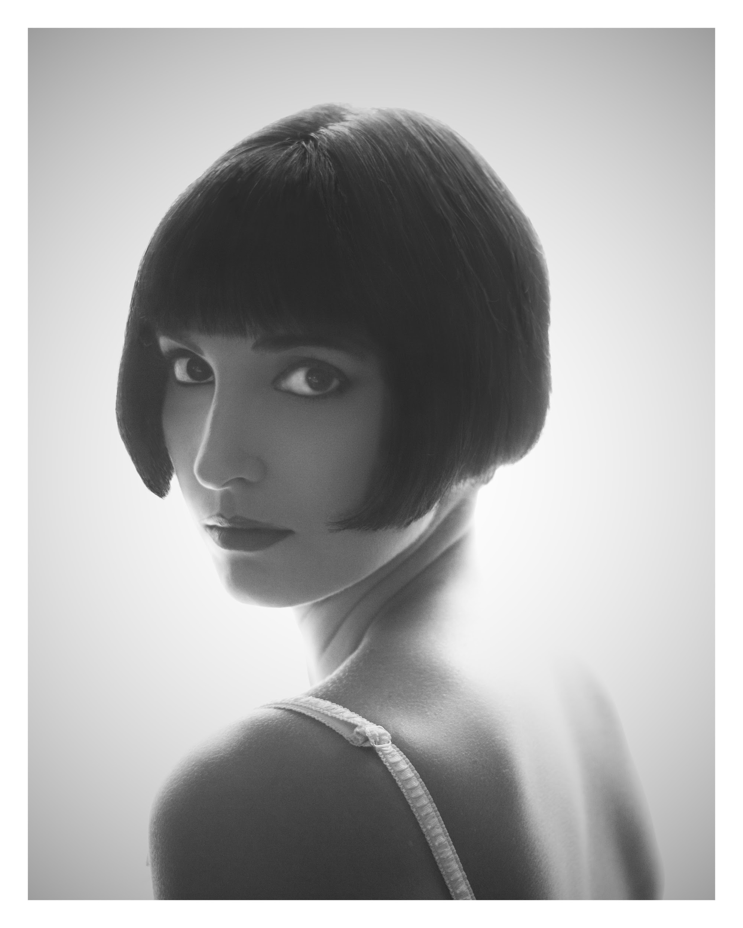

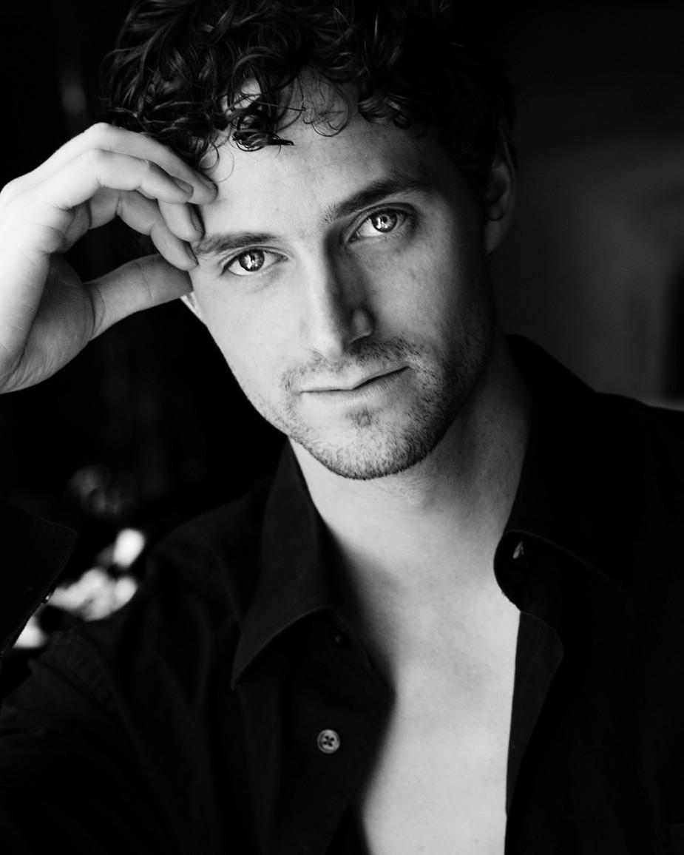
ALEXANDER RICHARDSON plays the role of LEAD MALE DANCER

Set

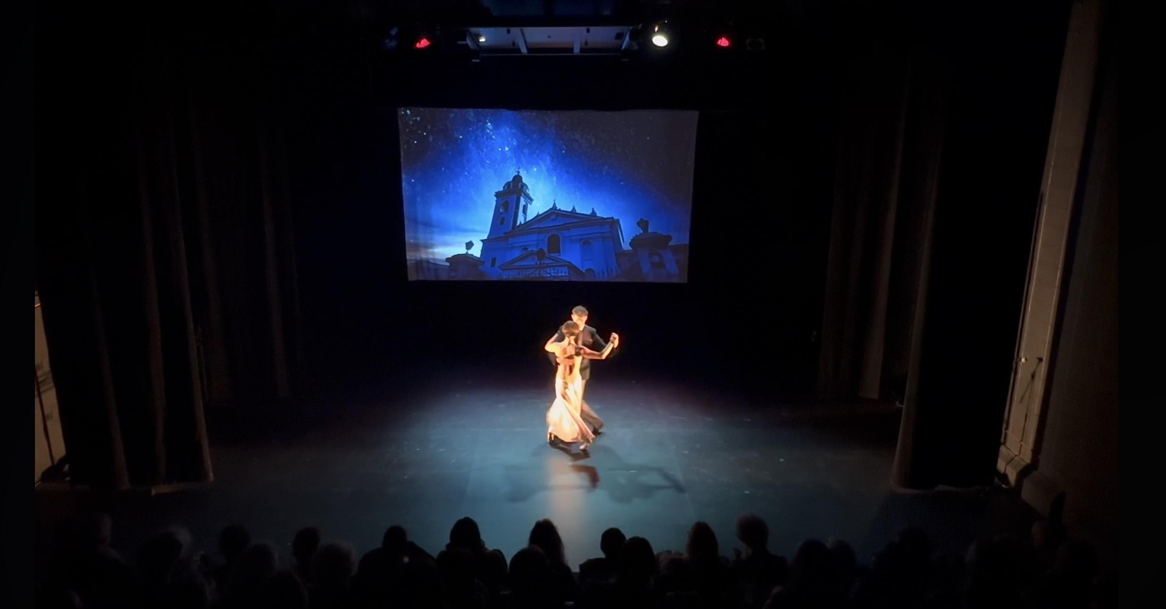

The show’s set is simple: a projection screen with video projections and one chair is brought on stage for a scene towards the end of the show.

Costumes

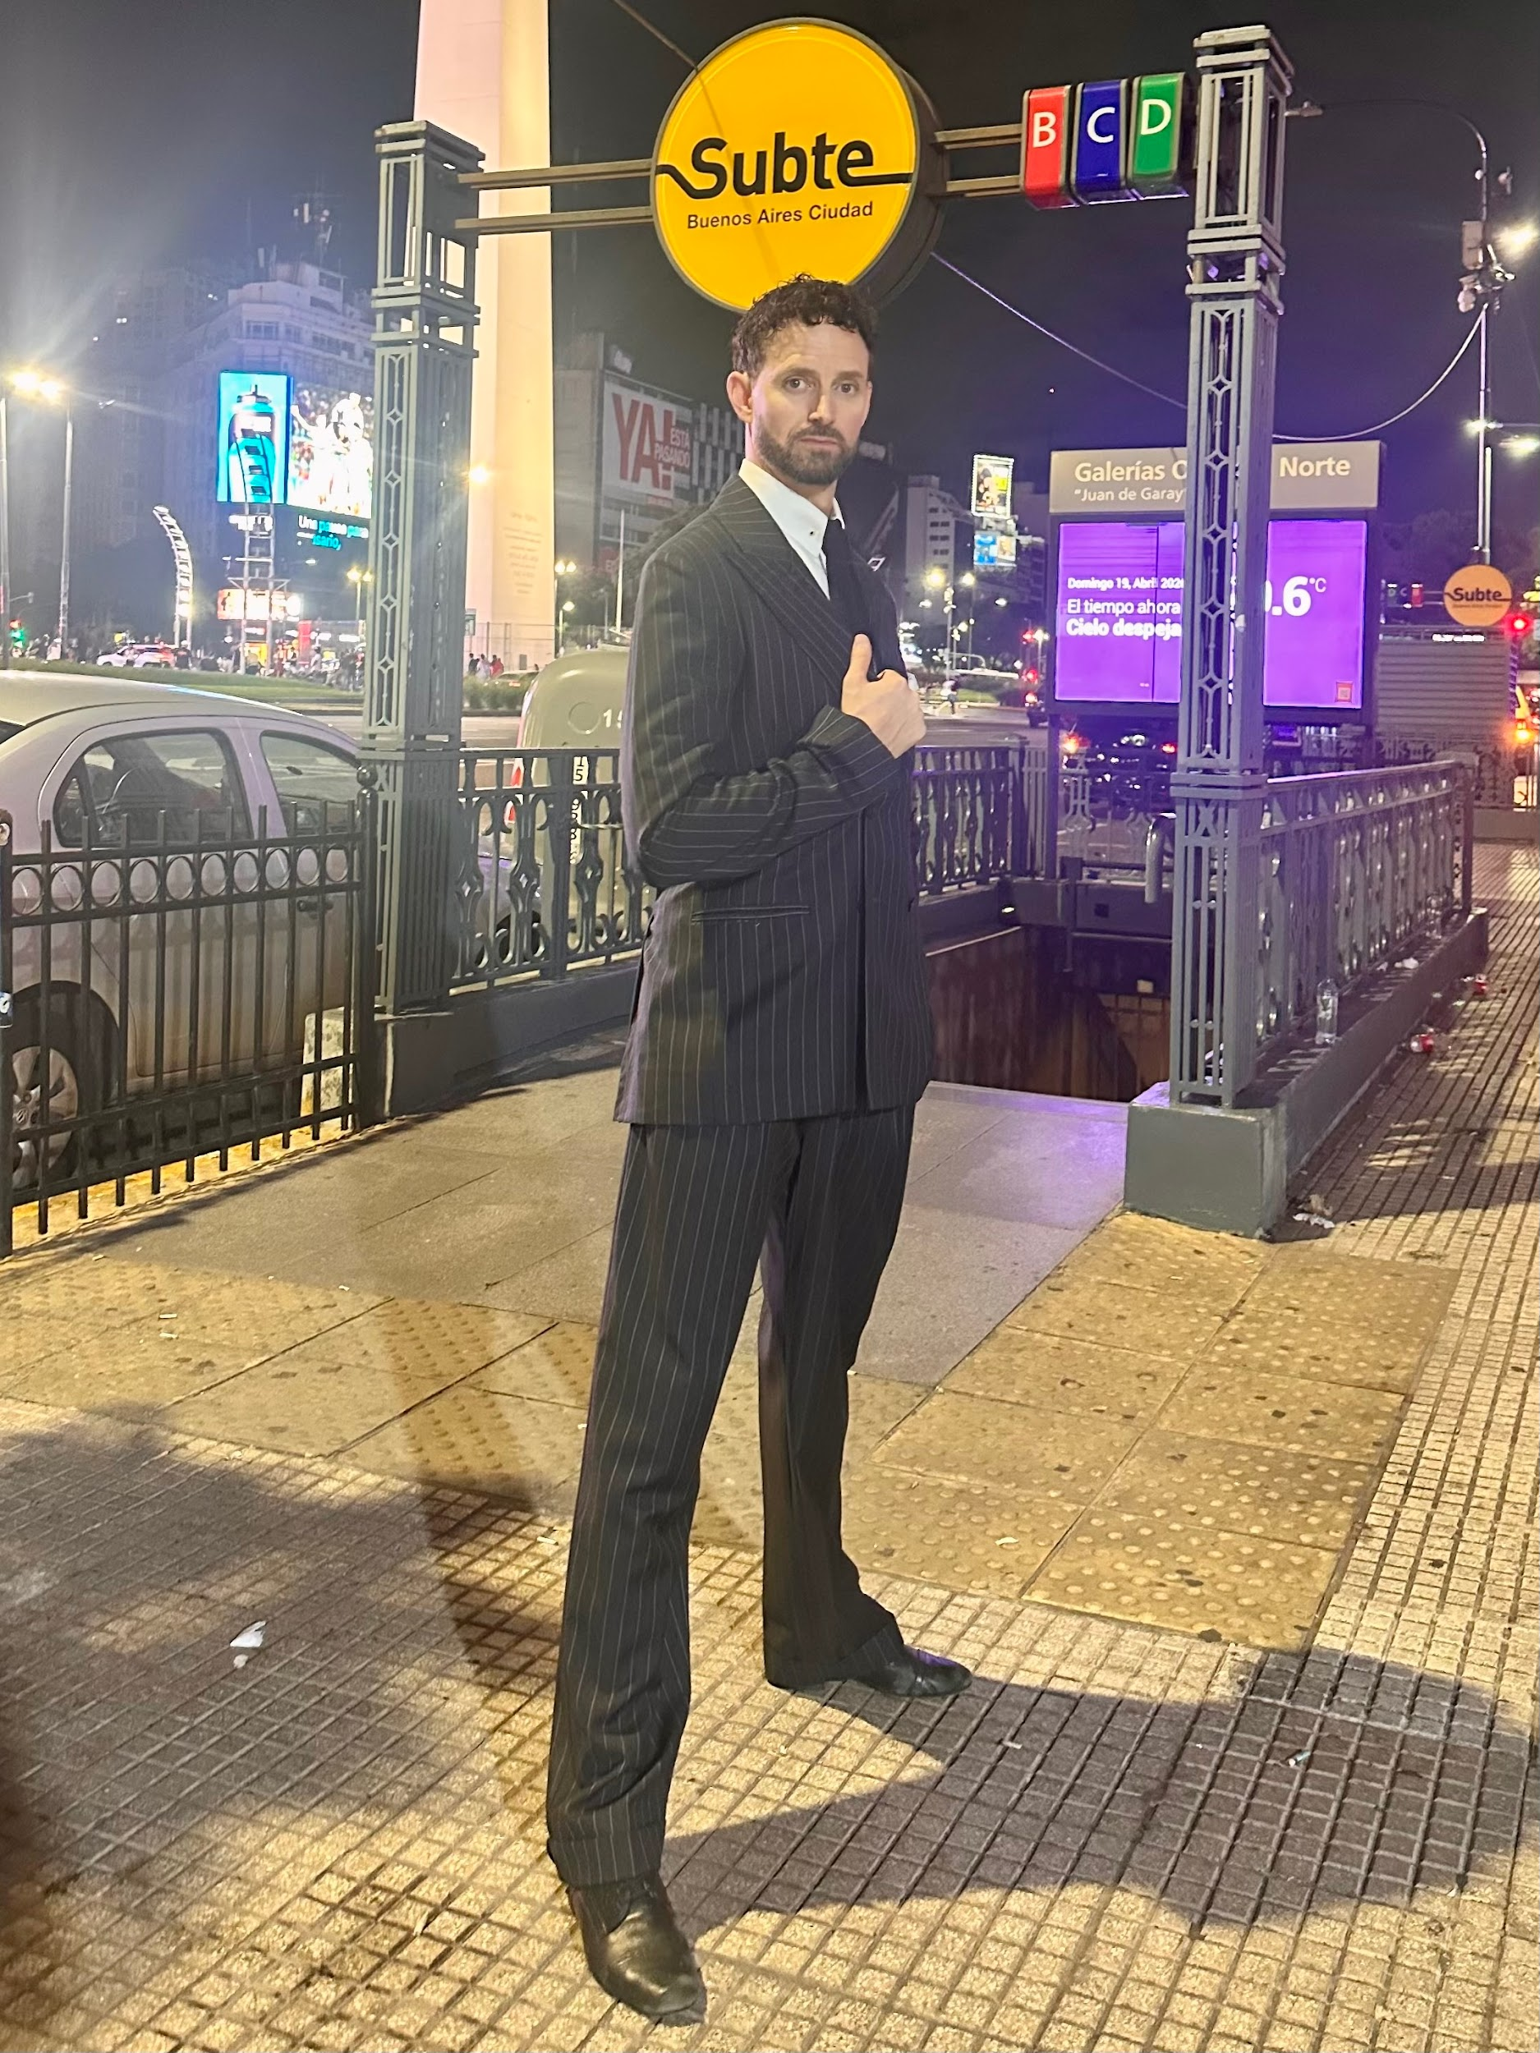
The lead male wears a typical tango suit.

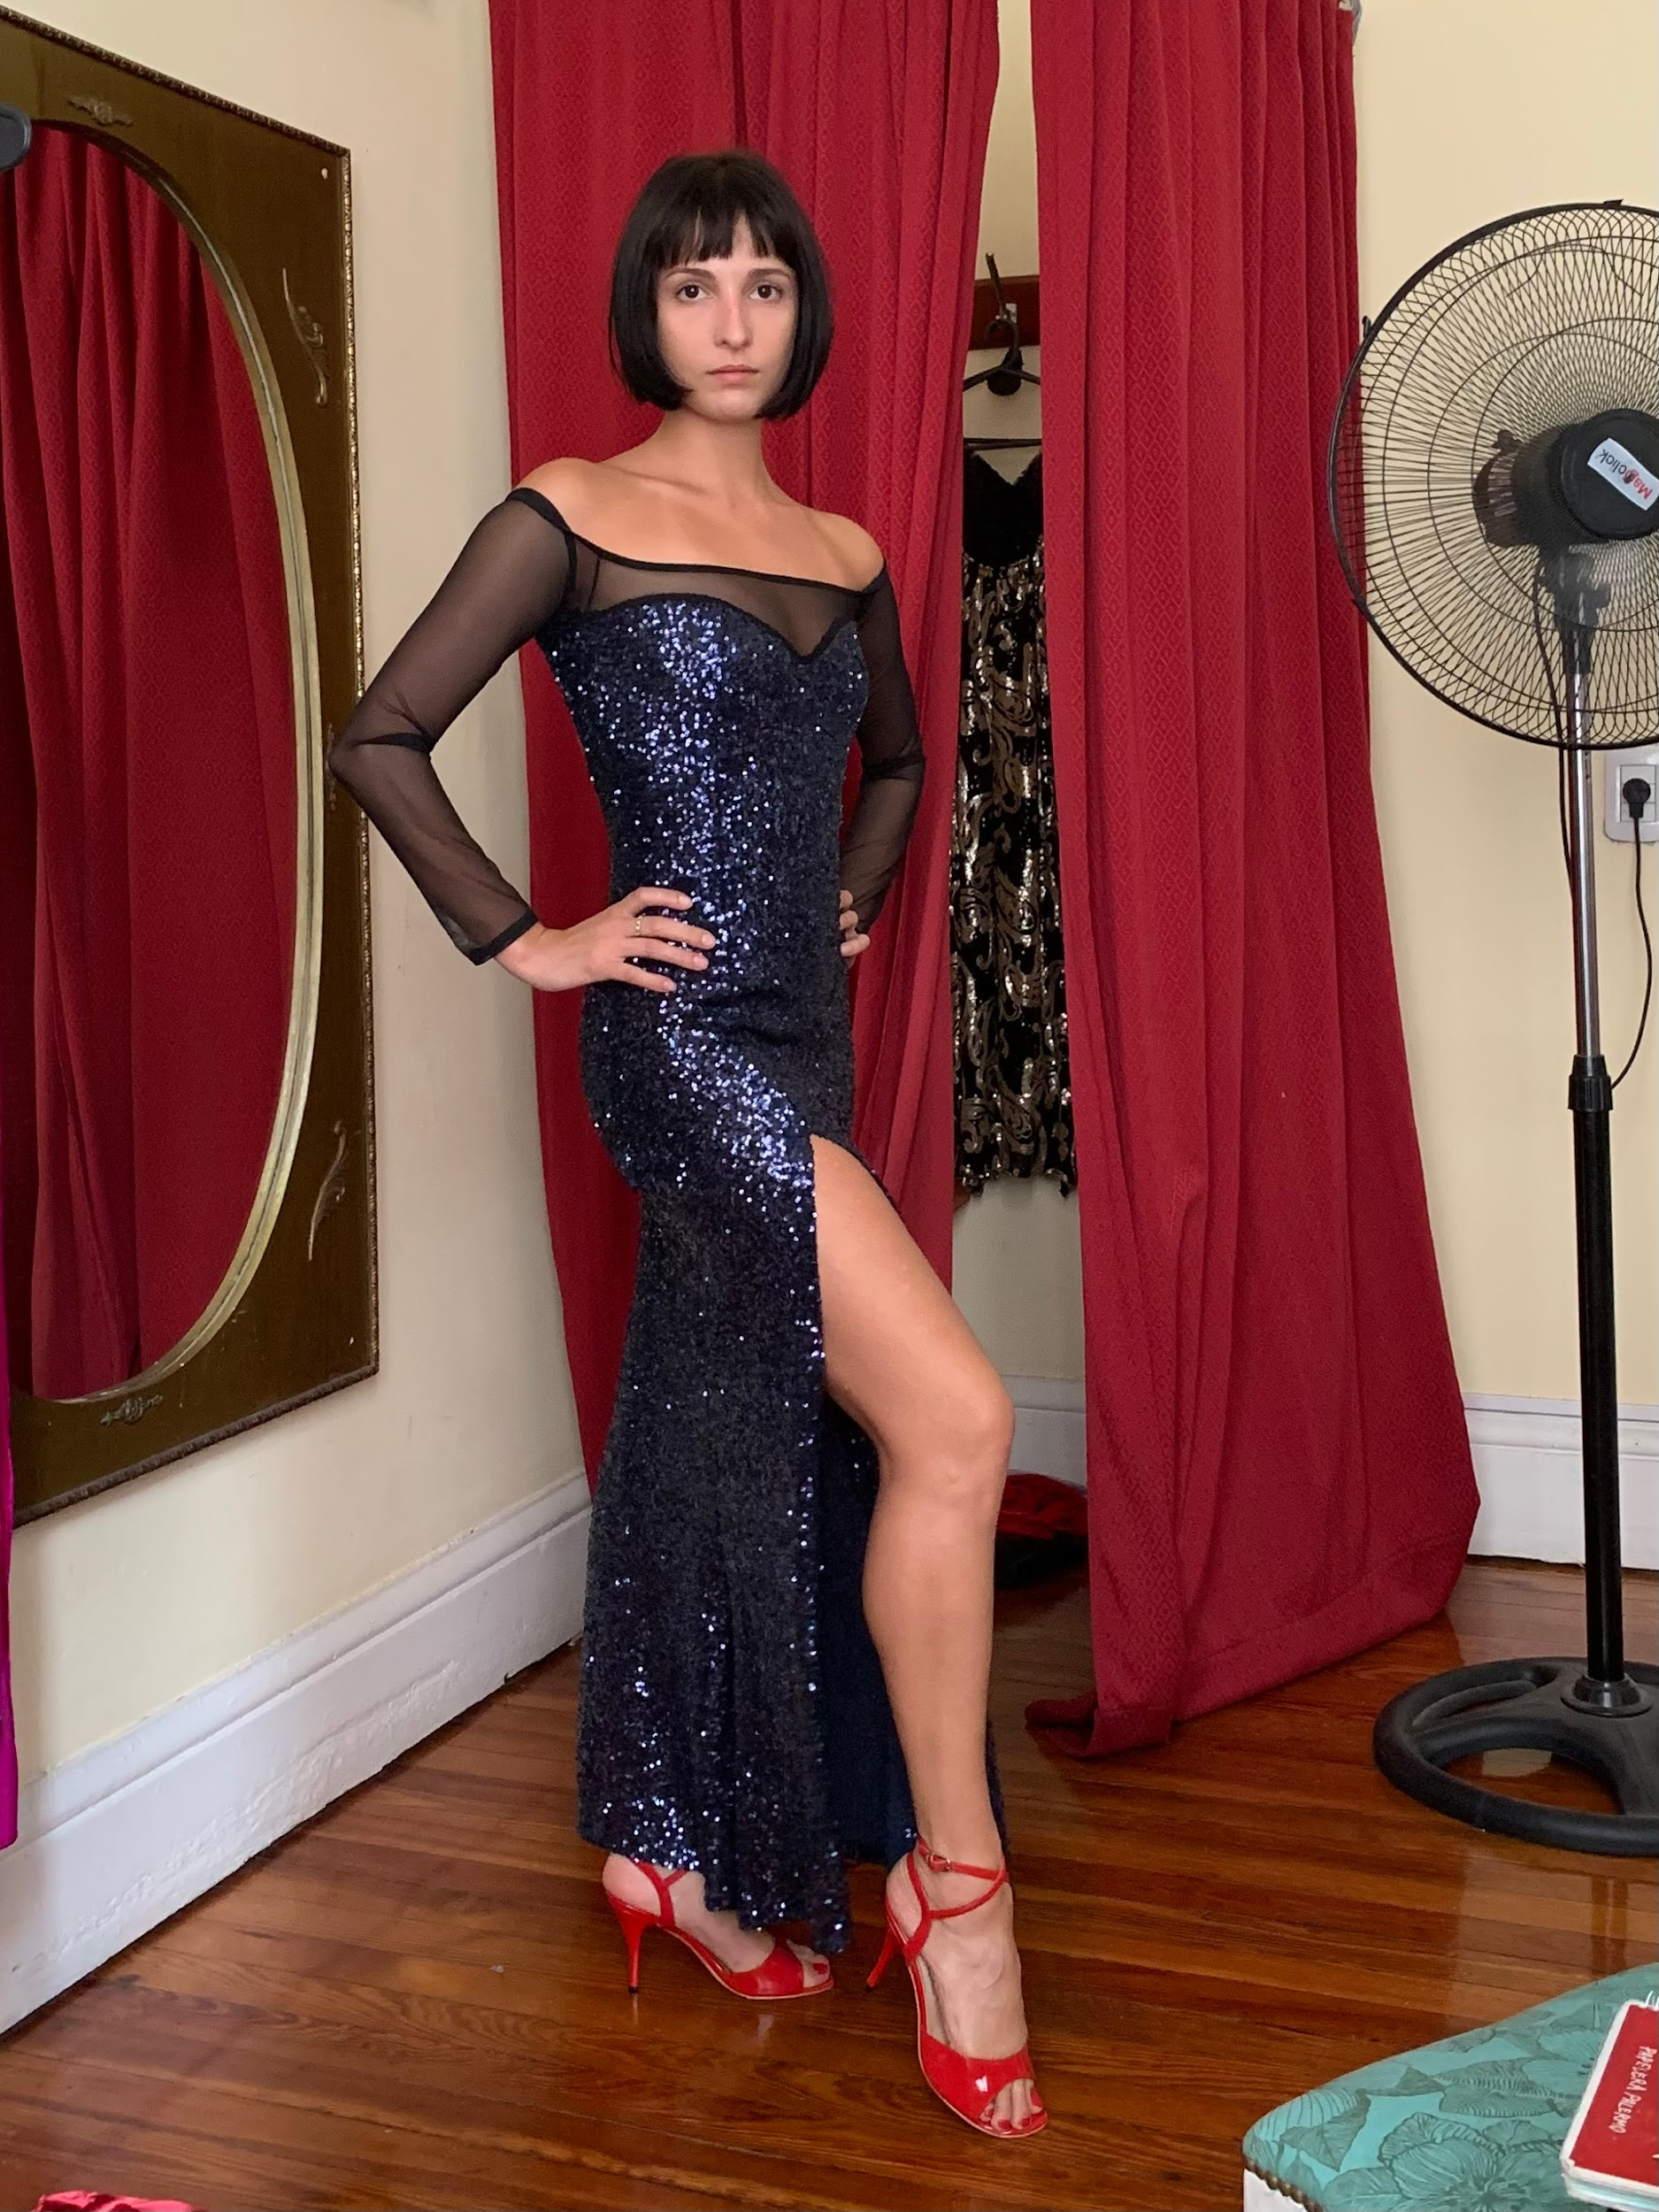
The lead female wears various tango dresses of different colours.

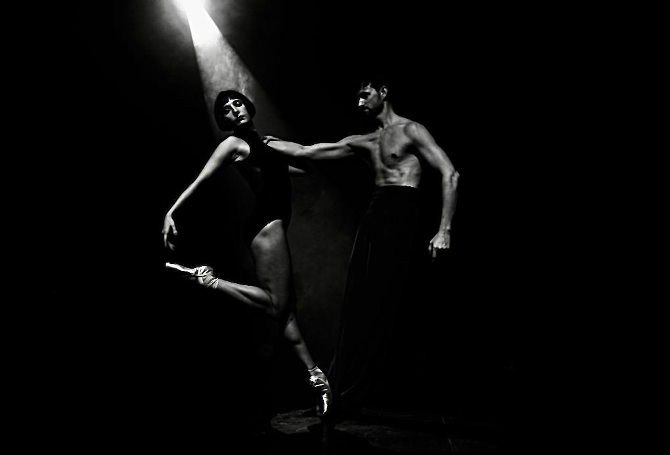
In the first scene, the female dancer wears a black bodysuit with pointe shoes and the male dancer is topless wearing dark pants.

Get in Touch
If you have any questions or concerns about this access guide or planning your visit to TANGO AFTER MIDNIGHT at the 2026 Toronto Fringe Festival, please reach out.

Erin Scott-Kafadar
Dancer/Producer
Email: pointetango@gmail.com
Phone: 514-999-7542

If you want to tell the Fringe about your experience or have feedback that you would like to share, you can call, write, or send an email to the Fringe.

Our address is:
100 Broadview Avenue, Suite 300
Toronto, ON
M4M 3H3

Our email address is:
access@fringetoronto.com

Our phone number is:
416-966-1062

Thank you for coming to the 2026 Toronto Fringe Festival.

