

1 Santosh Santosh 2 Go: Live at Grind-Con!
Access Guide

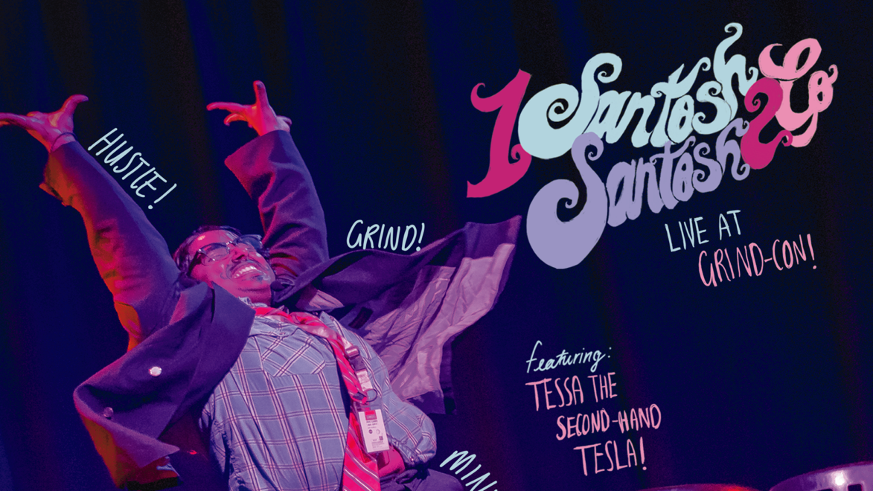

June 30 - July 12, 2026
Sweet Action Theatre

This guide uses plain language to provide audiences, particularly neurodiverse audiences, with specific sensory details of programming in advance to help guide your experience.

Table of Contents

Access Measures 3

About 1 Santosh Santosh 2 Go: Live At Grind-Con! 5

Run Time 5

Content Warnings and Advisories 5

Cast and Characters 6

Set 7

Costumes 8

Get in Touch 9

Access Measures
Relaxed Performance

Relaxed performances are open to everyone, but the environment has been specifically adapted for those who are neurodivergent and may experience sensory sensitivities, folks with communication or learning disabilities, and people who would benefit from a more relaxed environment.

The TIME performance on DATE will be a relaxed performance.

Audio Described Performance

At an audio described performance, audience members can listen to a description of the visual aspects of the performance described live through a small radio receiver. It is a narration with descriptions of the key visual elements, such as the setting, character descriptions, body language, and other key details that benefit blind and low-vision audiences. Audio description extends beyond the show itself with introductory notes before a performance starts, which include contextual information, the organization of the performance, a description of the cast and costumes, and relevant parts of the program such as credits and/or brief background information.

The TIME performance on DATE will be audio described by DESCRIBER NAME.

ASL Interpreted Performance

ASL interpreted performances are specifically designed to provide access to performances for audience members who are d/Deaf and/or hard of hearing. These performances feature ASL-English and/or Deaf interpreters who interpret all dialogue into American Sign Language (ASL) in real time, either on stage or to the side of the stage.

The TIME performance on DATE will be ASL interpreted by INTERPRETER NAMES.

Tactile Body Immersion (TBI) Chair

The ImmersX Tactile Body Immersion (TBI) Chair allows patrons who are d/Deaf, Hard of Hearing, or deafblind to experience music and other sounds through vibrations that are channeled through the seat and back rest of the chair.

The TBI Chair will be available at the TIME performance on DATE.

Touch Book

Touch books offer a tactile experience of various elements of the set, props, and costumes through touch. Touch books allow patrons from the blind and low vision community to enjoy a more complete experience of a show through touch.

A touch book will be available at the Front of House area for all performances.

About 1 Santosh Santosh 2 Go: Live at Grind-Con
Hustle! Grind! Mindset! Your favourite tech bro, thought leader and second-hand Tesla owner Santosh Santosh (aka TOSH) is delighted to be a very last minute speaker at Grind-Con! 5 ft 9 but with the ambition of 7’2, Santosh is the host of “Second-Hand Success”, an almost award-winning podcast. He’s known for his linkedIn presence, with over 37 endorsements and one heart reaction from Sundar Pichai’s fan account. When he’s not doing asynchronous API orchestration, Santosh likes to kick back, drink beer and spend time inside his girlfriend.

~*Developed through the Buddies in Bad Times Emerging Creators Unit in 2025*~

Run Time
55 minutes with no intermission

Content Warnings and Advisories
Please be advised that 1 Santosh Santosh 2 Go includes/mentions/references/depicts…gunshots, mature language, sexual content and audience participation.

Cast and Characters
Srutika Sabu plays the role of Santosh Santosh.
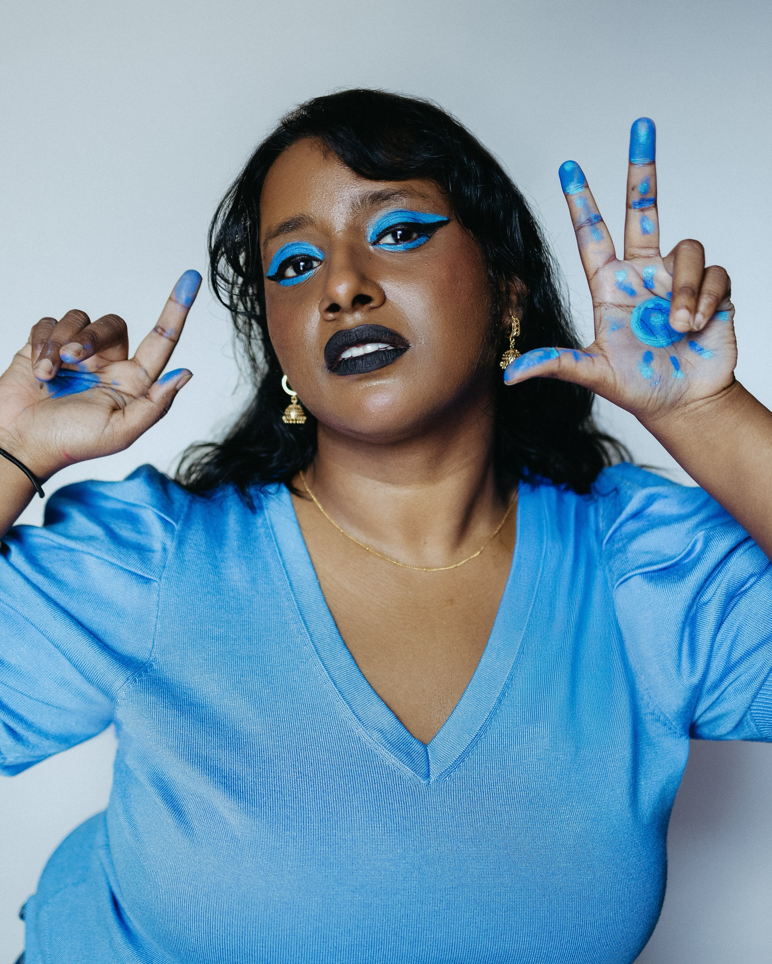SHOT

Set
PHOTO OF SET

Describe your set to the best of your ability here. If the set changes throughout your show, insert multiple photos and descriptions.

Costumes
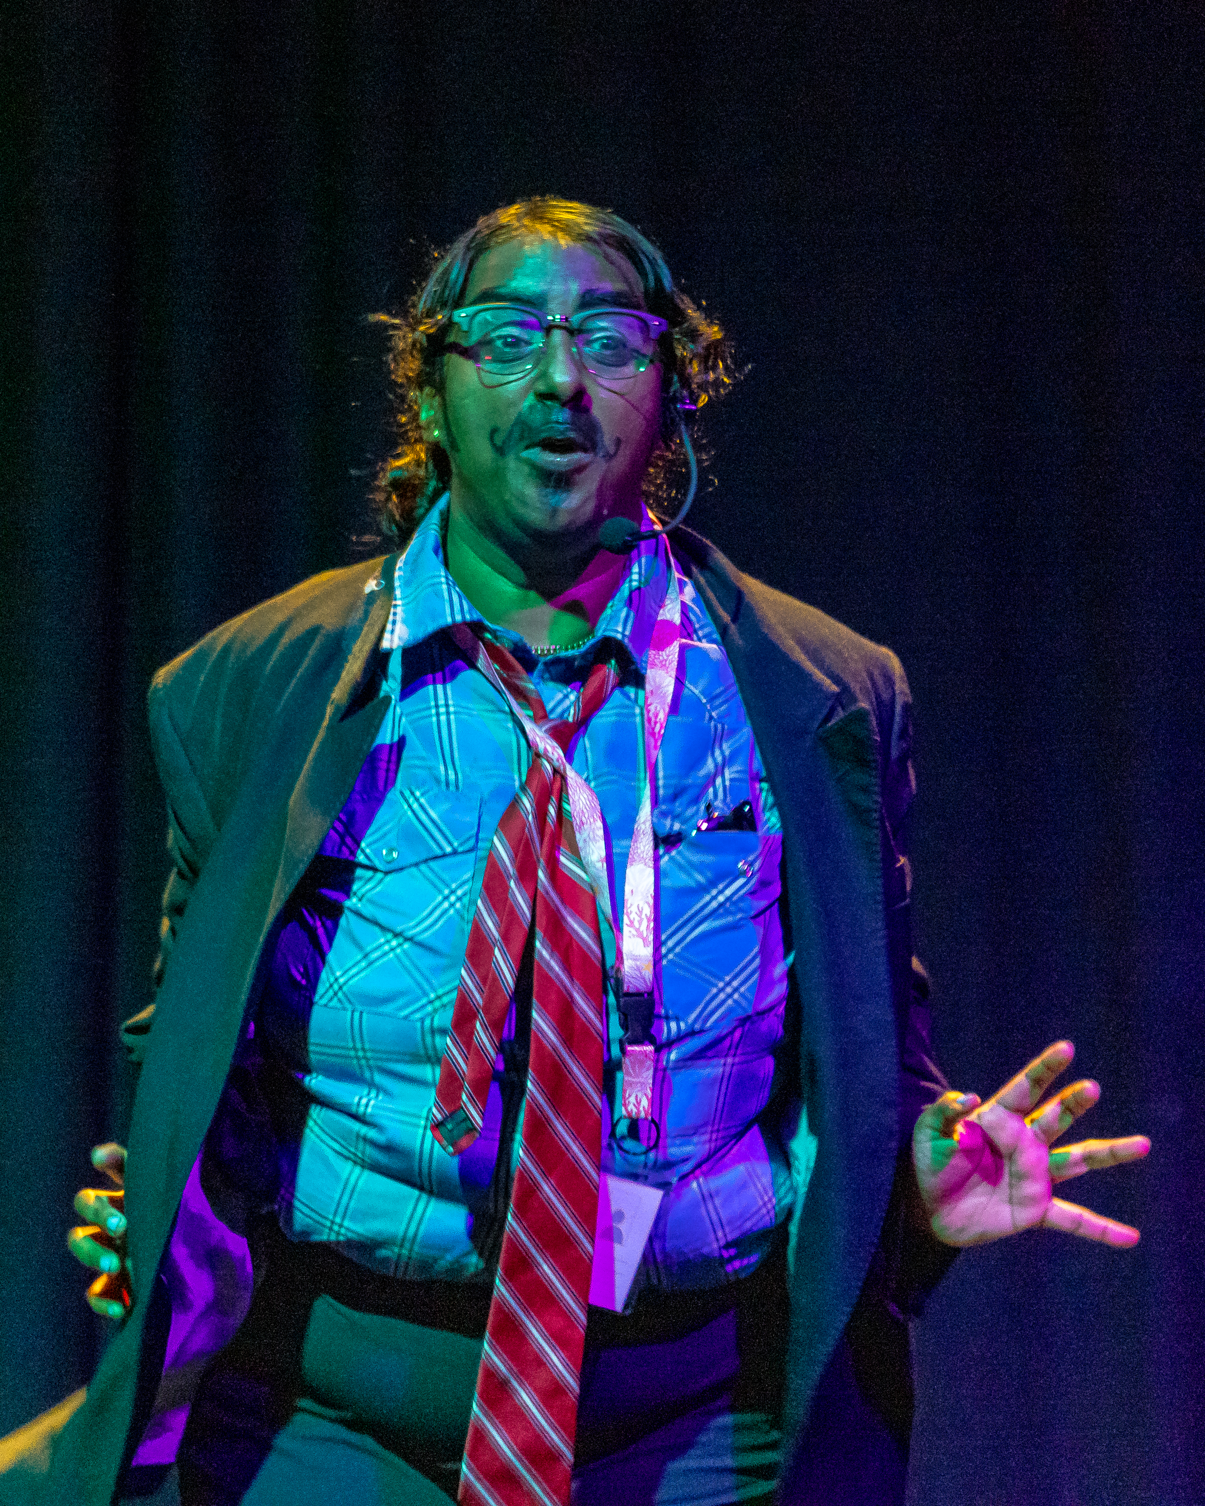

Costume: navy blue business suit, blue shirt, bold red tie and landyard. The face has glasses, and a moustache and beard draw with black makeup.

Get in Touch
If you have any questions or concerns about this access guide or planning your visit to SHOW NAME at the 2026 Toronto Fringe Festival, please reach out.

Contact Name
Producer Meryl Ochoa
Email: Meryl Ochoa <meryldianne@gmail.com>
Phone:

If you want to tell the Fringe about your experience or have feedback that you would like to share, you can call, write, or send an email to the Fringe.

Our address is:
100 Broadview Avenue, Suite 300
Toronto, ON
M4M 3H3

Our email address is:
access@fringetoronto.com

Our phone number is:
416-966-1062

Thank you for coming to the 2026 Toronto Fringe Festival.

