

NIGHT JOURNEY
Access Guide



July 3 - July 12, 2026
Arts & Letters Club of Toronto

This guide uses plain language to provide audiences, particularly neurodiverse audiences, with specific sensory details of programming in advance to help guide your experience.

Table of Contents

Access Measures 3

About NIGHT JOURNEY 4

Run Time 4

Content Warnings and Advisories 4

Cast and Characters 4

Set 7

Costumes 8

Get in Touch 9

Access Measures

Accessibility Measures

A slightly elevated ramp at the front of the 14 Elm Street building and an indoor lift for wheelchairs greet theatre-goers. An area of the audience space in the Great Hall will be set aside for patrons using mobility devices. Wheelchairs will be provided to attendees arriving via scooters or mechanized wheelchairs. Washrooms designed for accessibility are easily reached by elevator. The Great Hall is equipped with a hearing loop system, an assistive listening technology that transmits sound directly to hearing aids or cochlear implants, improving clarity and reducing background noise. (However, this is only of use if the actors are wearing mics and no decision has yet been made regarding this.) The audience will be seated comfortably on high-quality wooden seats, which are outfitted with seat and back cushions. The seating arrangement provides an excellent view of the elevated stage. As the 14 Elm Street building is on a side street, it is a quiet venue. The Great Hall performance space has excellent, professionally installed lighting.

Audio Described Performance

At an audio described performance, audience members can listen to a description of the visual aspects of the performance described live through a small radio receiver. It is a narration with descriptions of the key visual elements, such as the setting, character descriptions, body language, and other key details that benefit blind and low-vision audiences. Audio description extends beyond the show itself with introductory notes before a performance starts, which include contextual information, the organization of the performance, a description of the cast and costumes, and relevant parts of the program such as credits and/or brief background information.

The 7:30 performance on Tuesday, July 7 will be audio described by ______ (Person to be Determined).

About NIGHT JOURNEY
This original, full-length play explores the dynamics among five strangers in a college night class studying the Greek epic,The Odyssey. Each struggles with a troubled past; all are in quest of a better life. This challenging work is brought fully to life by Night Journey's exceptional cast of actors.

Run Time

80 minutes with no intermission

Content Warnings and Advisories
Please be advised that NIGHT JOURNEY includes references to the difficult personal experiences of the characters. These include the death of a grown child, a prison sentence, and growing up in a series of foster homes.

Cast and Characters
CAROLINE BARR RITCHIE plays the role of Joan, an attractive woman in her late 40s who works as an MRI technician.
ADSHOT

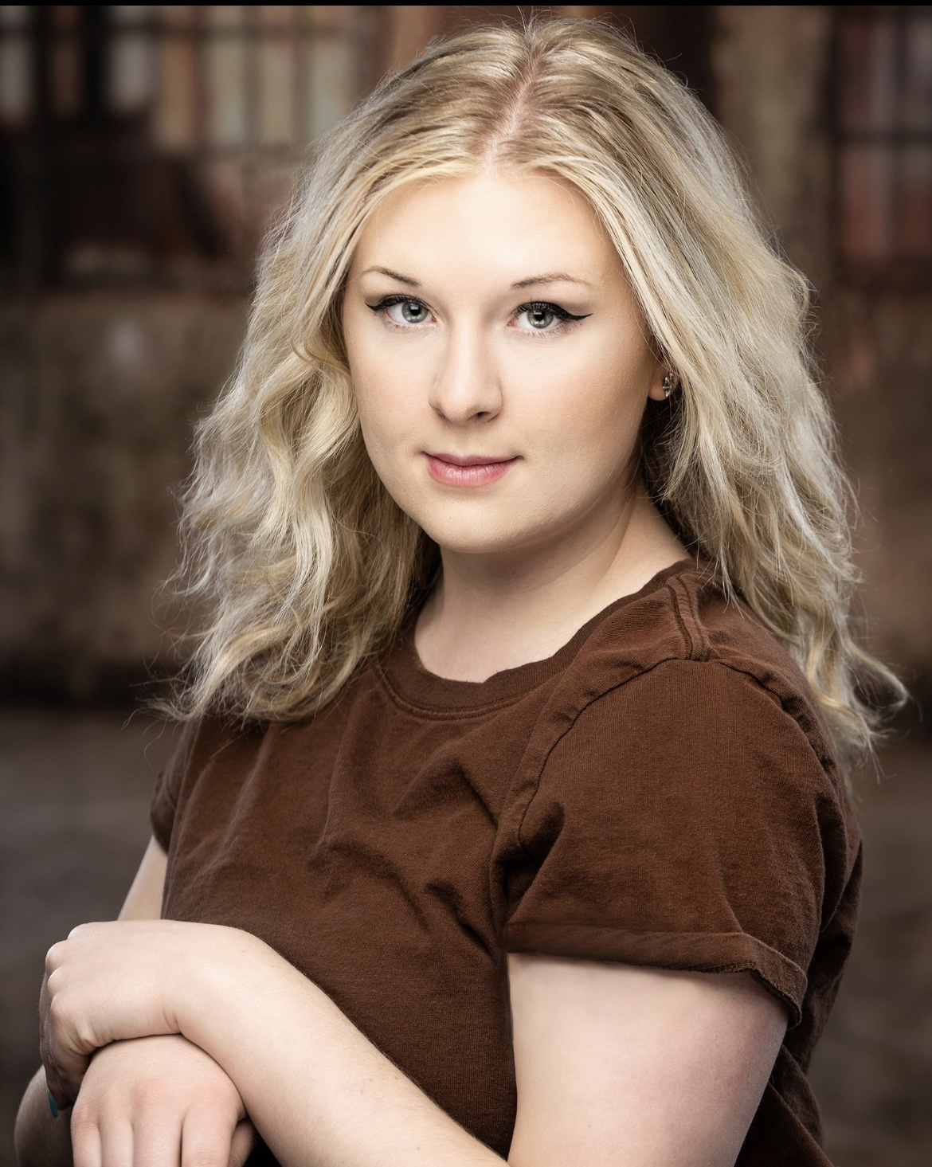SHOT
BRYNN BONNE plays the role of Ashley, a young woman attending her first college course.

SHOT
ERIC BRACCIODIETA plays the role of Paul Anthony Ramsbottom III, a dapper 30-ish fellow.

SHOT
PAUL DUDER plays the role of Harry, chairman of the Literature Department in a small-town College.

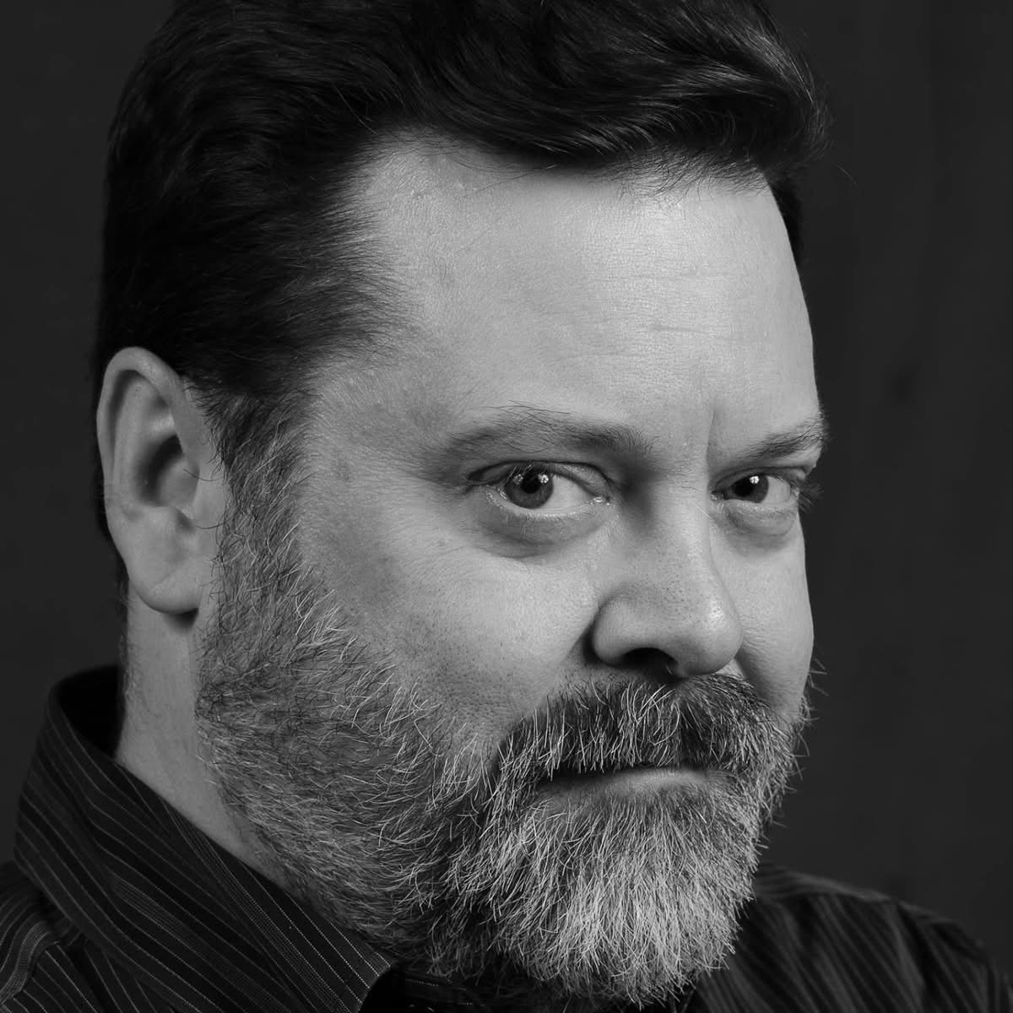
STEPHEN FLETT plays the role of ‘Zuke’ Zusserman, an elderly professor of Classics.


FRED KUHR plays the role of Ozzie, a middle-aged working man attending college for the first time.

DSHOT
RENEE STEIN plays the role of Carla, an attractive older woman.

Set
SET HAS NOT YET BEEN DESIGNED OR CONSTRUCTED

The setting: Present Day, College Basement.
The stage is divided into two spaces. A basement Storeroom. Stage left and a kitchen stage right with entrances between them and entrances off to the wings. The size of these spaces will change according to scenes, with the Storeroom generally being larger.
The Storeroom. In its present incarnation, the room is more of a storeroom than a Storeroom. But hints of its use as an art Storeroom, rehearsal space are still apparent. The central space is mostly empty. Surrounding it, haphazardly arranged and stacked, are pieces of secondhand furniture, chairs, tables, standing lamps, old art easels, theatrical props, a microphone stand, half-full boxes and plastic bins etc. Amid this assemblage, are a large bean bag, a beaten upholstered armchair, an old divan, and an old-fashioned worn mahogany chair with cushioned seat. More accessible are an old wood lectern and four stacked, stackable plastic garden chairs.
The Kitchen. Taking up a quarter of the stage is an old kitchen. Upstage is a sink next to counterspace long enough to accommodate an electric kettle, a coffee maker and a microwave. There are open shelves above the refrigerator for worn cups, mugs, bowls, plates and cutlery etc. Stage right is an old, low refrigerator. A couple of posters of past theatre productions on the wall. Downstage is a small circular table and plastic chairs.

Costumes
NO COSTUMES AS OF YET

The costumes are contemporary, everyday street clothes and casual office wear.

Get in Touch
If you have any questions or concerns about this access guide or planning your visit to SHOW NAME at the 2026 Toronto Fringe Festival, please reach out.

Contact Name
Title/Position
Email:
Phone:

If you want to tell the Fringe about your experience or have feedback that you would like to share, you can call, write, or send an email to the Fringe.

Our address is:
100 Broadview Avenue, Suite 300
Toronto, ON
M4M 3H3

Our email address is:
access@fringetoronto.com

Our phone number is:
416-966-1062

Thank you for coming to the 2026 Toronto Fringe Festival.

