

Fray

Access Guide

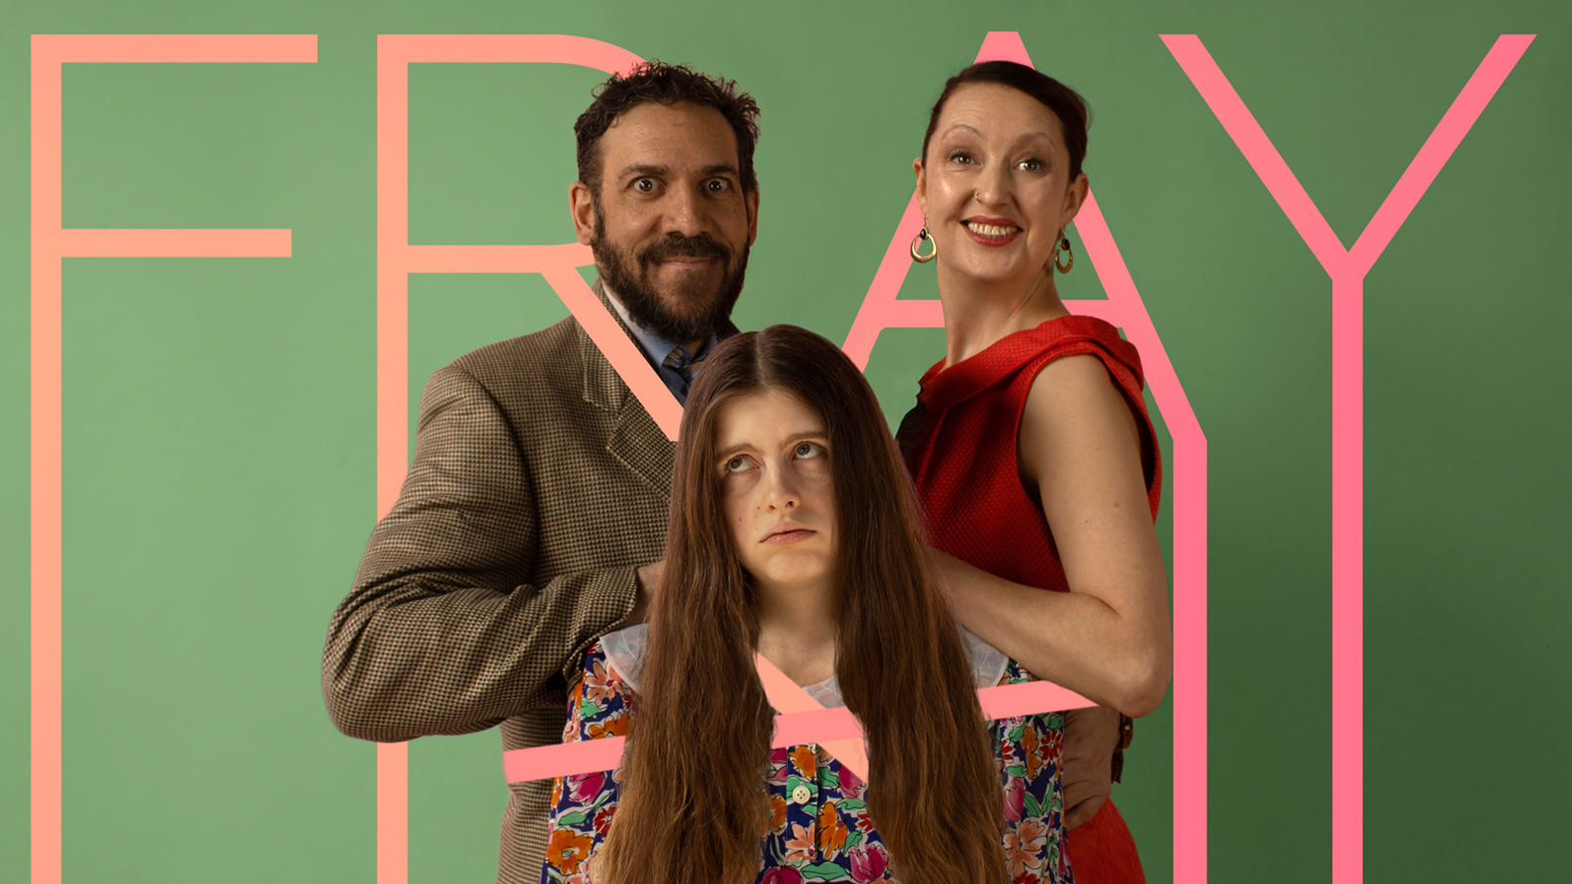
June 30 - July 12, 2026
Studio 162
15 Adrian Ave
Near Dupont & Symmington

This guide uses plain language to provide audiences, particularly neurodiverse audiences, with specific sensory details of programming in advance to help guide your experience.

Table of Contents

Access Measures 3

About Fray 4

Run Time 4

Content Warnings and Advisories 4

Cast and Characters 5

Set 6

Costumes 7

Get in Touch 8

Access Measures

More Information to come.

About Fray
“Fray” is a dark comedy about family and the urge to escape it. Not an easy thing to do when the actors are tied to each other, the set, and the props with yards and yards of stretchy string!
The choreography is inspired by physical theatre and contemporary dance, and is kinetic, visually striking, and rich in metaphor. The choreography, coupled with sharp dialogue and spot-on character work by the actors, creates a show that will have the audience laughing as well as wincing at how much the Mitchells remind them of their own families!

There is no audience interaction, and the cast never comes into the audience.

Run Time
60 minutes with no intermission

Content Warnings and Advisories
Please be advised that “Fray” contains dance, family arguments, books being thrown, a glass breaking, people shouting, one swear-word, and a reference to suicide.

There is a dance number with the showtune “I’ll Build a Stairway to Paradise” by Gershwin played at fairly high volume.

The lighting is a general wash with the occasional spotlight.

Cast and Characters
Melanie Pyne plays the role of Rose Mitchell, the mother.
ADSHOT

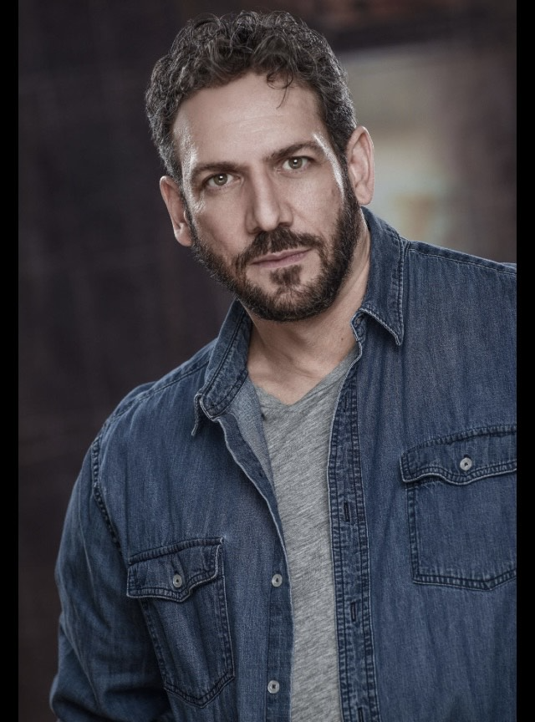DSHOT
Tim MacLean plays the role of Bill Mitchell, the father.

DSHOT
Maïa Greco plays the role of Meg Mitchell, the daughter.

Set
PHOTO OF SET

More Information to Come

Costumes
PHOTO OF COSTUME

More Information to Come

Get in Touch
If you have any questions or concerns about this access guide or planning your visit to SHOW NAME at the 2026 Toronto Fringe Festival, please reach out.

Robin North
Writer/Director
Email: robinnorth@hotmail.com

If you want to tell the Fringe about your experience or have feedback that you would like to share, you can call, write, or send an email to the Fringe.

Our address is:
100 Broadview Avenue, Suite 300
Toronto, ON
M4M 3H3

Our email address is:
access@fringetoronto.com

Our phone number is:
416-966-1062

Thank you for coming to the 2026 Toronto Fringe Festival.

