

Fray

Access Guide


June 30 - July 12, 2026
Geary Avenue Warehouse
209 Geary Ave.
Near Dupont & Dufferin

This guide uses plain language to provide audiences, particularly neurodiverse audiences, with specific sensory details of programming in advance to help guide your experience.

Table of Contents

Access Measures 3

About Three Descending Notes 4

Run Time 4

Content Warnings and Advisories 4

Cast and Characters 5,6 & 7

Set 8

Costumes 9

Get in Touch 10

Access Measures

More Information to come.

About Three Descending Notes
“Three Descending Notes” is about Odelia, a woman in the early stages of dementia, who gets lost on the subway and goes on a fantastical odyssey to find her way home.
Odelia is a live actor on the stage, but the rest of the cast appear as holograms, or illusions. This is created by using lights, lasers, mirrors, and a special scrim called a “Pepperscrim”
There is live singing and recorded music. The illusions are made of light and transform and change. The theatre will be kept very dark.

There is no audience interaction, and the cast never comes into the audience.

Run Time
60 minutes with no intermission

Content Warnings and Advisories
Please be advised that “Three Descending Notes” touches on dementia and aging. There are moments in the musical where Odelia is frightened. As the apparitions and illusions transform there will be lighting changes. There is also a storm at sea depicted with lightning.

Cast and Characters
Georgia Grant plays the role of Odelia



Liesl Adriaans plays the role of Siren

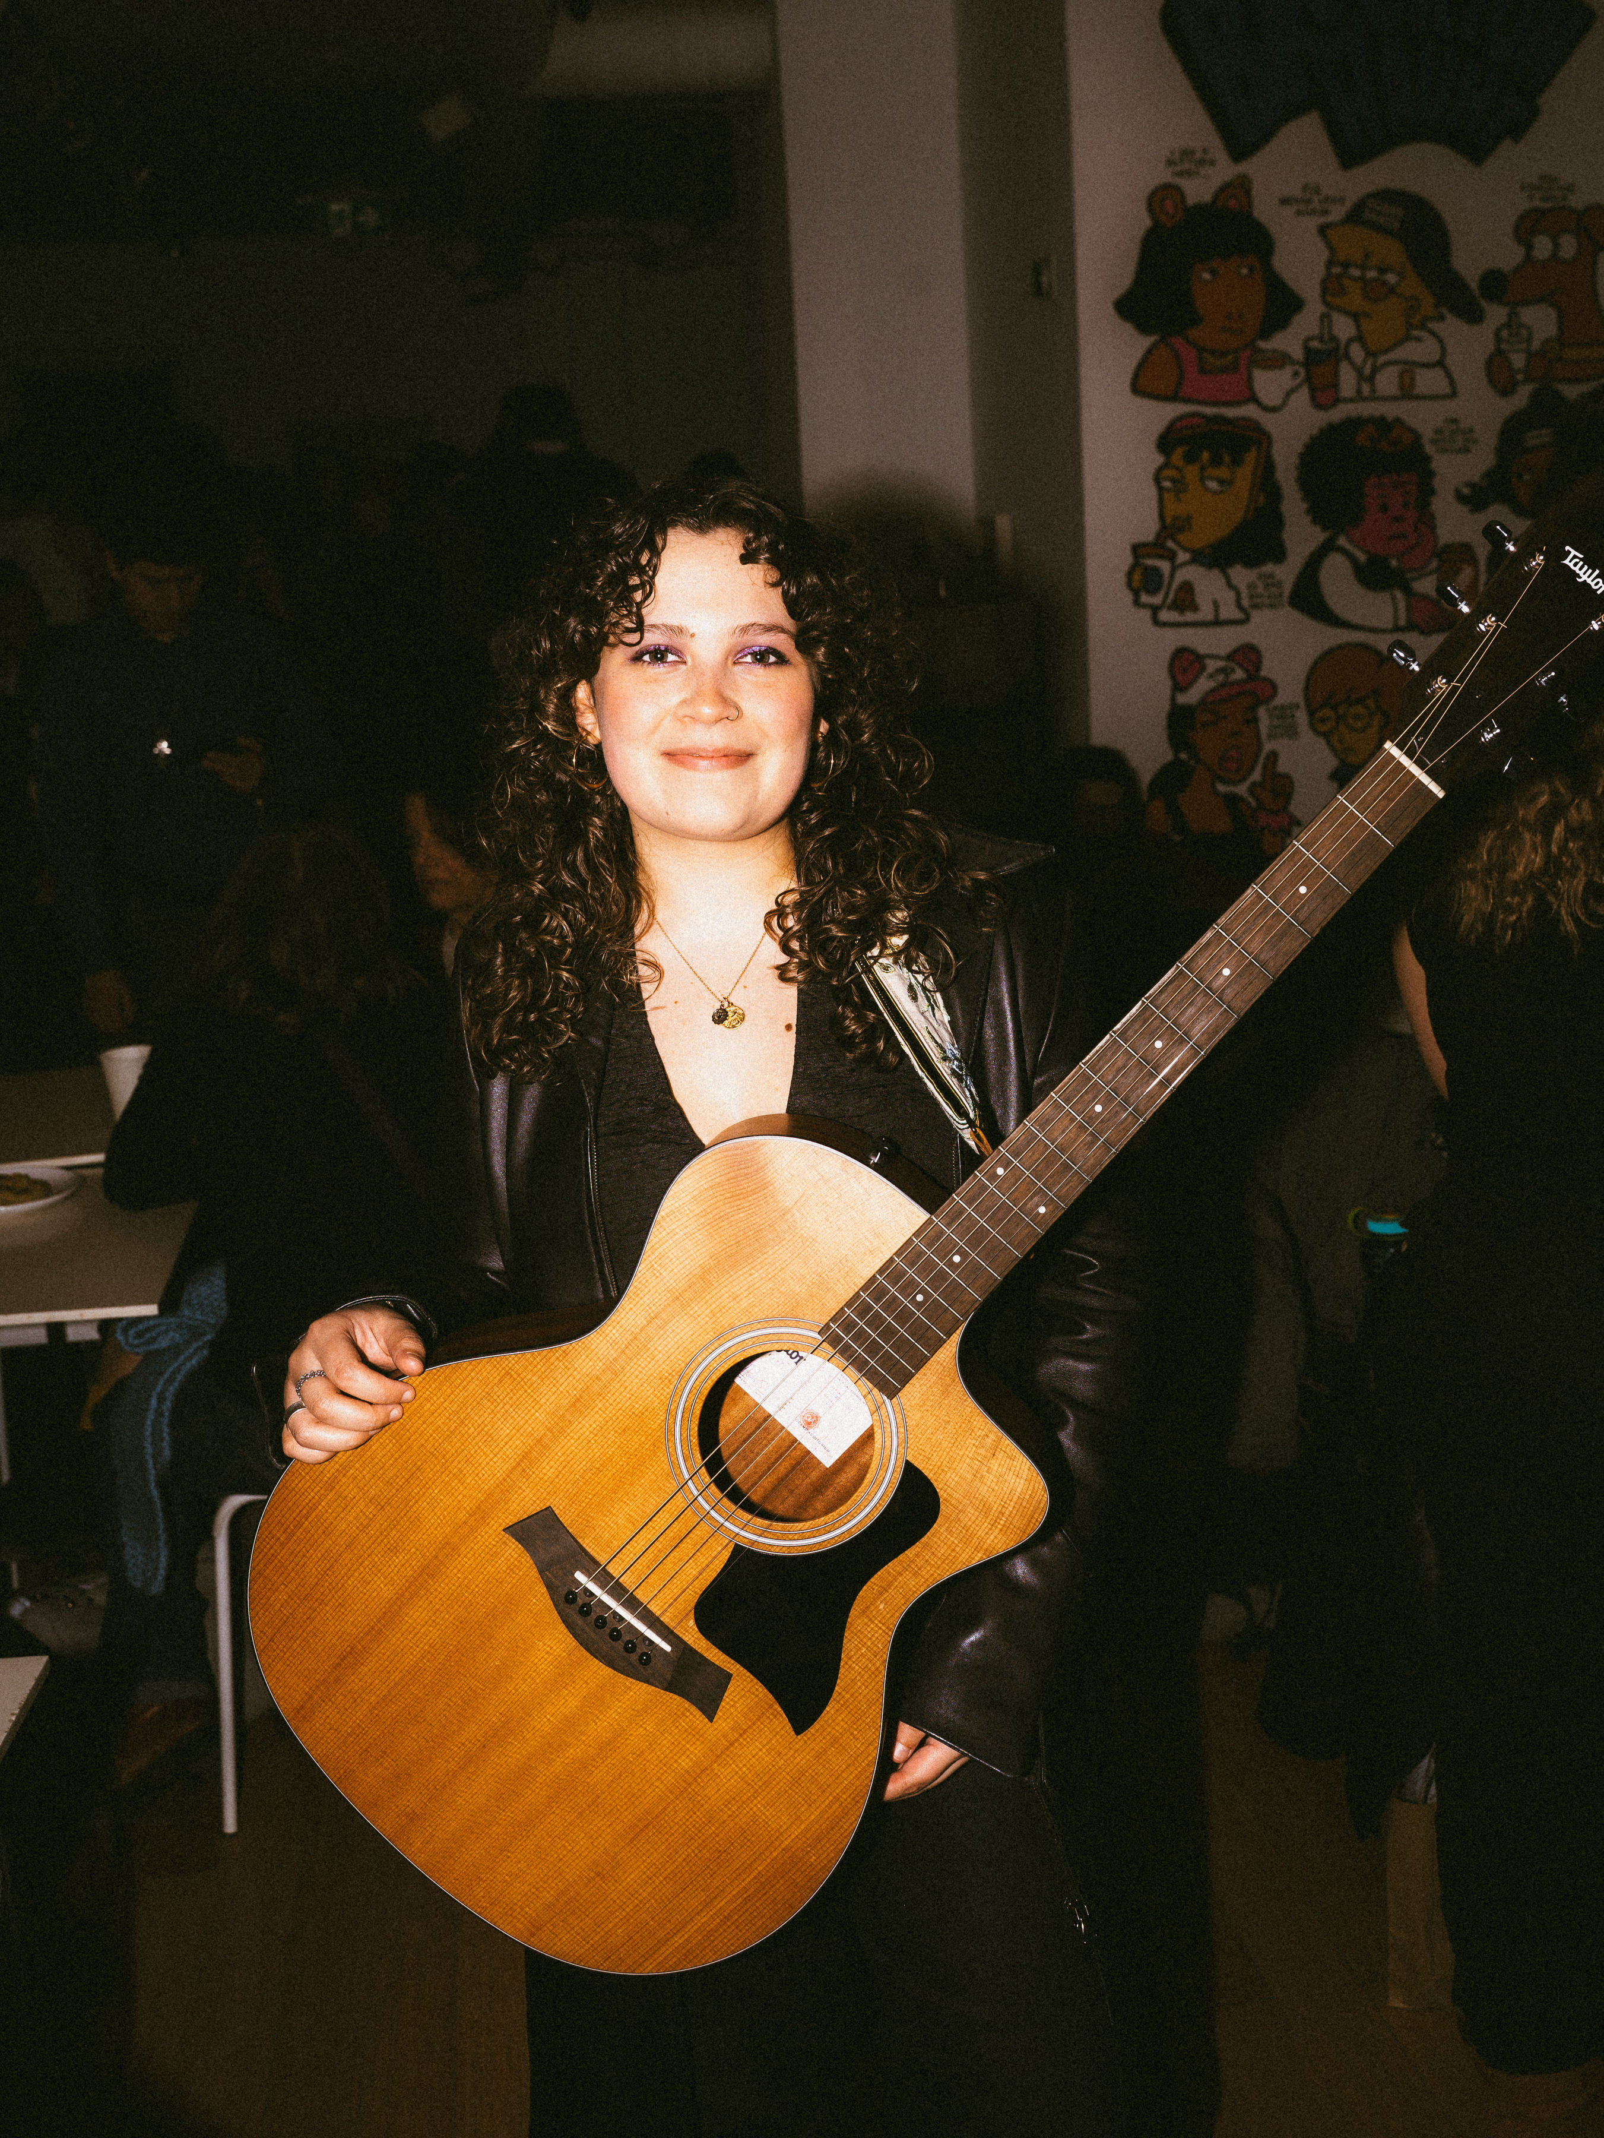
Ana Delgadillo plays the role of Siren

Blanca Espinoza plays the role of Siren


Francesca Argento plays the role of Siren


Jamie Salloum plays the role of The Bear/TTC Operator

Justan Myers Chapman plays the role of The Pirate


Set
PHOTO OF SET

More Information to Come

Costumes
PHOTO OF COSTUME

More Information to Come

Get in Touch
If you have any questions or concerns about this access guide or planning your visit to Three Descending Notes at the 2026 Toronto Fringe Festival, please reach out.

Robin North
Creator
Email: robinnorth@hotmail.com

If you want to tell the Fringe about your experience or have feedback that you would like to share, you can call, write, or send an email to the Fringe.

Our address is:
100 Broadview Avenue, Suite 300
Toronto, ON
M4M 3H3

Our email address is:
access@fringetoronto.com

Our phone number is:
416-966-1062

Thank you for coming to the 2026 Toronto Fringe Festival.

