

Mysteries and Lies
Access Guide

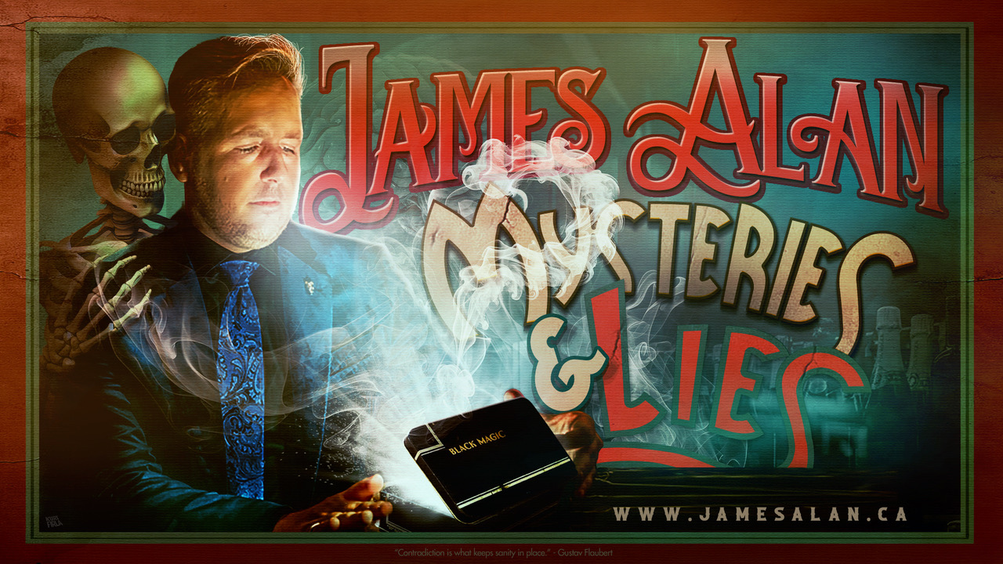

June 30 - July 12, 2026
Sweet Action Theatre

This guide uses plain language to provide audiences, particularly neurodiverse audiences, with specific sensory details of programming in advance to help guide your experience.

Table of Contents

Access Measures 3

About Mysteries and Lies 4

Run Time 4

Content Warnings and Advisories 4

Cast and Characters 5

Set 5

Get in Touch 6

Access Measures
Relaxed Performance

Relaxed performances are open to everyone, but the environment has been specifically adapted for those who are neurodivergent and may experience sensory sensitivities, folks with communication or learning disabilities, and people who would benefit from a more relaxed environment.

The 1:00 PM performance on July 10 will be a relaxed performance.

About Mysteries and Lies
Mysteries and Lies is an interactive magic performance with a significant amount of audience participation.

Run Time
60 minutes with no intermission

Content Warnings and Advisories
Please be advised that Mysteries and Lies contains surprising and unexpected events, annoying unanswered questions and language not suitable for children under fourteen.

Cast and Characters
James Alan plays the role of himself (include character description if desired).
ADSHOT

Set
The set consists of a rectangular table with five chairs facing the audience. Four of the chairs are occupied by members of the audience.

Get in Touch
If you have any questions or concerns about this access guide or planning your visit to SHOW NAME at the 2026 Toronto Fringe Festival, please reach out.

Contact Name
James Alan
Email:
info@jamesalan.ca

If you want to tell the Fringe about your experience or have feedback that you would like to share, you can call, write, or send an email to the Fringe.

Our address is:
100 Broadview Avenue, Suite 300
Toronto, ON
M4M 3H3

Our email address is:
access@fringetoronto.com

Our phone number is:
416-966-1062

Thank you for coming to the 2026 Toronto Fringe Festival.

