

Olivia O Musical
Access Guide

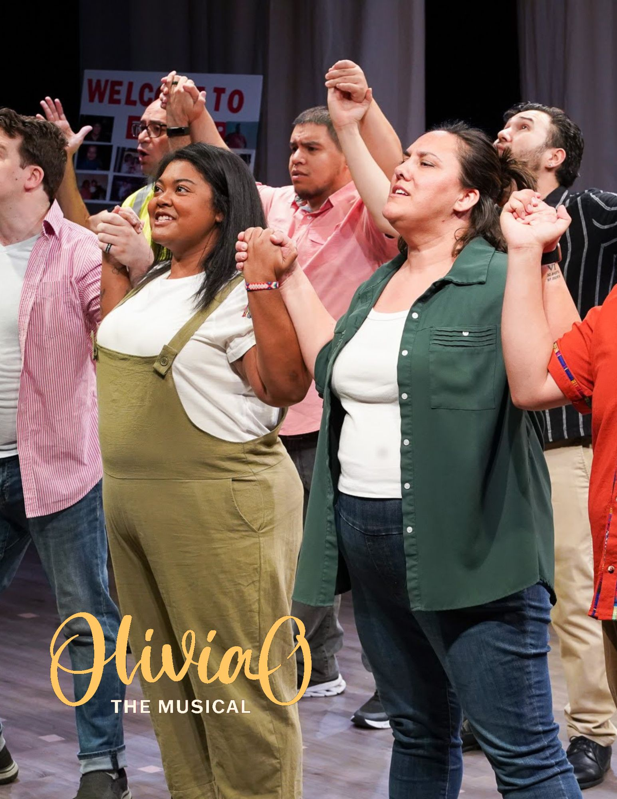

June 30 - July 12, 2026
Factory Theatre Mainstage

This guide uses plain language to provide audiences, particularly neurodiverse audiences, with specific sensory details of programming in advance to help guide your experience.

Table of Contents

About Olivia O Musical | ………………………………. | 3
Run Time | ………………………………. | 3
Content Warnings and Advisories | ………………………………. | 3
Cast and Characters | ………………………………. | 4
Set | ………………………………. | 8
Costumes | ………………………………. | 10
Get in Touch | ………………………………. | 12

About Olivia O Musical
Olivia O, The Musical tells the story of Olivia Ortiz, a 14 year undocumented migrant who is separated from her mother at the US-Mexican border.
Facing the loss of her mother, Olivia must maintain her hope, kindness and strength of will as she tries to unite with her American aunt she’s never met.
​
As Olivia struggles to adjust to a foster home that isn’t what it seems to be, and faces an immigration raid, her aunt Isabel builds a radical new network of support and activism as she fights against a system that is more powerful than she realized.

Run Time
90 minutes with no intermission

Content Warnings and Advisories
Please be advised that Olivia O Musical confronts the politically sensitive issue of migration, immigration policies and the movement of people across borders. It contains some minor violence, scene of family separation, scene of an immigration raid, and sounds of sirens and gunshots.

Cast and Characters

  Valeria Aceves | Olivia Ortiz (14) Olivia is the titular character and protagonist of the show. Facing the loss of her mother, and the cruelty of the system she’s caught in, she must maintain her hope, kindness and strength of will in order to survive.
  Ceci Nicoli | Isabel Castillo (27) Olivia’s newly-found aunt, Isabel was hoping to offer a new life to her niece, but now finds herself stuck in the neverending maze that is the immigration system. Strong willed and determined, she knows she has to emerge from her shell and understand more about her own past if she wants to find her family and create the life she wants.
  Kevin Forster | Guy Madden (30) A journalist-turned- activist who wears his heart on his sleeve. Guy continues to put the cause before himself, even as he struggles with anxiety from a past run-in with the border police, and the threats/risks of being a public-facing activist.
  Veronica Marín-Estrada | Gloria Ramirez (17) An undocumented immigrant who meets Olivia at the detention center. She appears tough, bitter and jaded when we first meet her, however we soon realise her sharp edges hide an inner vulnerability. She is trying to protect herself and survive in a world full of ‘monsters’ and cuts/scratches her wrists to relieve her anxiety.
  Luke Marty | Bill Collins (58) A charismatic pastor turned controlling foster parent. Bill sets his sights on rebuilding his failing TV ministry with a new family that can’t fight back.
  Jada Rifkin | Nancy Collins (57) The other half of Olivia’s foster family. Nancy has stood by Bill’s side through thick and thin, but may soon find her limit when Bill’s scheming comes into conflict with her beliefs.
  Cristian Wadsworth Vargas | Luis Martinez (31) A community leader, activist and long time friend of Guy, Luis likes to enjoy himself and have fun, while putting everything on the line and working passionately for a cause and community he believes in.
  Gabriela Velasquez | Jen Martinez (31) A co-leader of the immigration justice group along with her husband Luis, Jen is a community builder and organizer. Her growing friendship with Isabel and concern for Olivia’s plight moves her to activate the women of El Paso in support of the cause.
  Samuele Galli  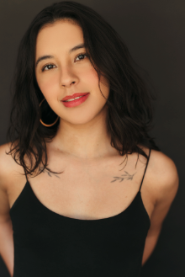  Fatima Sanchez  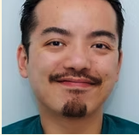  Anthony Chow    Cristina Paoletta    Ana Sofía Ferrer    Nick Ritchey | Ensemble / El Pasoans  The ensemble characters are a mix of six men and women representing the ordinary people of El Paso. Roles played include:  - Gabriella Ortiz (38) Olivia’s mother (and also a memory of her), who gives Olivia the strength she needs to get through this tough time. Played by an ensemble member.  - Detained Girls  - Guards/ICE Officers  - Working People (nurse, shipper, coffee kiosk owner, day laborers, volunteers, a ‘fan’)  - Immigration Community members - family members of detained/deported people who share stories with Isabel (Dia, Miguel, & Anna) and women volunteers who join Isabel and Jen as they pass out information pamphlets outside the courthouse (Favianna, Pat, Sophie)  - Carlos - Gloria’s uncle who runs a local coffee shop/kiosk  - Eric - Gloria’s older cousin (and co-worker at her uncle’s coffee shop)

Set
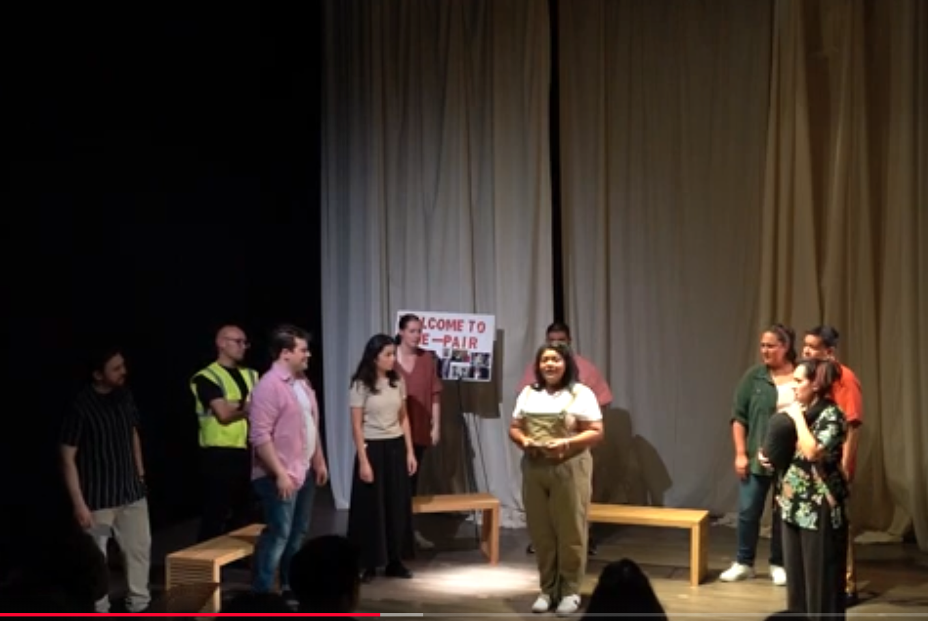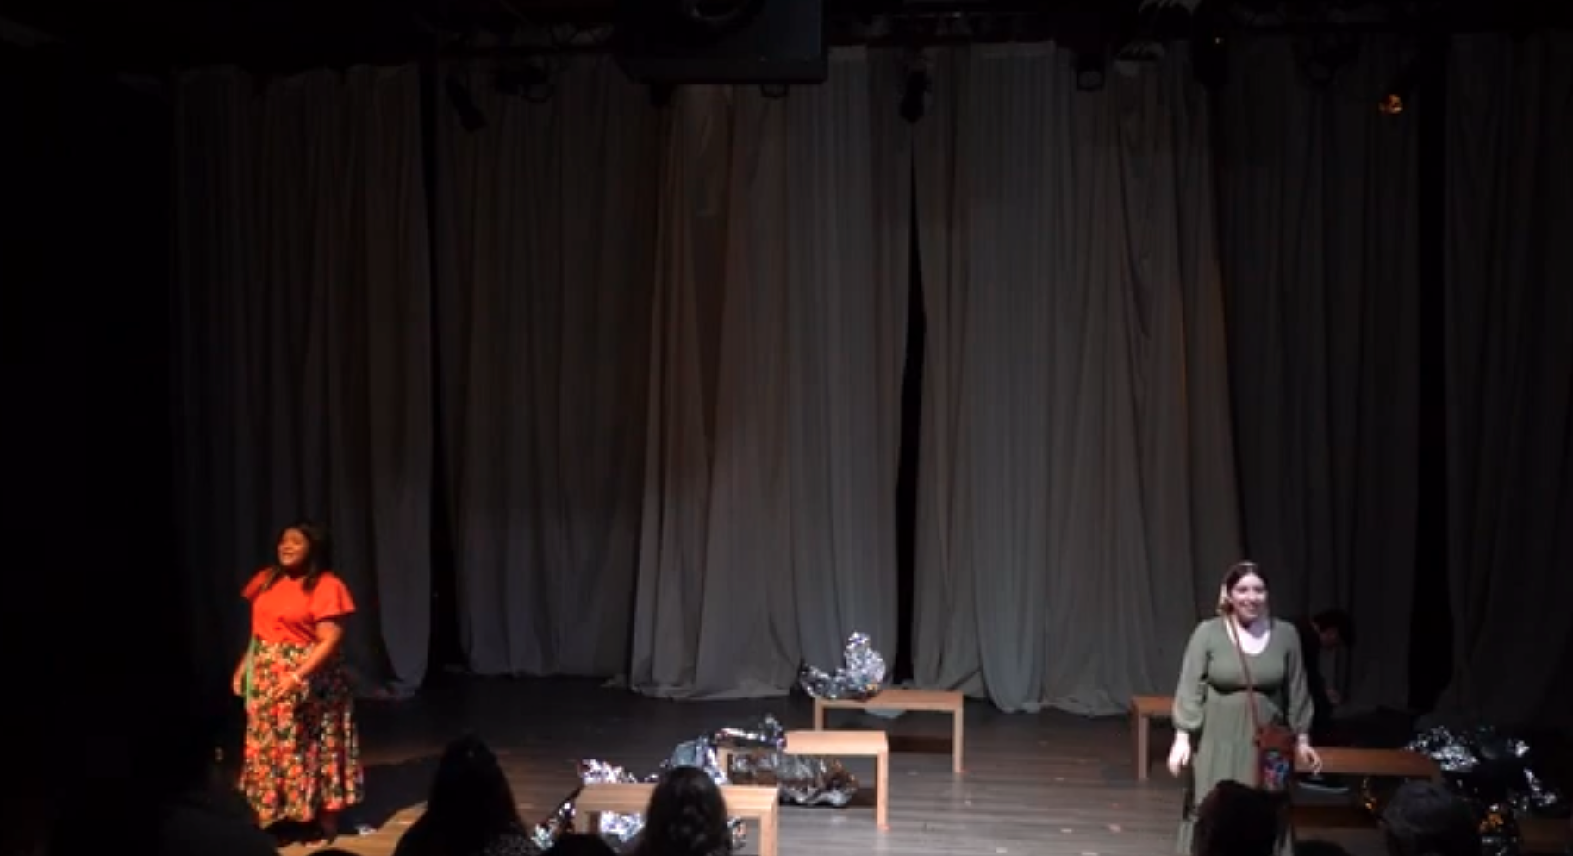

The story is set in El Paso, TX, in the immigration detention center and surrounding community. The set for the detention center is sparse, with silver ‘emergency’ blankets and benches. There are a number of scenes in a church-basement style setting with chairs/tables and a bulletin board. There is also a scene in an outdoor public square with minimal tables set up and some plants. We use projections to show the backdrop of the El Paso cityscape.

Costumes

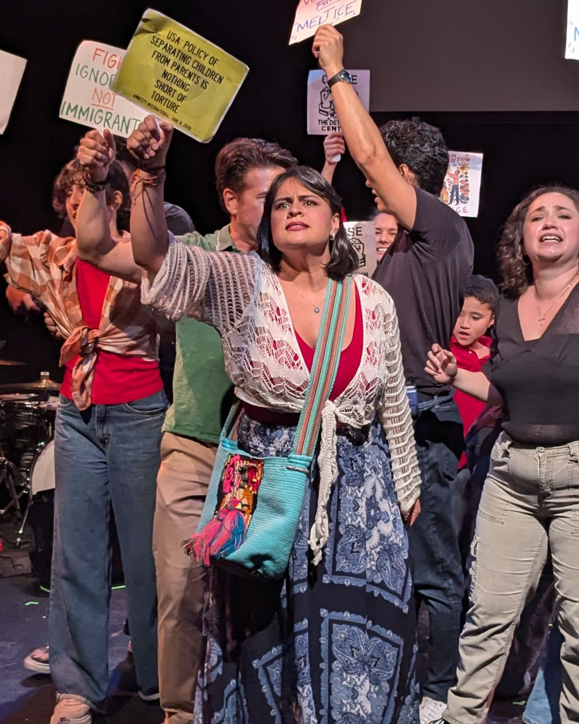

The story is set in 2017 in El Paso, Texas. The costumes are everyday wear such as jeans and t-shirts, typical of the time and location. The Latina characters sometimes wear latin-american style accessories such as scarfs and colourful fabric bags. During the “Guardian Angel” song, the cast wear stoles such as what you’d see in a church choir.

Get in Touch
If you have any questions or concerns about this access guide or planning your visit to Olivia O Musical at the 2026 Toronto Fringe Festival, please reach out.

Diane Currie Sam
Writer/Producer
Email: diane@beabetterstory.com
Phone: 604 788 8044

If you want to tell the Fringe about your experience or have feedback that you would like to share, you can call, write, or send an email to the Fringe.

Our address is:
100 Broadview Avenue, Suite 300
Toronto, ON
M4M 3H3

Our email address is:
access@fringetoronto.com

Our phone number is:
416-966-1062

Thank you for coming to the 2026 Toronto Fringe Festival.

