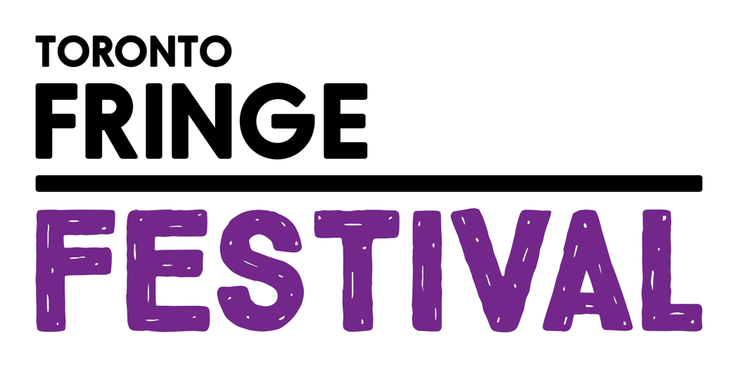

A Comedy Show at the End of the World
Access Guide

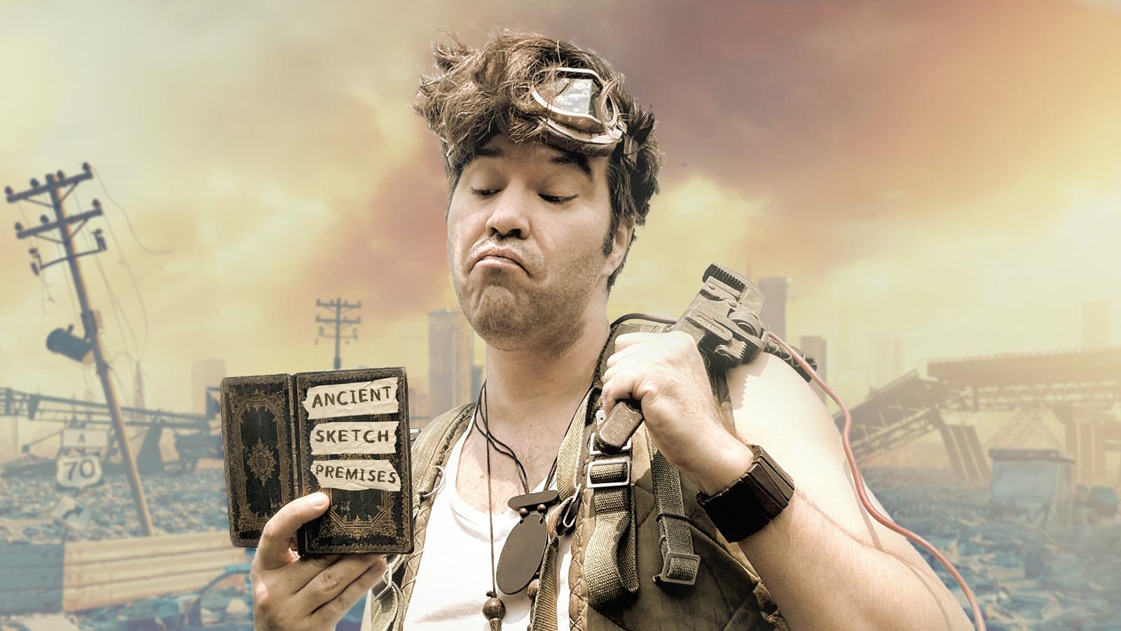

June 30 - July 12, 2026
Factory Studio Theatre

This guide uses plain language to provide audiences, particularly neurodiverse audiences, with specific sensory details of programming in advance to help guide your experience.

Table of Contents

Access Measures 3

About A Comedy Show at the End of the World 4

Run Time 4

Content Warnings and Advisories 4

Cast and Characters 5

Set 6

Costumes 7

Get in Touch 8

Access Measures
This show does not currently feature relaxed or interpreted performances, TBI equipment or a touch book.

About A Comedy Show at the End of the World
“A Comedy Show at the End of the World” is a play about Johnny, a sketch comedian still trying to pursue a career in comedy years after the apocalypse, putting on a show for the people in his settlement. Over the course of the show he plays several different characters in a series of one-man sketches, while at the same time flashbacks and stories from his past tell us more about who he used to be before the fall of civilization. As numerous obstacles and distractions interfere with the show, Johnny re-examines why comedy is important in difficult times, and comes to think of himself less as someone who is going to save the world all on his own and more as someone who provides cheer and comfort to his community.

Run Time
60 minutes with no intermission

Content Warnings and Advisories
Please be advised that A Comedy Show at the End of the World depicts and references violent themes, including a mimed one-person fist fight, a prop machete, an acted-out death on the battlefield, and several mentions of tropes in the post-apocalyptic genre including mentions of war and the destruction of cities, references to executions, images of skeletons, audible gunfire and combat.

The show also features occasional use of coarse or mature language, sudden noises including a door being broken down, cannon fire and one scene with a loud repetitive horn.

At one point in the show, Johnny will enter the audience space to give an object to a random audience member.

Cast and Characters
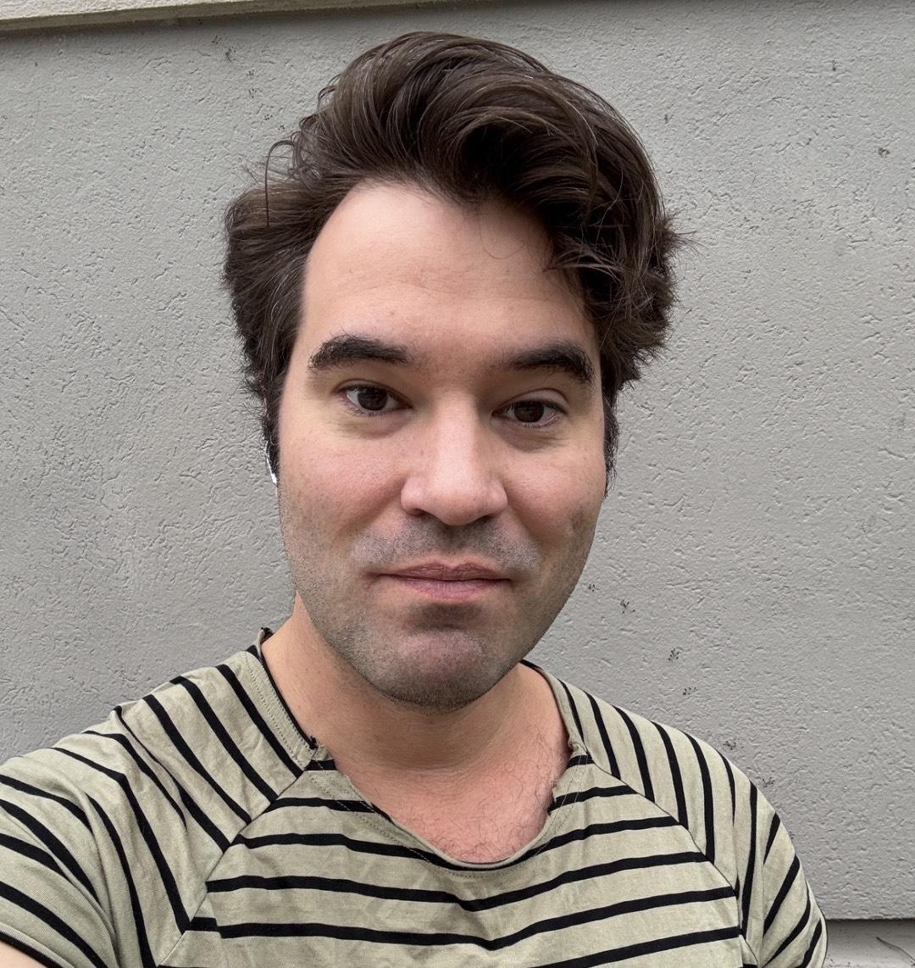
JON BLAIR plays the role of JOHNNY, a former television comedian still pursuing a career in comedy in the post-apocalypse. Over the course of his show he portrays a number of other characters, including a billionaire who owns a mountain, a wounded revolutionary, and a man emotionally-scarred from his time stranded alone in the woods. Blair also voices a number of other characters heard over audio, such as the wasteland’s barbaric warlord, a woman broadcasting details of a mutant attack, and various people from Johnny’s past.

Set
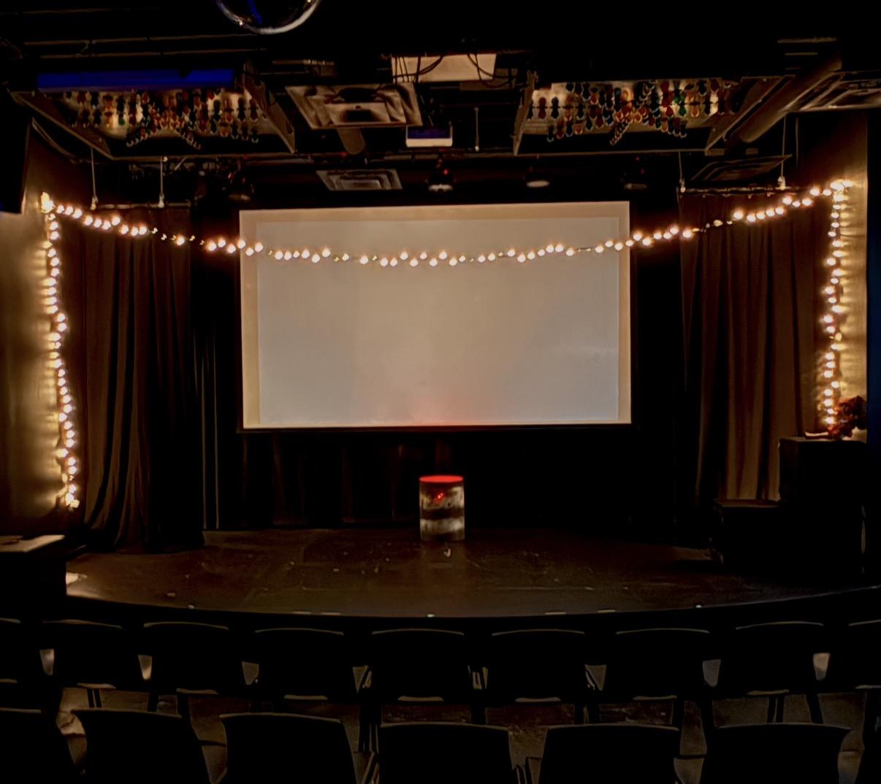

The show takes place in the Factory Studio theatre, a narrow room with seating on risers and a medium-sized stage. The set design is minimal, with a fake bonfire in a barrel set centre-stage and some string lights and electronic candles scattered around. There is currently going to be occasional projection on the rear wall or curtain. Changes in set are accomplished by projection or by minor changes in onstage set pieces - at one point projected backdrops are used to portray a flashback to a bar, and at another time a dingy backstage area. Throughout the show a partially singed and reconstructed doll sits off to the side. Lighting involves frequent blackouts between sketches, occasional use of spotlights or red lighting.

Costumes
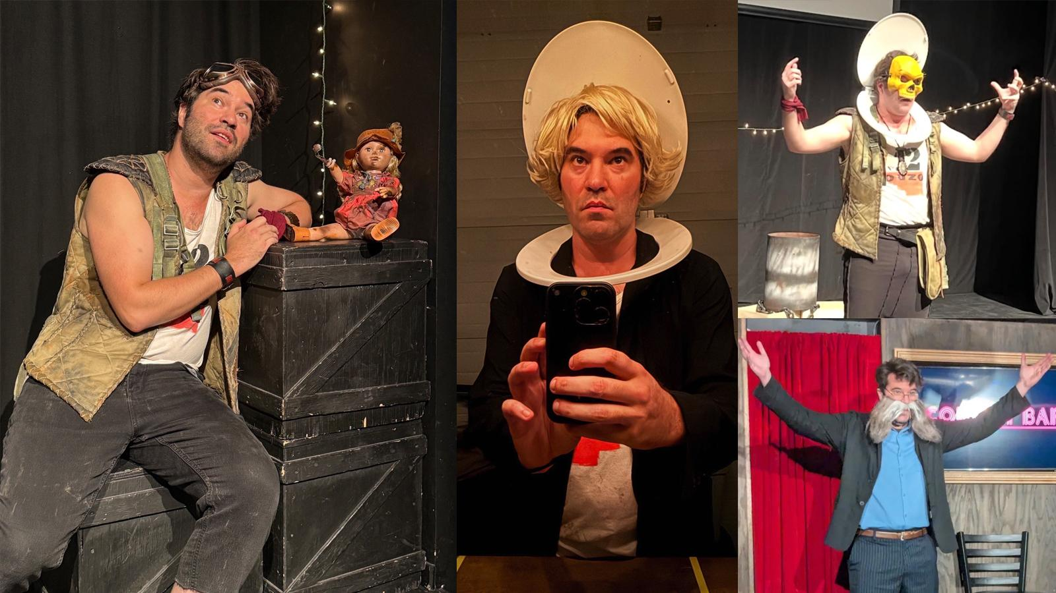

Johnny’s main costume consists of a dirty tank top, a patchwork armored vest, motorcycle goggles and sweatpants. He also wears a few random accessories around his wrists and neck.

Over the course of the show he plays other characters with minor variations in costume, including:
- A patchwork blazer, glasses and a large moustache
- A sleeveless shirt and 1980s style sunglasses
- A ragged cardigan and fake beard
- A patchwork blazer and scarf, while briefly wielding a sword
- A blazer and blonde wig, while wearing a toilet seat around his neck
- A yellow skull mask, while wearing a toilet seat around his neck.

Get in Touch
If you have any questions or concerns about this access guide or planning your visit to SHOW NAME at the 2026 Toronto Fringe Festival, please reach out.

Jon Blair
Creator/Performer
Email: itsjonblair@gmail.com

If you want to tell the Fringe about your experience or have feedback that you would like to share, you can call, write, or send an email to the Fringe.

Our address is:
100 Broadview Avenue, Suite 300
Toronto, ON
M4M 3H3

Our email address is:
access@fringetoronto.com

Our phone number is:
416-966-1062

Thank you for coming to the 2026 Toronto Fringe Festival.

