

Finding Jamie

Access Guide

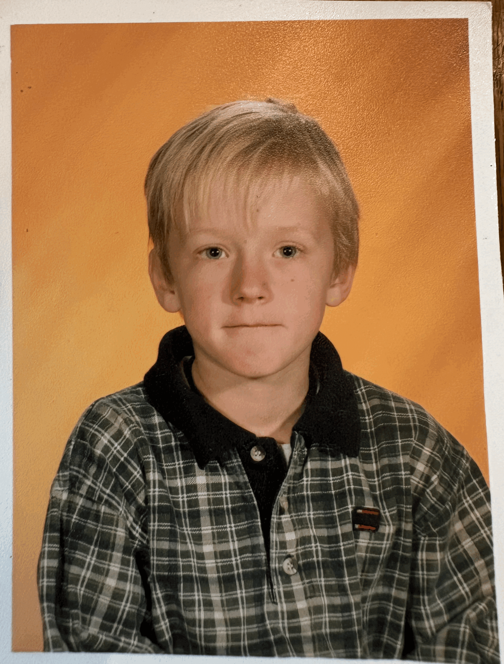

June 30 - July 12, 2026
Video Cabaret - Deanne Taylor Theatre
This guide uses plain language to provide audiences, particularly neurodiverse audiences, with specific sensory details of programming in advance to help guide your experience

About Finding Jamie
Part romantic comedy. Part coming-of-age tale. Part mystery. The story of a teacher searching for a missing student on a field trip. The story pre-dominantly features flashbacks to the teacher’s childhood.

Run Time
60 minutes with no intermission

Content Warnings and Advisories
Please be advised that Finding Jamie includes some mild mature language

Cast and Characters

Zac plays the role of all characters in the show. Including the protagonist, Jamie. He plays Jamie in the present day, as a 32 year old teacher. He also plays Jamie as a 6 year old during flashbacks to his childhood.
HEADSHOT

Set

The set is minimalist. The show is performed in the round.

Costumes

The protagonist, Jamie, is dressed as a grade 8 school teacher,

Get in Touch
If you have any questions or concerns about this access guide or planning your visit to SHOW NAME at the 2026 Toronto Fringe Festival, please reach out.

Zac Williams
Show Creator
Email: zac.b.williams@gmail.com
Phone: 604 315 0596

If you want to tell the Fringe about your experience or have feedback that you would like to share, you can call, write, or send an email to the Fringe.

Our address is:
100 Broadview Avenue, Suite 300
Toronto, ON
M4M 3H3

Our email address is:
access@fringetoronto.com

Our phone number is:
416-966-1062

Thank you for coming to the 2026 Toronto Fringe Festival.

