

who? hú? 狐
Access Guide
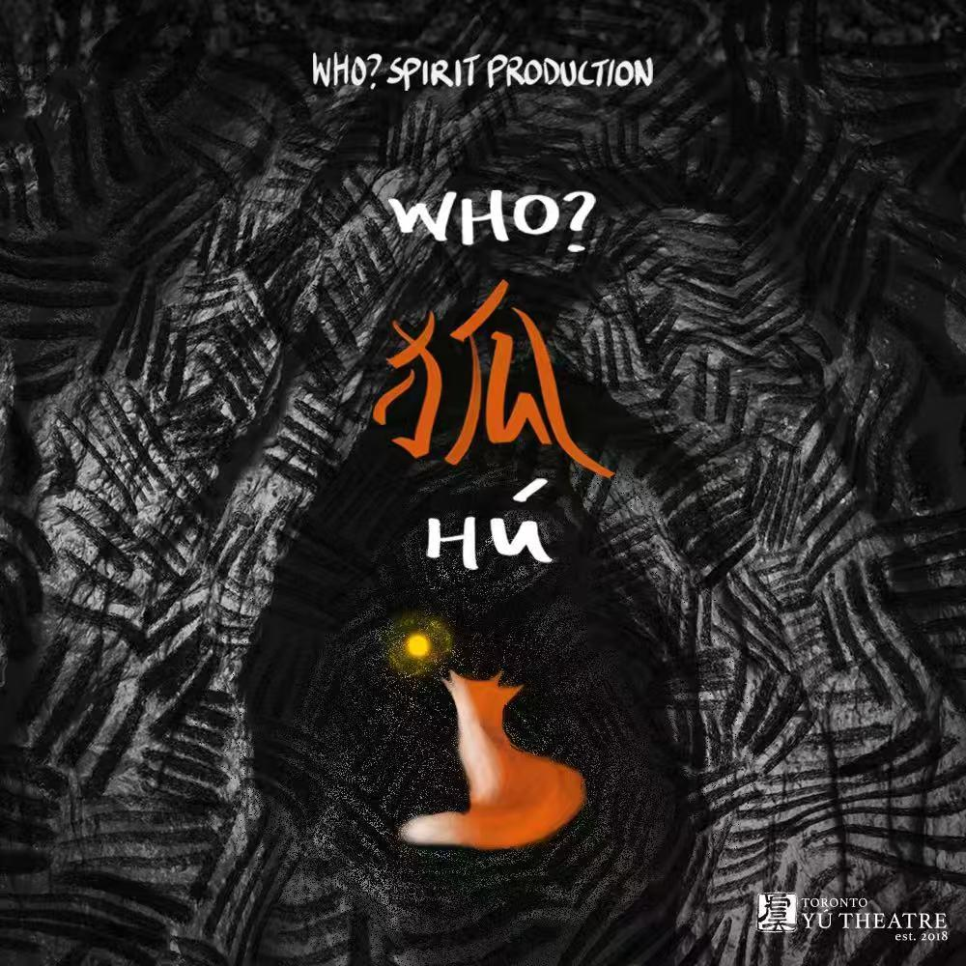

June 30 - July 12, 2026
Tarragon Theatre Mainstage

This guide uses plain language to provide audiences, particularly neurodiverse audiences, with specific sensory details of programming in advance to help guide your experience.

Table of Contents

Access Measures 3

About who? hú? 狐 4

Run Time 4

Content Warnings and Advisories 4

Cast and Characters 5

Set 7

Costumes 8

Get in Touch 9

Access Measures
Relaxed Performance

Relaxed performances are open to everyone, but the environment has been specifically adapted for those who are neurodivergent and may experience sensory sensitivities, folks with communication or learning disabilities, and people who would benefit from a more relaxed environment.

The 7:30pm performance on July 8th will be a relaxed performance.

About who? hú? 狐
who? hú 狐 is a bilingual play set in the aftermath of a shattered world. In a cave on the edge of survival, two immigrants struggle to protect the fragile life they have built together. When a mysterious stranger arrives — a fox that may be more than a fox — the boundaries between human and animal, trust and hunger, myth and violence begin to dissolve.

Run Time
60 minutes with no intermission

Content Warnings and Advisories
Please be advised that who? hú? 狐 includes adult content and language, racial slurs/racism, and violence.


Cast and Characters
HEADSHOT
Antong Xu plays the role of Fox
A fox spirit who appears in animal form and human forms: one with the image of a Northern Chinese person, another white-passing with possibly Asian features.


Jing Cui plays the role of C
A first-generation Chinese immigrant woman with broken glasses and severely impaired vision.


Muhammad Akbar Lashari plays the role of Hamza
A 1.5-generation immigrant from West Asia.
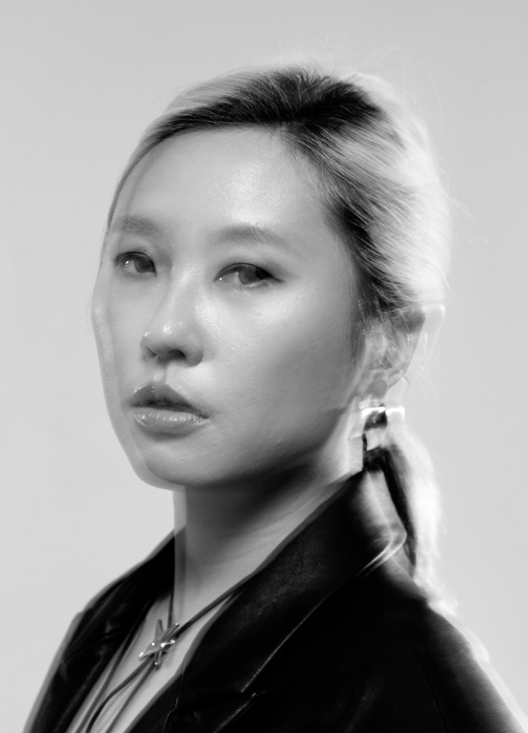
RX Wang plays the role of White Ghost
A white-clothed figure with an energetic, childlike physicality.

Set
PHOTO OF SET

Describe your set to the best of your ability here. If the set changes throughout your show, insert multiple photos and descriptions.

Several translucent fabric pieces covered in ink painting style brushwork will be hung across the stage, with some overlap between the pieces. They depict the rock structures that form a cave, where the protagonists hide out and live in a post-apocalyptic world. The translucent nature of the fabrics will help delineate the inside/outside spaces (inside and outside the cave), while representing the transient/ephemeral nature of this temporary living space/arrangement.

Costumes
PHOTO OF COSTUME

Describe the costume to the best of your ability here. Insert a photo for each and description for each costume.

All three actors will be dressed for a post-apocalyptic world — mismatched, scavenged pieces that are worn and not too clean, but very comfortable to move in. Hamza will also have a blond wig that helps him camouflage his race.
The Fox transforms into his true spirit form at one point, which consists of a highly stylized, human-sized puppet.

Get in Touch
If you have any questions or concerns about this access guide or planning your visit to who? hú? 狐at the 2026 Toronto Fringe Festival, please reach out.

Contact Name
Title/Position: Nick Fangzheng Wang
Email: info@yutheatre.com
Phone: 613-929-1694

If you want to tell the Fringe about your experience or have feedback that you would like to share, you can call, write, or send an email to the Fringe.

Our address is:
100 Broadview Avenue, Suite 300
Toronto, ON
M4M 3H3

Our email address is:
access@fringetoronto.com

Our phone number is:
416-966-1062

Thank you for coming to the 2026 Toronto Fringe Festival.

