

FIRST KISS
Access Guide
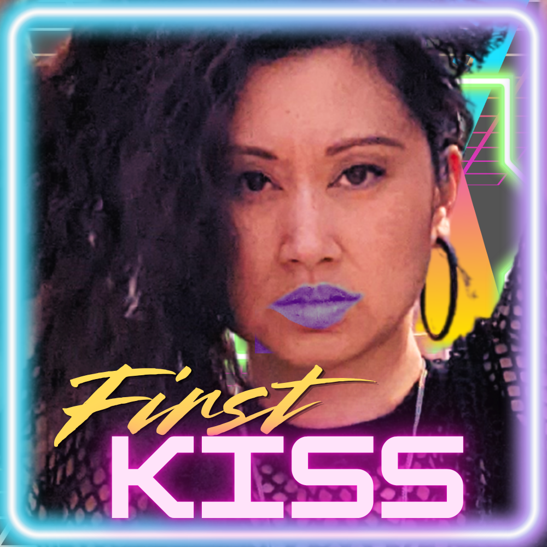

July 3 - July 11, 2026
Aki Studio Theatre

This guide uses plain language to provide audiences, particularly neurodiverse audiences, with specific sensory details of programming in advance to help guide your experience.

Table of Contents

Access Measures 3

About First Kiss 5

Run Time 5

Content Warnings and Advisories 5

Cast and Characters 6

Set 7

Costumes 8

Get in Touch 9

Access Measures
Relaxed Performance

Relaxed performances are open to everyone, but the environment has been specifically adapted for those who are neurodivergent and may experience sensory sensitivities, folks with communication or learning disabilities, and people who would benefit from a more relaxed environment.

The 12:45pm performance on Sunday, July 5 will be a relaxed performance.

ASL Interpreted Performance

ASL interpreted performances are specifically designed to provide access to performances for audience members who are d/Deaf and/or hard of hearing. These performances feature ASL-English and/or Deaf interpreters who interpret all dialogue into American Sign Language (ASL) in real time, either on stage or to the side of the stage.

The 6:30pm performance on Wednesday, July 8, 2026 will be ASL interpreted by TBC - INTERPRETER NAMES.

Tactile Body Immersion (TBI) Chair

The ImmersX Tactile Body Immersion (TBI) Chair allows patrons who are d/Deaf, Hard of Hearing, or deafblind to experience music and other sounds through vibrations that are channeled through the seat and back rest of the chair.

The TBI Chair will be available at the TIME - TBC performance on TBC.

Touch Book

Touch books offer a tactile experience of various elements of the set, props, and costumes through touch. Touch books allow patrons from the blind and low vision community to enjoy a more complete experience of a show through touch.

A touch book will be available at the Front of House area for all performances.

About FIRST KISS
This story is set in the 1980s. A teen desperately wants to get her first kiss before she turns 16. She imagines her first kiss to be like the popular romcoms of the day, movies that she watches obsessively and sees herself starring in. But reality hits as she starts to realize that in all the movies, there's no one who looks like her. Nobody who is Asian. Unless it's being the butt of the joke like the racist depiction of Long Duk Dong.

So if she is going to accomplish her goal, she will have to battle that internalized racism and love herself for who she is. Once she does, she will be able to soar in the air like in Dirty Dancing.

FIRST KISS is a one-woman show where the actor is playing 5 different roles. She will also be acting out some scenes from 1980s rom coms. She will be dancing and singing too. There will be a live band.

Run Time
50 minutes with no intermission

Content Warnings and Advisories
Please be advised that FIRST KISS includes/mentions/references/depicts…
-racist stereotypes against Asians

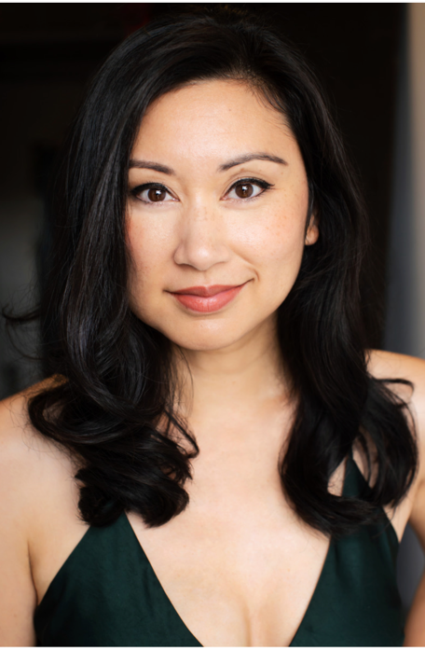
Cast and Characters
JOSETTE JORGE plays multiple roles:
1. FIONA MAY WONG, almost 16. She daydreams she's the romantic lead in 1980s movies, but it's far from reality. Plays piano. Awkward, shy, not part of the in-crowd. Has never kissed a boy but really really wants to.

2. MOM, (CONNIE WONG) 40s. Stay-at-home mom who sells Avon between chauffeuring her children to their various extra-curricular activities while her husband works at Hamilton's Dofasco steel factory. She has a mild Chinese-Filipina accent that emerges when she's angry.

3. MARCIE TRAVIS, 16. Fiona's best friend. Not part of the in-crowd but doesn't care. Bubbly personality who can’t wait to regale you with her tales. Has kissed many, many boys.

4. CHEERLEADERS, 15-18. They are the "in" crowd girls. Dress the same, talk the same, move as one. Like robots.

5. RJ GRADY, 19. Jock and heartthrob. Could be on the cover of Teen Vogue or Sweet Valley High.

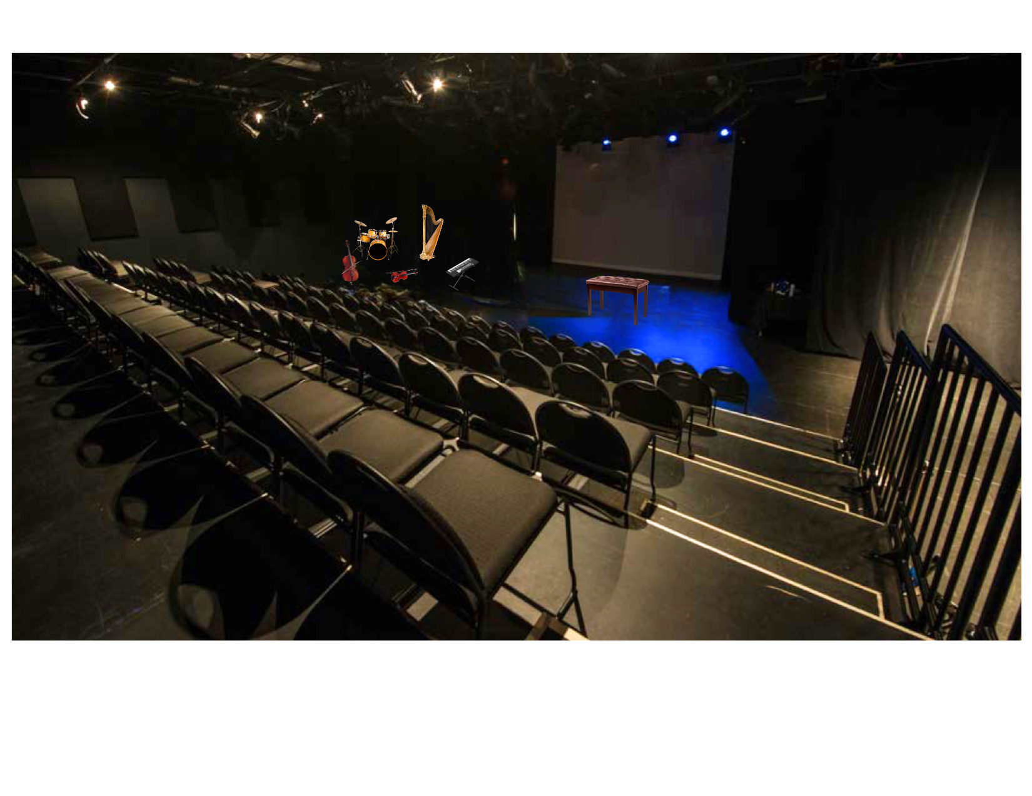
Set

The theatre is a black box stage. There will be a 5-piece band on the left, with drum kit, cello, violin, keyboards and harp. At the centre of the stage, there will be a piano bench. There will be a few projections at the back of the stage throughout the performance.

Costumes
PHOTO OF COSTUME

The costume has not been decided yet.

Get in Touch
If you have any questions or concerns about this access guide or planning your visit to SHOW NAME at the 2026 Toronto Fringe Festival, please reach out.

Nathalie Younglai
Writer-Producer
nathalieyounglai@gmail.com

If you want to tell the Fringe about your experience or have feedback that you would like to share, you can call, write, or send an email to the Fringe.

Our address is:
100 Broadview Avenue, Suite 300
Toronto, ON
M4M 3H3

Our email address is:
access@fringetoronto.com

Our phone number is:
416-966-1062

Thank you for coming to the 2026 Toronto Fringe Festival.

