

Sincerely, E
Access Guide

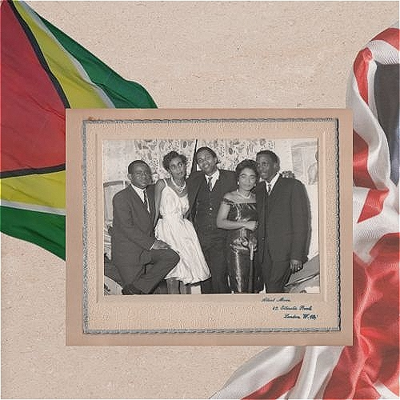

June 30 - July 12, 2026
Soulpepper Theatre's Kevin & Roger Garland Cabaret

This guide uses plain language to provide audiences, particularly neurodiverse audiences, with specific sensory details of programming in advance to help guide your experience.

Table of Contents

Access Measures 3

About Sincerely, E 4

Run Time 4

Content Warnings and Advisories 4

Cast and Characters 5

Set 6

Costumes 7

Get in Touch 8

Access Measures
Relaxed Performance

Relaxed performances are open to everyone, but the environment has been specifically adapted for those who are neurodivergent and may experience sensory sensitivities, folks with communication or learning disabilities, and people who would benefit from a more relaxed environment.

The 8:15 PM performance on July 6 will be a relaxed performance.

The 1:00 PM performance on July 9 will be a relaxed performance.

About Sincerely, E
Sincerely, E is an intimate portrait of a young Caribbean woman forging a new life across oceans. Set between 1960s London and Toronto, it follows her journey through migration, love, and the search for belonging. Rooted in the legacy of the Windrush generation, it is a story of resilience and home.

Run Time
55 minutes with no intermission

Content Warnings and Advisories
Please be advised that Sincerely E, contains themes of racism, mature language, loud noises, strobe lighting and depictions of implied violence.

Cast and Characters
Siarra Burke-Smith plays the role of Eselynn (Ese).Our lead character.
HOT

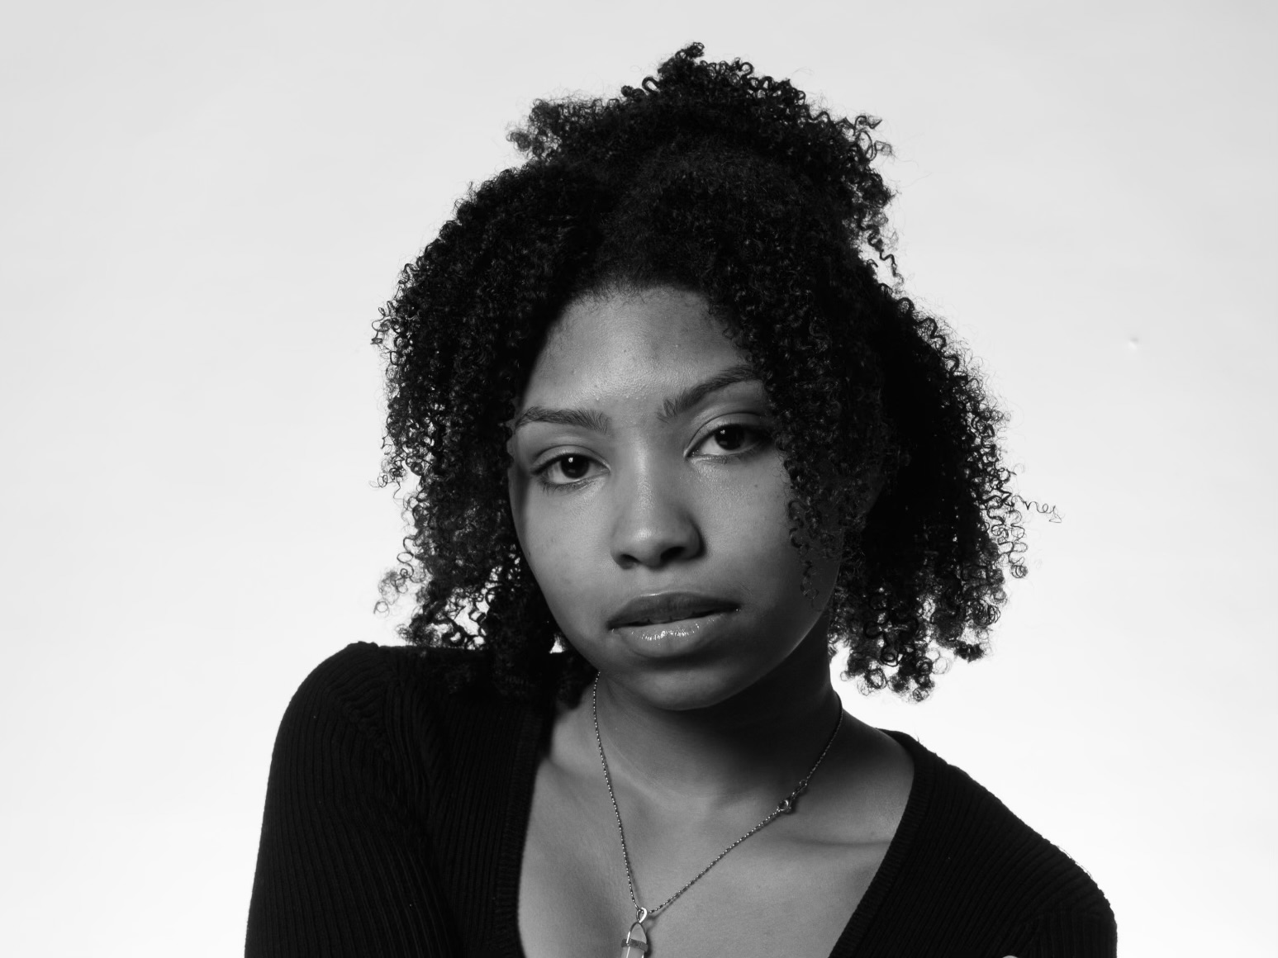
Zaniq King plays the role of Rose. Eselynn’s best friend and confidant.

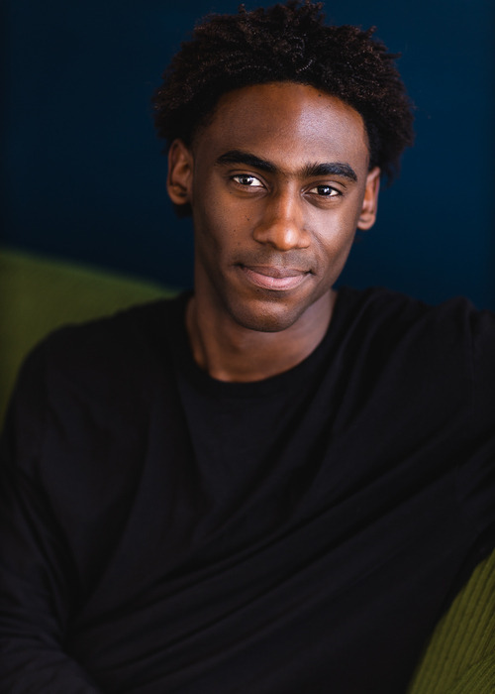
Jonathan Isaiah Tucker plays the role of Thomas. Eselynn’s love interest.

Ophilia Davis plays the role of Mama, mother of Eselynn. She also plays Eselynn’s sister, Anita.
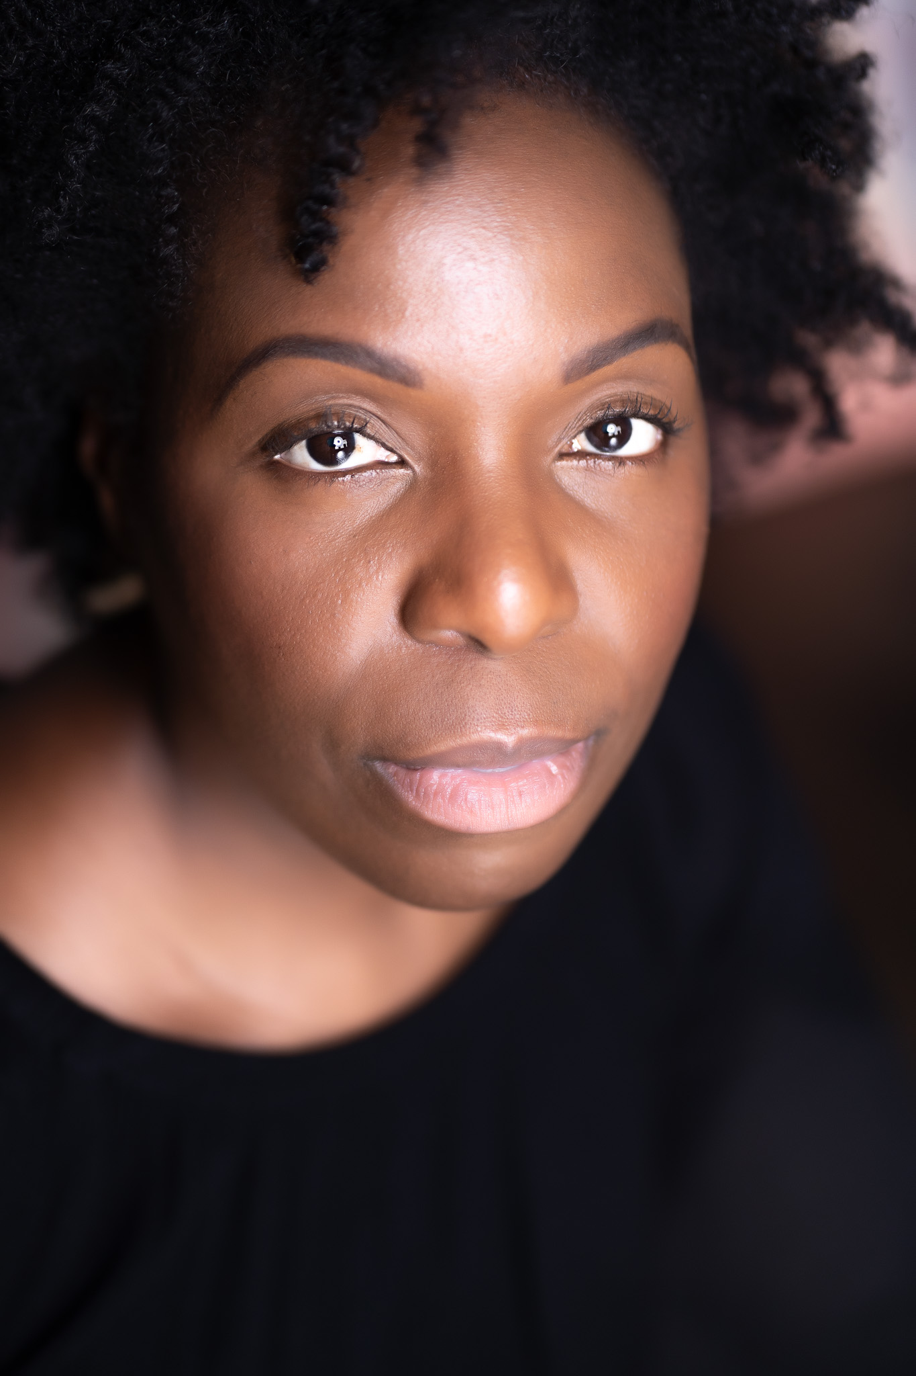

Set
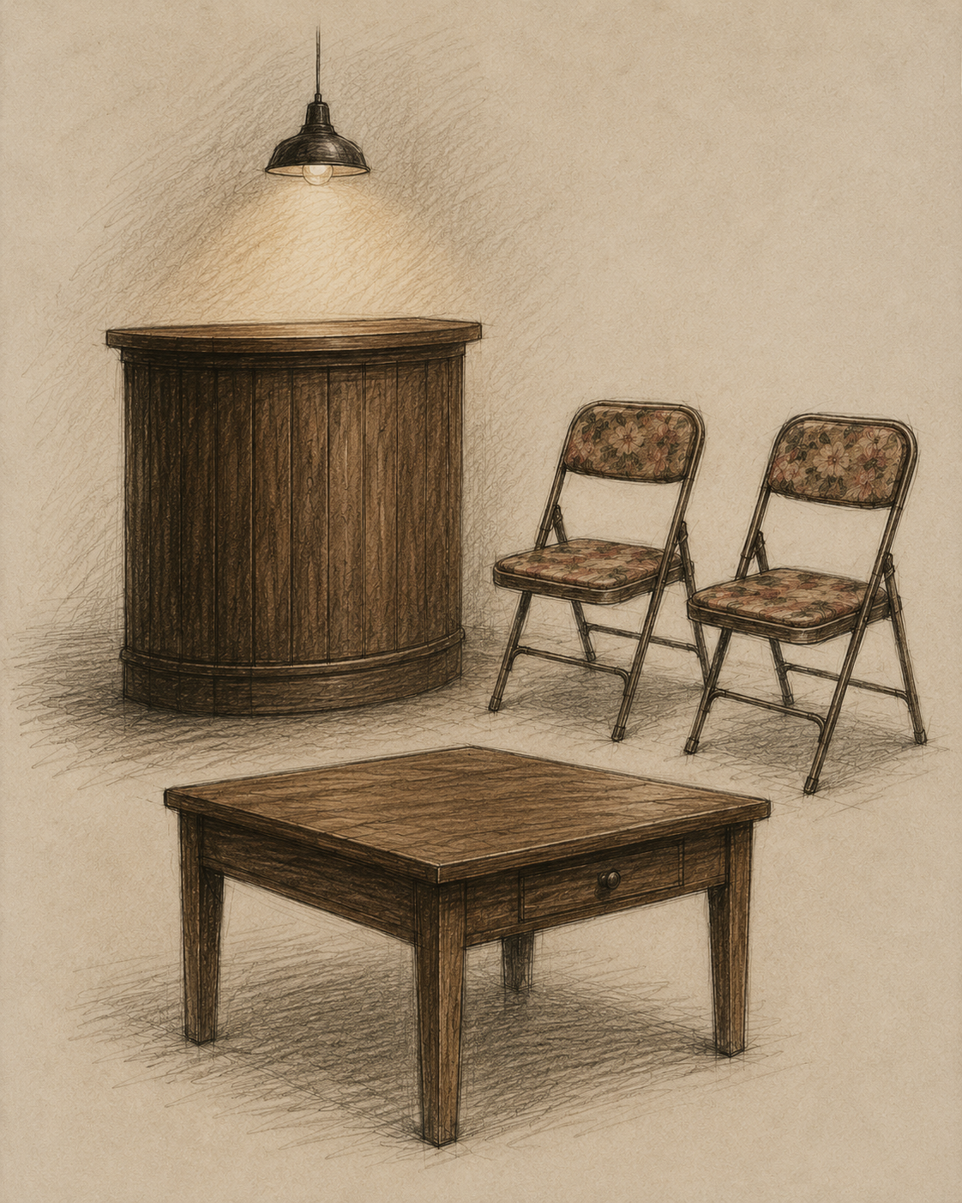

Sincerely, E takes place in an after-hours club in London, England, in the late 1960s. The story unfolds between a small club bar and a modest arrangement of chairs and a table.

The set remains largely unchanged throughout the performance.

Costumes
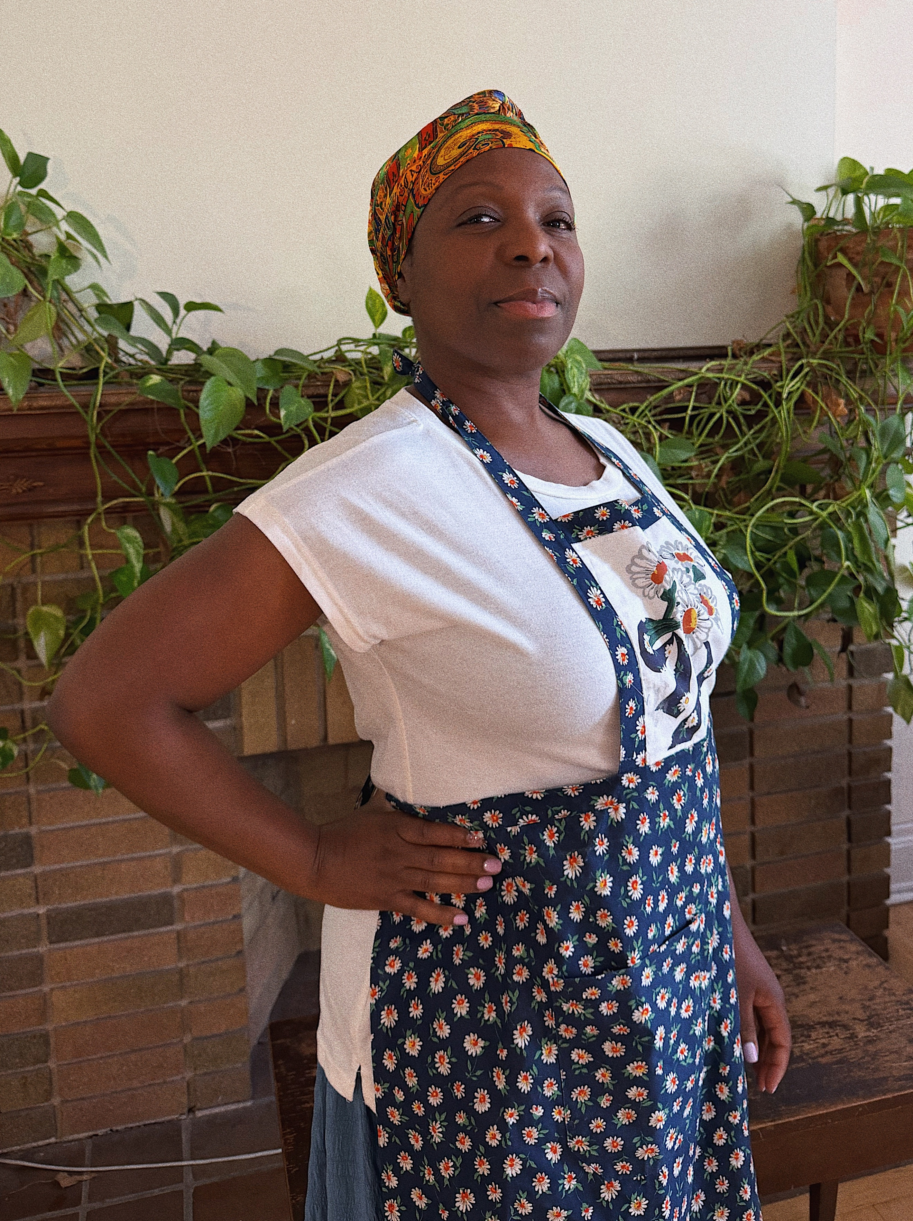

Mama is wearing a multicoloured headscarf, a white T-shirt, and a blue apron printed with sunflower designs. She pairs these pieces with a long blue skirt.

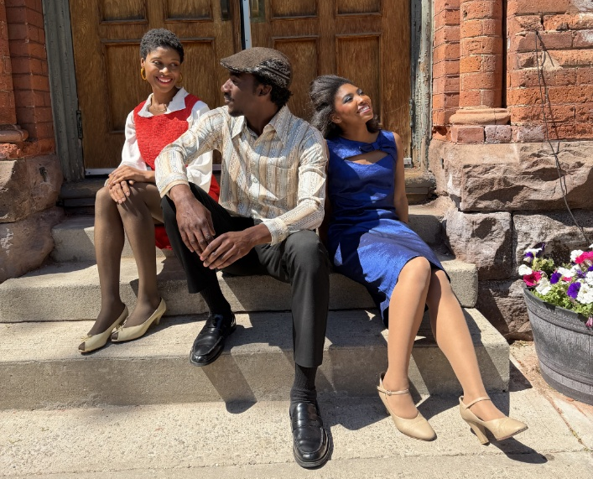

(From left to right)

Eselynn is wearing a red midi dress with white sleeves that billow at the wrists. She completes the look with beige open-toe heeled shoes.
Thomas is dressed in a multicoloured long-sleeve silk shirt, black dress pants, and slightly shiny black dress shoes. He also wears a textured brown cap.
Rose is wearing a dark blue midi-length dress featuring a cut-out detail at the neckline. She pairs the dress with beige heels.

Get in Touch
If you have any questions or concerns about this access guide or planning your visit to Sincerely, E at the 2026 Toronto Fringe Festival, please reach out.

Neisha Pierre
Director/ Producer
Email: Neishapierre@live.com

If you want to tell the Fringe about your experience or have feedback that you would like to share, you can call, write, or send an email to the Fringe.

Our address is:
100 Broadview Avenue, Suite 300
Toronto, ON
M4M 3H3

Our email address is:
access@fringetoronto.com

Our phone number is:
416-966-1062

Thank you for coming to the 2026 Toronto Fringe Festival.

