COMPANY HISTORY
Benny the Bullet Productions was formed in 2018 by Kerri Salata to honour her late grandfather, Benny Salata, who was the inspiration for the main character, Benny the Bullet, in her grandmother’s best-selling children’s novel Mice at Centre Ice, later made into an animated feature film, Tales of the Mouse Hockey League.
The book’s author, Estelle Salata, taught her granddaughter Kerri that girls can be and do anything, leading by example – Estelle is a successful author who received her degree after raising four children. This is an important lesson, and one that Kerri, who, aside from being this play’s author/adapter, is a lawyer and competitive hockey player, wanted to pass on to her newborn daughter and KidsFest audiences. While pregnant, the 93 year-old author granted permission to adapt her original children’s novel for the stage. Kerri formed Benny the Bullet Productions in order to present Mice at Centre Ice at this year’s Toronto Fringe.
Joining her in this family affair are her father Michael on music, and her aunts Paula and Kathy, who design the costumes. Included in the team are Fringe favourites, The Lactors’ Studio (of whom Kerri is a founding member.) The Lactors’ Studio’s first foray in the Toronto Fringe was 2014’s acclaimed Watching Seana McKenna Watch Paint Dry. These lawyer-actors returned as gods and divas in In Gods We Trust, performed at the Toronto Fringe in 2016.
The Lactors’ Studio is not new to the Fringe. Comprised (almost) entirely of “lactors” (lawyer/actors) with dramatic tendencies who met while performing in Nightwood Theatre’s Lawyer Show annual fundraising productions of Shakespeare comedies, The Lactors’ Studio’s first foray in the Toronto Fringe was 2014’s acclaimed Watching Seana McKenna Watch Paint Dry. These lawyer-actors returned as gods and divas in In Gods We Trust, performed at the Toronto Fringe in 2016. Proceeds from Lactors’ Studio productions are donated to the Toronto Lawyers Feed the Hungry Program – to date, a combined $12,500 has been raised.
Benny the Bullet Productions will be donating all proceeds from the 2019 Toronto Fringe production of Mice at Centre Ice to the Toronto Lawyers Feed the Hungry Program. For more information please visit http://www.lawyersfeedthehungry.ca/toronto.html.
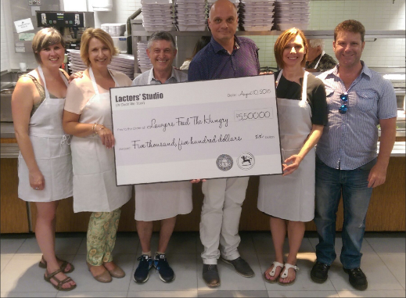
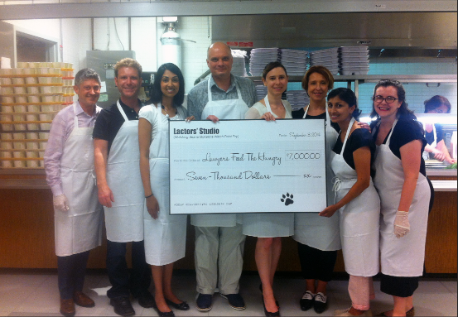

2014 – Donation to Lawyers Feed the Hungry
2016 Donation to Lawyers Feed the Hungry
Company Bios:
Satinder Besrai (Peppy Le Pierre): After spending twenty years practicing criminal law in the courtrooms of Toronto, Satinder decided to rehabilitate herself. Over the years, she has appeared in five plays for Nightwood Theatre’s “The Lawyers Show”, television commercials, and two previous Fringe Festival productions with the Lactors’ Studio.

Paula Eyles (Costume Designer): Paula started sewing at the age of 4 when her mother, Estelle Salata, and grandmother, Alice, taught her to sew. Ever since then she has volunteered to make many costumes for her daughter’s dance company and children’s school plays. She can’t say “no” so she has sewn for anyone who asks for anything for years and years and years! Paula is thrilled to be the lead costume designer and make the mice and rats in her mother’s novel come to life.

Janice Peters Gibson (Benny the Bullet III): Janice Peters Gibson is a theatre-maker originally from Souris, PEI. By day she is Communications Manager for The Company Theatre and most recently produced their Dora Award-winning Jerusalem starring Kim Coates. Selected performance credits: Entertaining Angels (Stage Centre Productions); Villette, Madwoman of Chaillot, Cyrano De Bergerac, All My Sons (Amicus Productions); Dying City (EnLIVEn Productions); Buck, The Stone Princess (Young Public Theatre); How Amazing You Can Be (Kid-Safe Productions). Janice is a graduate of Acadia University’s theatre program and Humber College’s School for Creative and Performing Arts with honours in arts administration. Awards: Thea award for Stage Management.

Peter Hamiwka (Scarface): a founding member of The Lactors' Studio, studied film before taking up law and qualifying as a barrister at the Inns of Court in London. He’s been playing with actors and other artists for years – as a pitcher on a softball team whose motto is “We Play OK”. Peter has also appeared in the first seven Lawyer Show benefit theatrical productions supporting Nightwood Theatre, where he was proud of having had the fewest spoken lines and the best pratfalls.

Ajay Krishnan (Maurice / Jake): Ajay is a linch pin of the show, supplying rehearsal space, occasional snacks, constant good humour and sage millennial advice to his unwoke elders. He also deals with all things digital and performs. Ajay appeared in The Lawyers Show for Nightwood Theatre and the Lactors' Studio shows at the Fringe. After studying law, in an obvious career move Ajay began working for a genetic testing start up where is now. Having rehearsals at his office means he never has to go home.

Gavin Magrath (Figaro the Flyer): Gavin was part of the Lactors’ Studio Fringe productions of In Gods We Trust (2016) as Poseidon, and Watching Seanna McKenna Watch Paint Dry (2014) as Cecil. He has performed with Theatre Etobicoke in The Dining Room, as Mr. Nasty in Funny Money and as Max in Lend Me a Tenor (Thea nominated, Best Actor in a Comedy, 2018), and in fundraisers for Outside the March (Devon, TomorrowLove) and for Nightwood Theatre’s Lawyer Show (Dromio of Syracuse, Comedy of Errors; Benedick, Much Ado About Nothing, Touchstone, As You Like It). Gavin was a professional actor as a child but disappointed his parents by going to university and becoming a lawyer; he now provides advice and advocacy in the fields of international transportation and international human rights law.

Llana Nakonechny (Director / Big Boris): Llana received a BFA in Acting from Brock University and worked with the Orpheus Theatre in Ottawa and the Lakeside Theatre in Essex, UK. She also was a sessional lecturer at Concordia University teaching courses in Developmental Drama, History of Children's Theatre and ensemble acting. After this she became a lawyer, practicing in the area of family law, but also continuing life in the arts, including stints with cabaret musicals to raise money for Casey House, The Lawyers Show for Nightwood Theatre, and the previous two Lactors Studio shows for Lawyers Feed the Hungry (Fringe 2014, 2016).

Estelle Salata (Writer): Estelle is a well-known Canadian children's author whose work sold widely and won awards including the Vicky Metcalf Short Story Award, CommCept's Canadian KidLit Contest (3rd Prize), Centennial Story Writing Competition, Writing for Young Canada Award, Gage. The story on which Mice at Centre Ice became an animated film, Tales from the Mouse Hockey League.

Kerri Salata (Playwright / Producer): Kerri is currently on maternity leave from the Legal Group of a large financial institution after giving birth to a daughter in March 2019. Kerri is the without whom of Mice at Centre Ice, developing the creative concept, adapting her grandmother’s play, producing, co-directing, coordinating, cajoling, scheduling and coping, make her the heart of the team. Mice at Centre Ice is her first production, but Kerri has taken improv and performed in previous Lactors' Studio shows (Fringe 2014, 2016), with Nightwood Theatre and in productions with Theatre Etobicoke.

Kathy Salata (Costume Assistant): Kathy is the co-costumer maker, working as her sister’s (Paula) assistant to create mouse and rat ears and tails. She is Estelle’s daughter, a retired kindergarten teacher and an accomplished knitter. As a vocalist, Kathy currently performs concerts in venues at Churches and Retirement Homes. She can also sew and uses her creative spirit to make the mice and rats of her mother’s novel a reality.

Michael Salata (Sound Designer / Composer): Michael is a retired teacher who spent most of his career teaching children music. This is Michael’s first foray into composing and performing scores for theatre. He is an accomplished pianist and performs for audiences, most recently in retirement homes with his talented vocalist sister, Kathy.

Jeff Soucy (Stage Manager): Jeff is an actor turned Stage Manager. He attended the Randolph College for Performing Arts to study acting and is a member of the Canadian Actors’ Equity Association.

Brent Vickar (Mister Mouse): Brent is both theatre-mad and a happily retired lawyer. He has appeared in eight versions of the Lawyers Show for Nightwood Theatre, two benefits for Convergence/Outside the March, and the two Lactors Studio shows (Fringe 2014, 2016). Brent has served on the boards of community One Foundation, HouseLink and Nightwood Theatre; in retirement he continues his volunteer work, teaching ESL and working with a seniors group.

Doug Watters (Old Rat Fink / Sam): Doug co-produced Lemons Lemons Lemons Lemons Lemons at the Fringe in 2017. He has appeared in The Lawyers Show for Nightwood Theatre, in benefits for Convergence Theatre/Outside the March, for PLS, as well as at Hart House Theatre. Retired from law.

Catherine Wiley (The Big M): Catherine has appeared in the Lawyers Show for Nightwood Theatre six times and in the two Lactors’ Studio shows (Fringe 2014, 2016). A former figure skater, she is thrilled to be with Benny the Bullet Productions in Mice at Centre Ice playing the Big M. By day Catherine is Associate Vice President and Lead Counsel for Manulife Securities. Prior to becoming a lawyer she worked for a TV production company and on crew for independent films.

