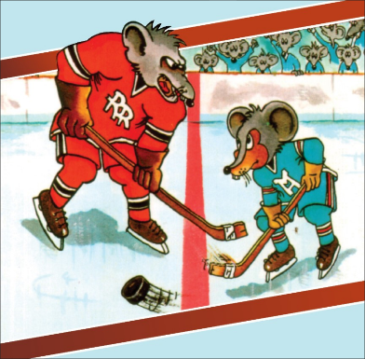
Synopsis
In Kerri Salata’s Mice at Centre Ice, a plucky mouse, Benny the Bullet, and fellow Mouse Hockey Leaguers take on the Rink Rats in a game for the Cheddar Cup. A loving adaptation of her grandmother Estelle Salata’s best-selling 1980s novel and animated feature, the play tells the story of a team of mice who use determination, heart and teamwork to win back the Cup. With a modern twist on 1960s hockey, Mice at Centre Ice is destined to be the cheesiest show at the Fringe.

