

Nearly Departed
Access Guide

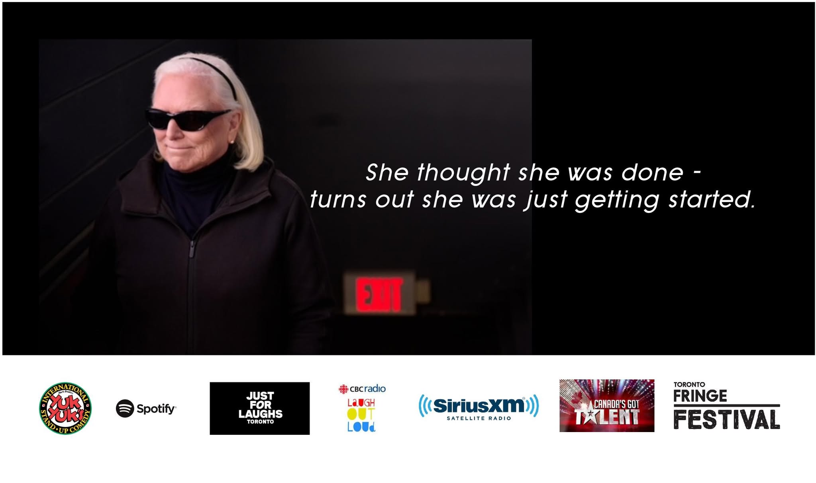

July 2-13, 2025
Thu 3rd Jul 3:00 pm; Fri 4th Jul 8:15 pm;
Sun 6th Jul 1:00 pm; Mon 7th Jul 4:30 pm;
Wed 9th Jul 6:15 pm; Thu 10th Jul 1:00 pm;
Fri 11th Jul 6:30; Sat 12th Jul 10:15 pm.
Tarragon Theatre Solo Room

This guide uses plain language to provide audiences, particularly neurodiverse audiences, with specific sensory details of programming in advance to help guide your experience.

Table of Contents

Access Measures 4

About Nearly Departed 5

Run Time 5

Content Warnings and Advisories 5

Cast and Characters 6

Set 7

Get in Touch 8

ACCESS MEASURES
No specific sensory details.

About Nearly Departed

Run Time
50 minutes with no intermission

Content Warnings and Advisories
Please be advised that Nearly Departed is a stand-up routine with my spin on observations. There’s lots of innuendo and mainly cleanish.

Cast and Characters
Cathy Boyd is a brutally honest Stand-Up Comedian, mother of four and a mediocre tennis player.



Set consists of just me and a mic

Get in Touch
If you have any questions or concerns about this access guide or planning your visit to Nearly Departed at the 2025 Toronto Fringe Festival, please reach out.

Cathy Boyd
Creator/Producer
Email:Boydsoflondon@sympatico.ca
Phone: 416-938-7532

If you want to tell the Fringe about your experience or have feedback that you would like to share, you can call, write, or send an email to the Fringe.

Our address is:
100 Broadview Avenue, Suite 400
Toronto, ON
M4M 3H3

Our email address is:
access@fringetoronto.com

Our phone number is:
416-966-1062

Thank you for coming to the 2025 Toronto Fringe Festival.

