

Imagined Love

Access Guide

[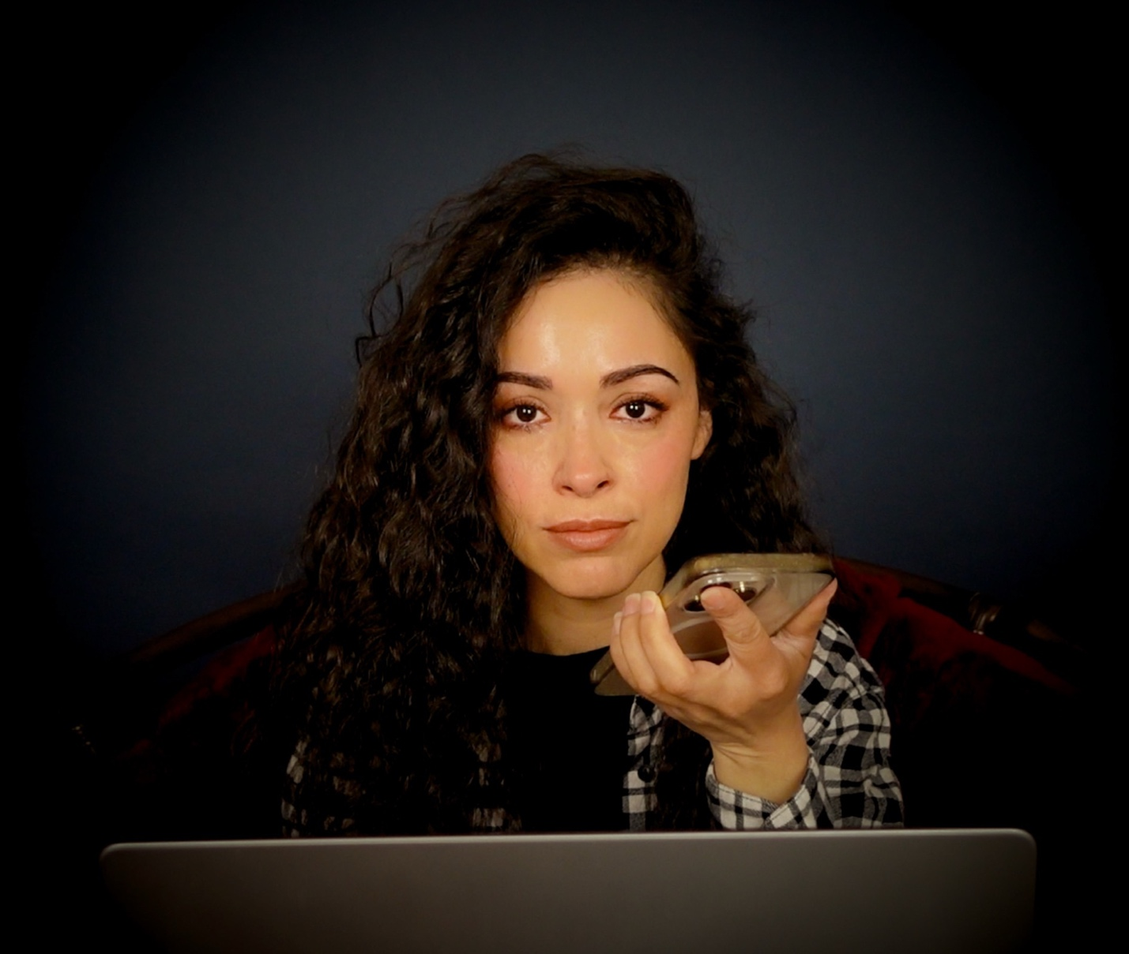

June 30 - July 12, 2026
Sweet Action Theatre

This guide uses plain language to provide audiences, particularly neurodiverse audiences, with specific sensory details of programming in advance to help guide your experience.

Table of Contents

About Imagined Love 4

Run Time 4

Content Warnings and Advisories

Cast and Characters 5

Set 6

Costumes 6

Get in Touch 7

About Imagined Love
A woman who feels isolated from family, friends and herself, develops an unexpected companion for connection.

Seeking comfort from an AI Chatbot after a heartbreak, things are about to get real...

Run Time
45-55 minutes with no intermission

Content Warnings and Advisories
Please be advised that Imagined Love has some adult language and the character of Ana screams loudly. We have loud music. There is a scene where Ana begins to undress to take a shower.

Cast and Characters


Tamara Almeida plays the role of Ana. She is a late 30’s something actor, living on her own, unsure of which way her life and her heart are headed.



Colin A Doyle plays the role of Clayton, an AI ChatBot. He starts the show speaking into a microphone seated in the audience but eventually makes his way onto the stage as Ana’s need for him grows.

Set
It is a minimal set with an L shaped couch. It comes to represent other locations in Ana’s life: bed, restaurant, meeting place.

Costumes
Ana wears athleisurewear. Clayton is in casual dress but wears a laptop on a harness in front of him.

Sound
The music of Adele, Bad Bunny, and Toni Braxton is played at times. Some times these songs and sound effects are played loudly.

Get in Touch
If you have any questions or concerns about this access guide or planning your visit to SHOW NAME at the 2026 Toronto Fringe Festival, please reach out.

Colin Doyle
Producer
Email: colindoyle32@gmail.com
Phone:

If you want to tell the Fringe about your experience or have feedback that you would like to share, you can call, write, or send an email to the Fringe.

Our address is:
100 Broadview Avenue, Suite 300
Toronto, ON
M4M 3H3

Our email address is:
access@fringetoronto.com

Our phone number is:
416-966-1062

Thank you for coming to the 2026 Toronto Fringe Festival.

