

In Search Of…

Access Guide


June 30 - July 12, 2026
Alumnae Theatre

This guide uses plain language to provide audiences, particularly neurodiverse audiences, with specific sensory details of programming in advance to help guide your experience.

Table of Contents

Access Measures 4

About ISO… 4

Run Time 4

Content Warnings and Advisories 4

Cast and Characters 5

Set 5

Costumes 7

Get in Touch 8

Access Measures
Relaxed Performance

Relaxed performances are open to everyone, but the environment has
been specifically adapted for those who are neurodivergent and may
experience sensory sensitivities, folks with communication or learning
disabilities, and people who would benefit from a more relaxed
environment.

The 2:15PM performance on July 7th will be a relaxed performance.

Notice of photography

There will be photography during June 30th performance and videography during July 4th performance

About In Search Of…
In Search Of... is a comedic, surrealist play that follows a Black girl
navigating her sexuality and discovering her own power. A chorus of boys
shapes the world around her, guiding her journey from submission toward
self-acceptance and empowerment.

Run Time
60 minutes with no intermission

Content Warnings
Please be advised that In Search Of… includes mature language, sexual
content, and abrupt sound and lighting cues.

Cast and Characters
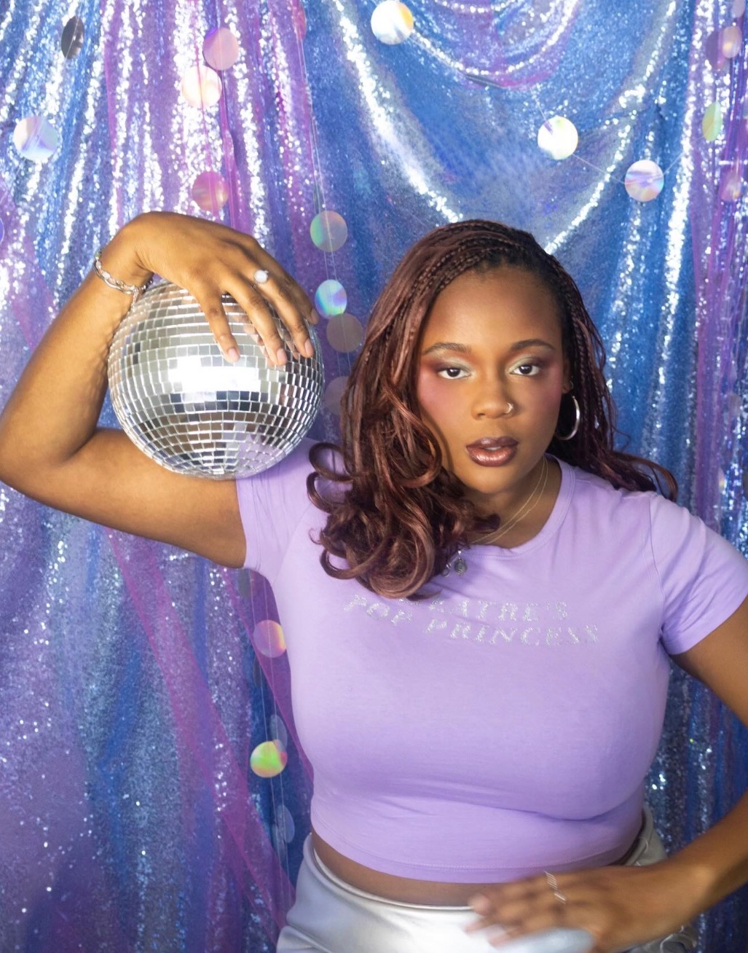
Oprah Lemorin plays the role of Black Girl

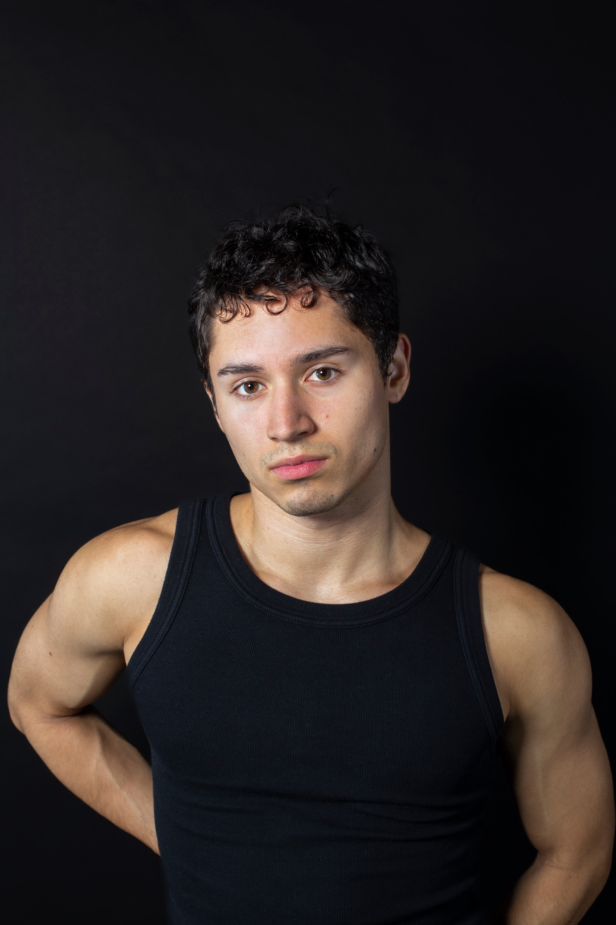

Miguel Gallego plays the role of Boy



Bongani plays the role of Boy



Han/nah Beatty plays the role of The Boys

Autumn Taylor plays the role of Ted Talk Host/The Bed


Set
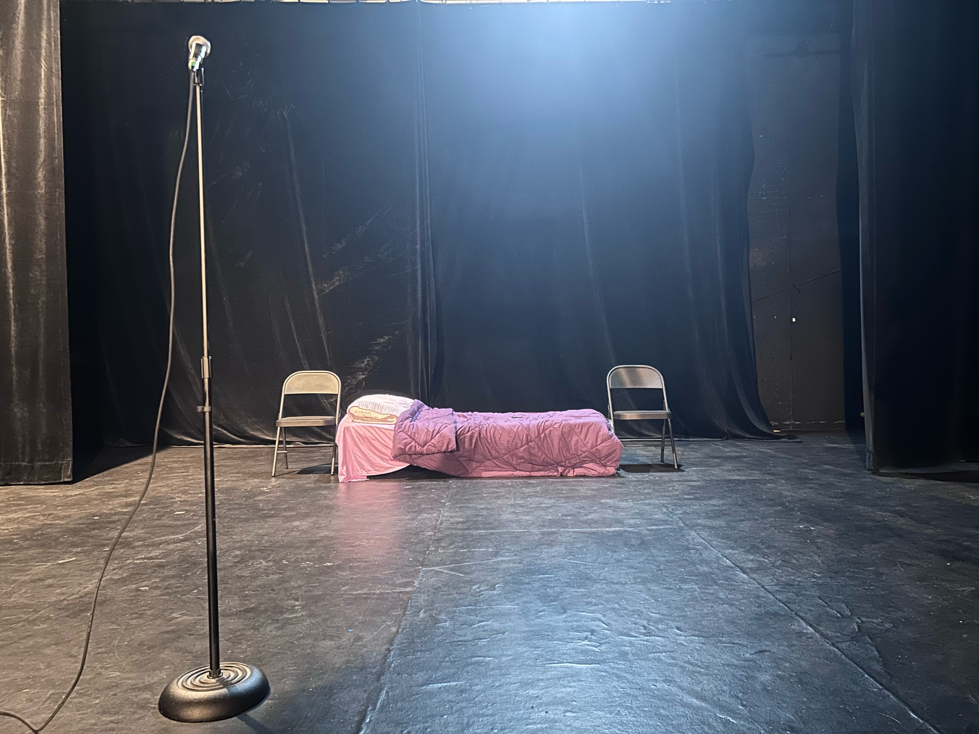

A single bed with purple bedding, a purple chair on each side of the bed.
Costumes
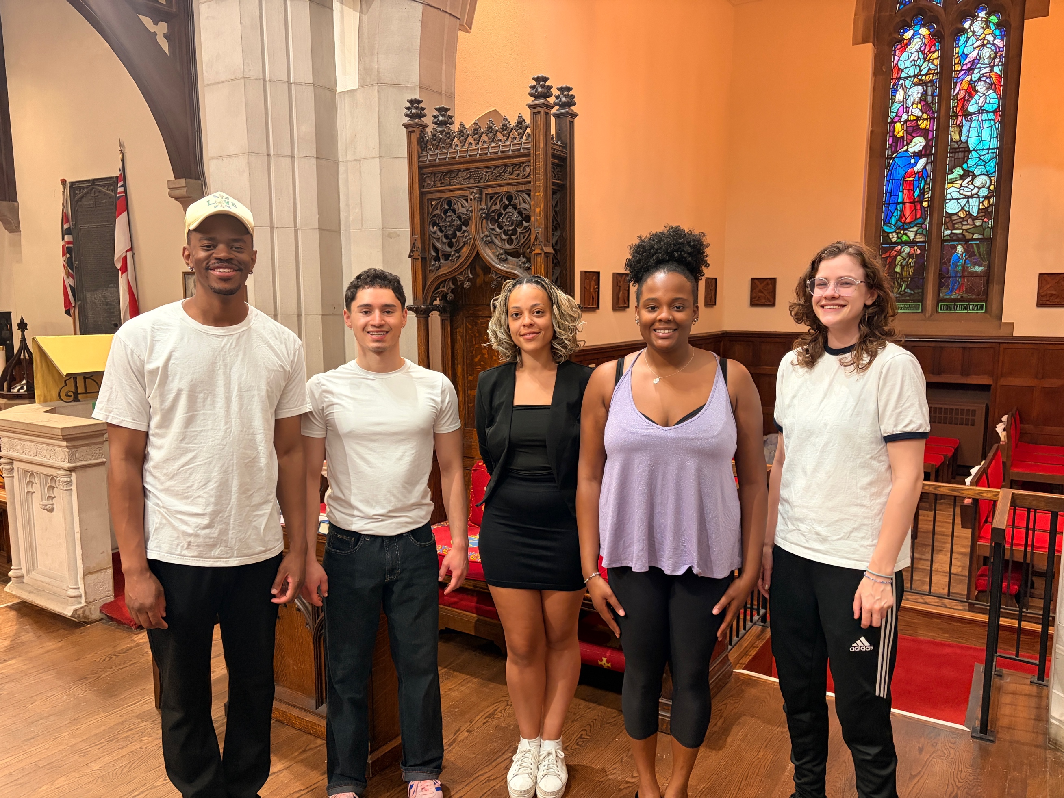OSTUME

The Boys wear white T-shirts and black pants
The bed/TED Talk host wears a black dress with a black cardigan
Black Girl wears dark yoga pants and a purple tank top

Get in Touch

If you have any questions or concerns about this access guide or planning
your visit to In Search Of… at the 2026 Toronto Fringe Festival, please
reach out.

Oprah Lemorin
Producer
Email: Glitterpopprod@gmail.com

If you want to tell the Fringe about your experience or have feedback that you would like to share, you can call, write, or send an email to the Fringe.

Our address is:
100 Broadview Avenue, Suite 300
Toronto, ON
M4M 3H3

Our email address is:
access@fringetoronto.com

Our phone number is:
416-966-1062

Thank you for coming to the 2026 Toronto Fringe Festival.

