

OLD-FASHIONED & NEW-FASHIONED
Access Guide

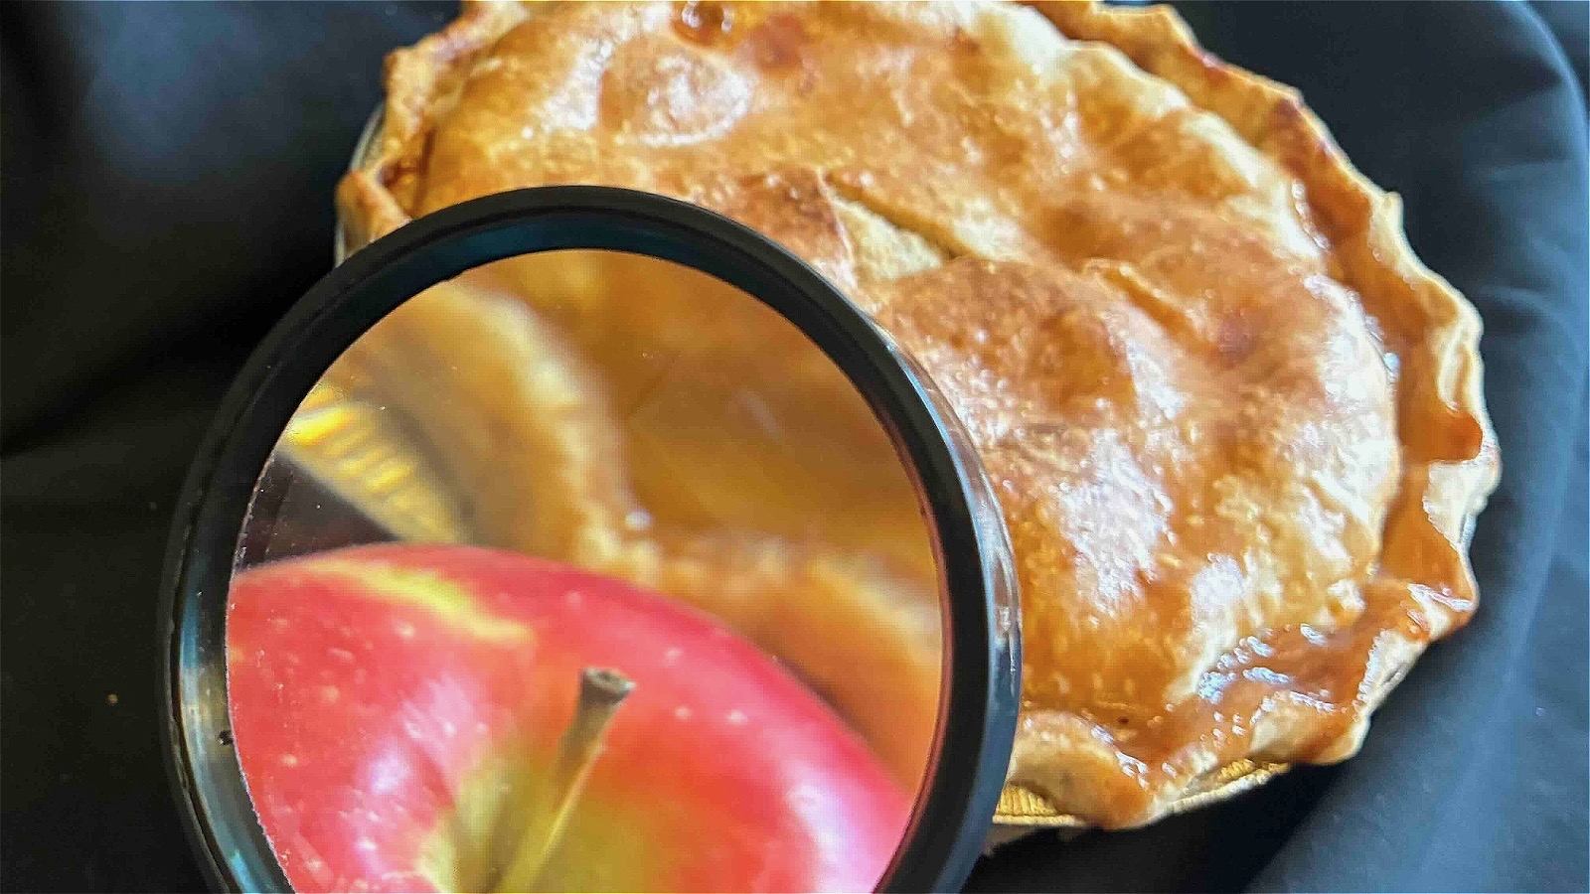

June 30 - July 12, 2026
Young People’s Theatre, Studio

This guide uses plain language to provide audiences, particularly neurodiverse audiences, with specific sensory details of programming in advance to help guide your experience.

Table of Contents

Access Measures 3

About Old-Fashioned & New-Fashioned 3

Run Time 3

Content Warnings and Advisories 5

Cast and Characters 6

Set 7

Costumes 7

Get in Touch 8

Access Measures
Relaxed Performance

Relaxed performances are open to everyone, but the environment has been specifically adapted for those who are neurodivergent and may experience sensory sensitivities, folks with communication or learning disabilities, and people who would benefit from a more relaxed environment.

The 2:30 PM performance on JULY 5th will be a relaxed performance.

ASL Interpreted Performance

ASL interpreted performances are specifically designed to provide access to performances for audience members who are d/Deaf and/or hard of hearing. These performances feature ASL-English and/or Deaf interpreters who interpret all dialogue into American Sign Language (ASL) in real time, either on stage or to the side of the stage.

The 4:30 PM performance on JULY 11th will be ASL interpreted by JAIDEEP GORAY (Deaf Interpreter) and MARCIA ADOLPHE
(ASL Interpreter).

About Old-Fashioned & New-Fashioned
When her best-baked plans stick to the bottom of the pan, the old-fashioned county champion pie-baker must throw in her apron or ask her new-fashioned neighbour for a favour! It’s about baking with love and making new friends! Suitable for ages 5 to 10, and the young at heart.

Run Time
50 minutes with no intermission

Content Warnings and Advisories
Please be advised that OLD-FASHIONED & NEW-FASHIONED includes references to the passing of a family member and one of the characters gets upset and appears to almost cry.

Cast and Characters
JEFF DINGLE plays MR. NEW-FASHIONED, a young professor who is a to pie baking novice.


Jeff is a White male with short brown hair and blue eyes. He smiles into the camera and wears a purple v-neck T-shirt. The backround has multiple shades of blue mixed with purple.

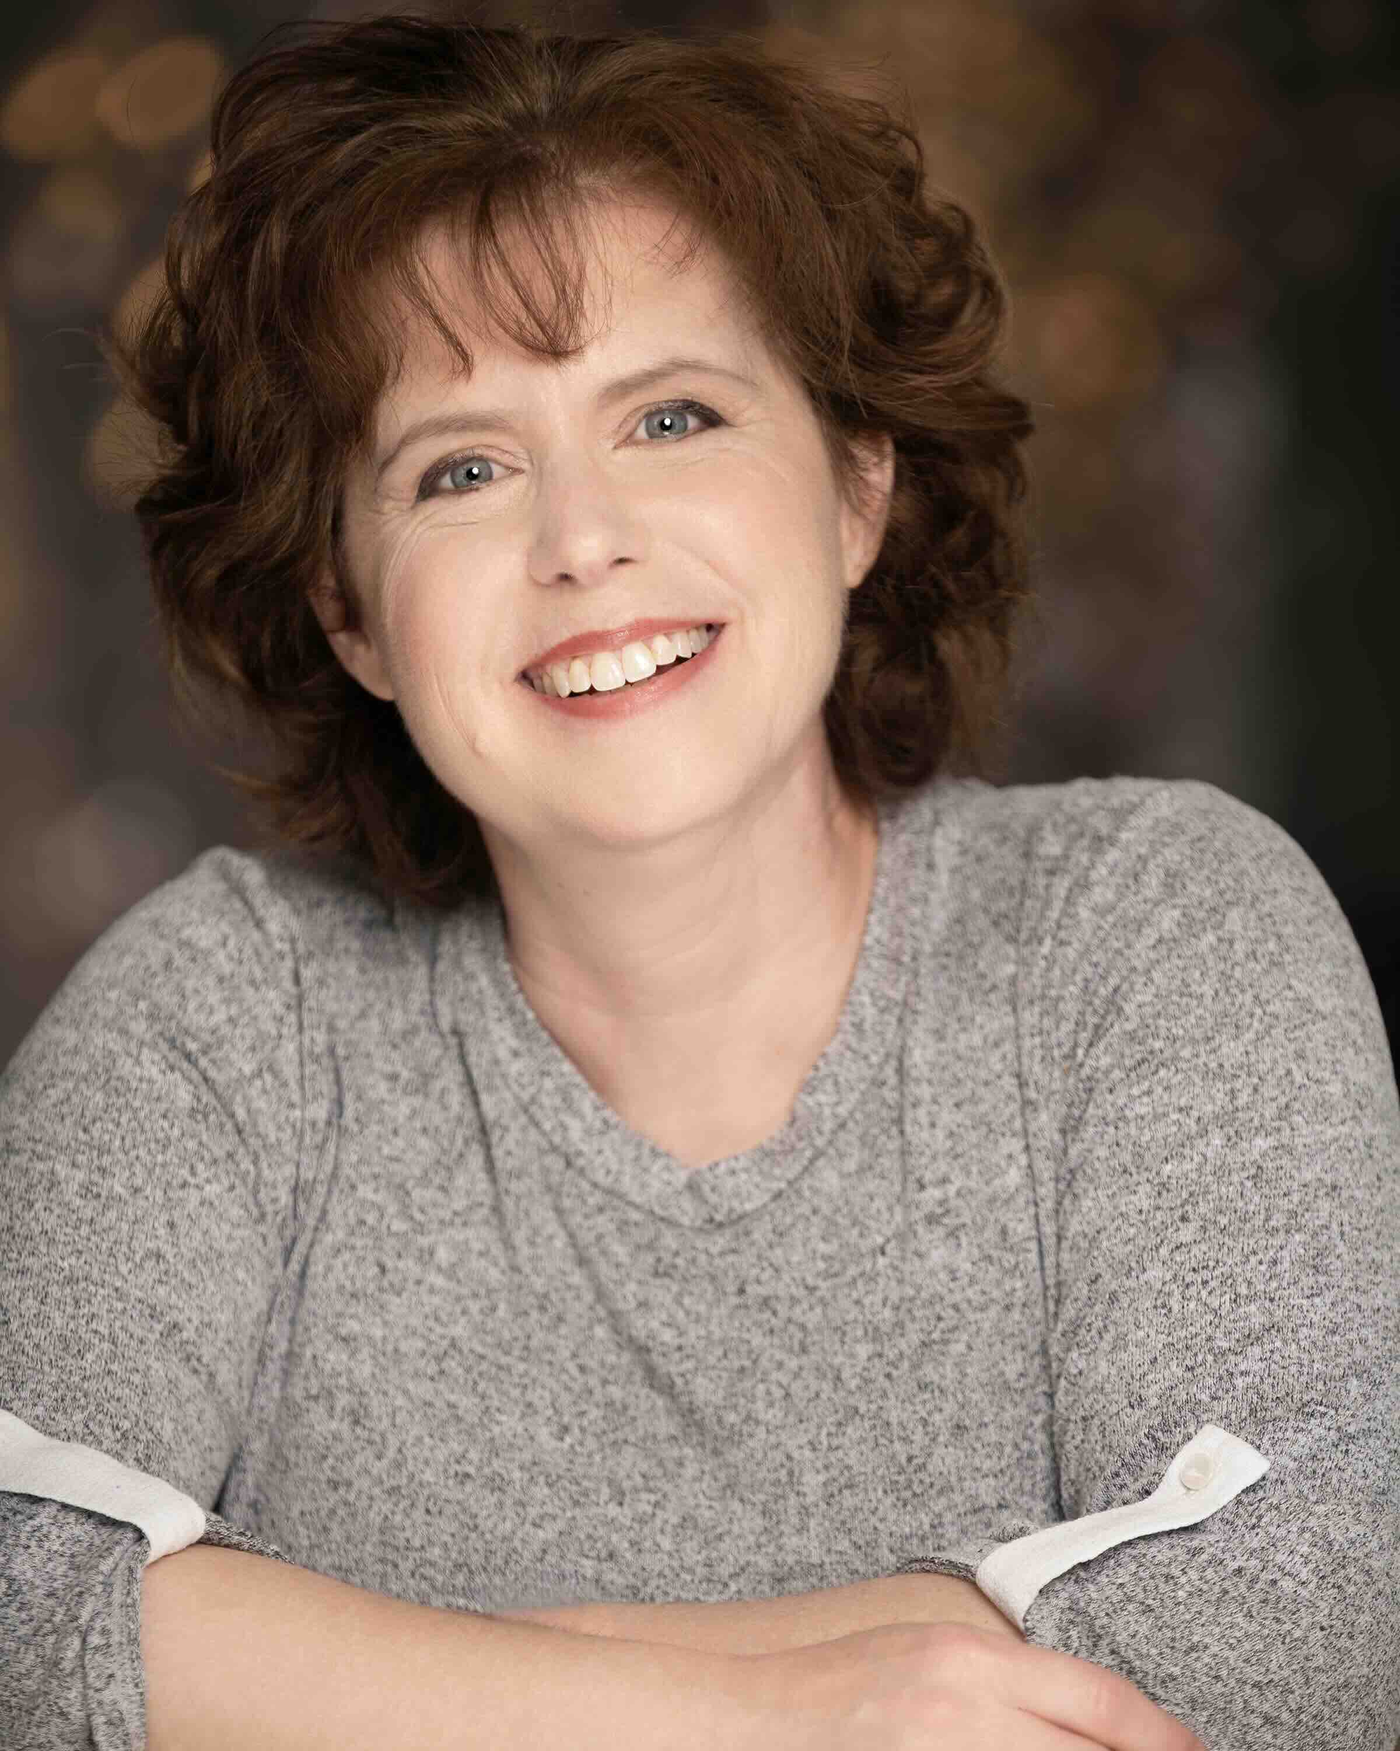SHOT
CARI HAIM plays MRS. OLD-FASHIONED, a grandmother and champion apple pie baker.
Cari is a White female with curly reddish-brown hair and green eyes. Wearing a grey v-neck top, she smiles into the camera, her head slight tilts to the left, arms crossed in front of her. The background is dark grey with reddish-orange highlights.


ALICIA PAYNE plays the NARRATOR who helps put love into everyone’s apple pie recipe.

Alicia is Black with shoulder length black curly hair and dark brown eyes. Wearing a purple top, Alicia smiles into the camera against a light bluish purple background.

Set
PHOTO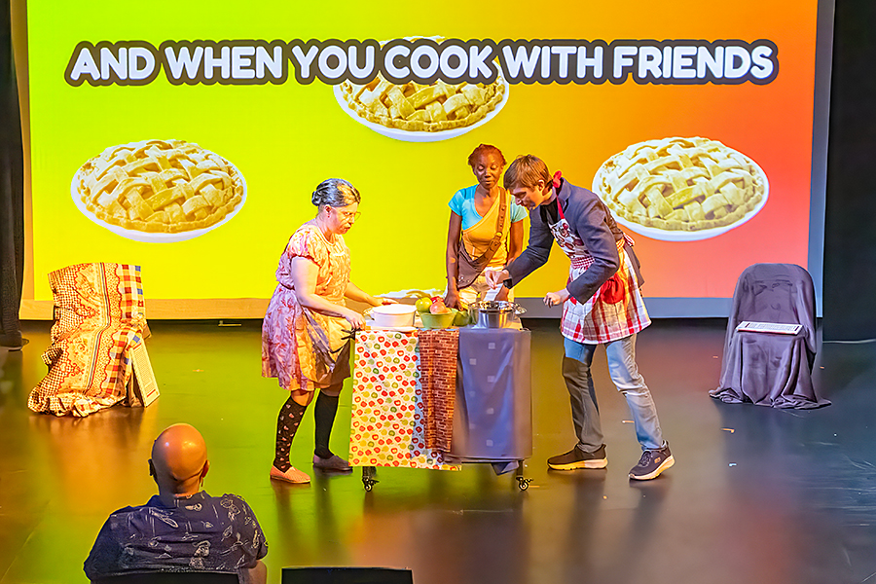 OF SET

The set has two chairs. The upstage right chair is covered in a colorful blanket. The upstage left chair is covered by three cloths: on the left is a cream coloured clothe with red apples; in the middle is a thin strip of cloth with red bricks on it; and on the right is navy blue cloth. At centre stage is a portable kitchen island on wheels. A large bowl of colorful apples sits on top of the island. There are also smaller bowls, a spoon, and rolling pin for baking. Throughout the play, different pies are placed on the counter and removed. There is a projection on the back wall that is green on the left and then changes to become orange on the right. There large apple pies also appear on the screen with the words “AND WHEN YOU COOK WITH FRIENDS.”

Costumes
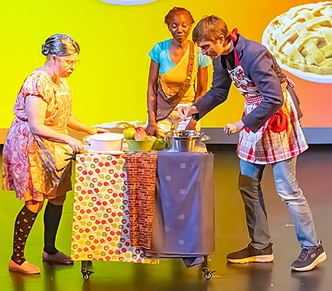 OFCOSTUME

On the left, Mrs. Old-Fashioned wears a colorful flowered dress, a colorful flowered apron, black socks with red apples, and beige slippers. Her hair is gray and in a bun behind her head.

In the middle, the Narrator wears a sky-blue T-shirt and bright golden-yellow over-one-shoulder top and white shorts. The narrator’s reddish brown hair is pulled back in a bun.

On the right, Mr. New-Fashioned wears a black turtleneck, blue jeans, navy shoes and a red and white apron with apples. Sometimes he wears a black jacket.

Get in Touch
If you have any questions or concerns about this access guide or planning your visit to OLD-FASHIONED & NEW-FASHIONED at the 2026 Toronto Fringe Festival, please reach out.

Alicia Payne
Co-Producer and Actor
Email: info@arbezdrama.com

If you want to tell the Fringe about your experience or have feedback that you would like to share, you can call, write, or send an email to the Fringe.

Our address is:
100 Broadview Avenue, Suite 300
Toronto, ON
M4M 3H3

Our email address is:
access@fringetoronto.com

Our phone number is:
416-966-1062

Thank you for coming to the 2026 Toronto Fringe Festival.

