WHO YOU CALLIN BLACK EH? (RJ DEVERELL PRODUCTIONS) 2019 TORONTO FRINGE REVIEW
JULY 5, 2019 DIANA MANOLE 1 COMMENT
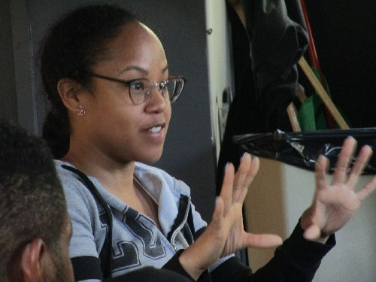
Who You Callin Black Eh? by Rita Shelton Deverell (RJ DEverell Productions) tells us the story of a young woman born in Atlantic Canada and now living in Toronto. As a bi-racial kid (white mother, black father), called Our Heroine, she is either not “Black Enough” or not “White Enough.” She is lonely and struggles to find her people.
Shadeism (also known as colourism) is a form of discrimination based on one’s skin tone. Like racism, it is also the result of slavery and colonialism. It reinforces the imperialistic idea of white supremacy.
In Who You Callin Black Eh? Shelton Deverell shows the courage to “call it like it is,” regarding both white and Black skin-based prejudices. The problem is that the script clearly aims to teach us lessons.
The characters are stereotypes, most of the scenes are just sketched out, and I could feel the rush to check off as many social issues as possible: racism, shadeism, tokenism, feminism, politicians’ lies, Obama, blonde Barbie dolls, trophy wives, lack of self-respect, bullying, and the list goes on.
For example, the play refers to a racial high school riot in Atlantic Canada as “a schoolyard fight with snowballs, the weapon of choice.” I was shocked to find out this kind of thing ever happened here.
As nothing else was mentioned, I decided to Google it. The horrifying nature of what happened in 1989 at Cole Harbour District High School in Halifax wasn’t even alluded to in the script.
The final message, literally spoken on stage, is the only one that could save humanity: any skin colour is fine and only together can we make the world a better place. I fully agree but when I go to the theatre I’d prefer to be shown rather than told.
This might come as a surprise after all of the above, but I loved Who You Callin Black Eh?! I’m sure the other viewers did too. Director Clara McBride, the talented, energetic, and passionate cast, and musician Osaze Dolabaille saved the script from patronizing its audience.
McBride made the stereotypical characters into even more of a stereotype: she gave them grotesque beast-like masks, which she designed and made herself. She also effectively avoided the “blackface” diminishing device: the Black actor plays a white character with a white mask and vice versa.
The characters with some traces of complexity, Our Heroine (always charming Chattrisse Dolabaille, the musician’s real-life daughter) and her parents (Jason Pilgrim and Jessica Bowmer), the BFF (also Bowmer) don’t have masks. I found that it helped the actors convincingly portray human beings and the audience empathizes with the characters.
Except for the lead and the MC, all the actors play multiple roles and do it very well. The opportunistic middle-class fiancé (Brendan Chandler) and his mother (Bowmer) in search of a Black wife to make him “look good” show us the depth of the ugliness of racism. All other masked Black or white characters do the same.
The commedia dell’arte style enriched with audience participation was a brilliant idea in my eyes. One concern, though: why does the energetic MC/Greek tragedy chorus (Iliana Spirakis) have a foreign, non-Canadian accent? Are immigrants less prone to discrimination?
As an immigrant with an accent, I’d love it to be true despite my doubts. But this is another issue, one not covered in the show. Go see it to enjoy the talent and passion for justice of a wonderful group of performers. I can’t praise them enough.
And leave chanting Shelton Deverell’s best lines: “I am who I am. I am a person, not a colour!”
Details
- Who You Callin Black Eh? plays at the Factory Theatre Studio. (125 Bathurst St.)
- Tickets are $13, including a $2 service charge. The festival also offers a range of money-saving passes and discounts for serious Fringers.
- Tickets can be purchased online, by telephone (416-966-1062), from the Festival Box Office at Scadding Court (275 Bathurst St.), and — if any remain — from the venue’s box office starting one hour before curtain.
- Content Warnings: realistic violence or gore; audience participation.
- The Fringe Festival considers this venue to be wheelchair-accessible.
- Be aware that Fringe performances always start exactly on time, and that latecomers are never admitted.
- The Toronto Fringe Festival is scent-free: please do not wear perfumes, colognes, or other strongly-scented products.
Performances
- Thursday July 4th, 10:15 pm
- Saturday July 6th, 6:45 pm
- Sunday July 7th, 1:00 pm
- Tuesday July 9th, 8:00 pm
- Thursday July 11th, 5:45 pm
- Friday July 12th, 4:15 pm
- Sunday July 14th, 12:15 pm
Photo of Chattrisse Dolabaille by Jim Plaxton

